

Task Title: Compare Cell Phone Plans

# OALCF Cover Sheet – Practitioner Copy

**Learner Name: __________________________________________**

**Date Started: ___________________________________________**

**Date Completed: _________________________________________**

|  |  |  |
| --- | --- | --- |
| **Goal Path:** | Employment | Apprenticeship |
| Secondary School | Post Secondary | Independence |

**Successful Completion:**  Yes No

**Task Description:** Compare cell phone plan options to determine the best deal.

**Main Competency/Task Group/Level Indicator:**

* Understand and Use Numbers/Manage money/C1.3

**Materials Required:**

* Pen/pencil and paper and/or digital device
* Calculator or digital device with calculator function

# Learner Information

An administrative assistant or purchasing assistant may be asked to determine which cell phone plan is the best option for their employer. You will also want to compare cell phone plans before making a purchase for yourself.

Look at the provided plan information from Koodo, Fido and Public Mobile. All three companies offer a variety of low-cost plans when you bring your own phone.

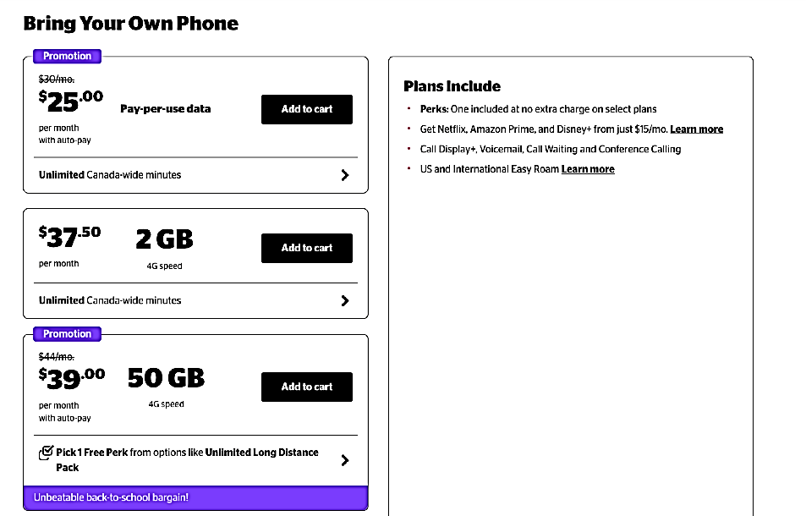**Koodo Fido**

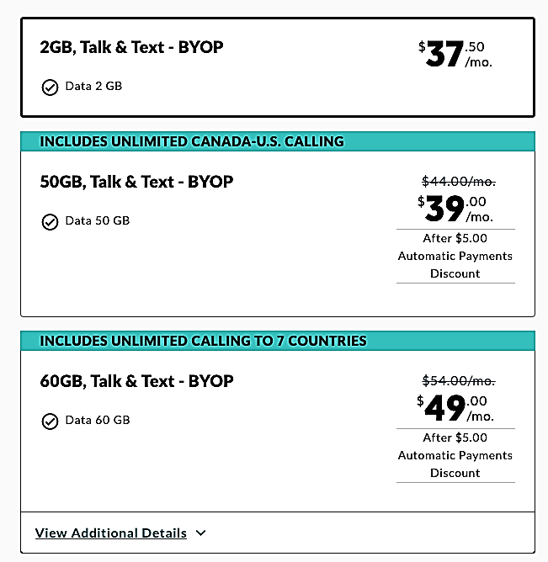

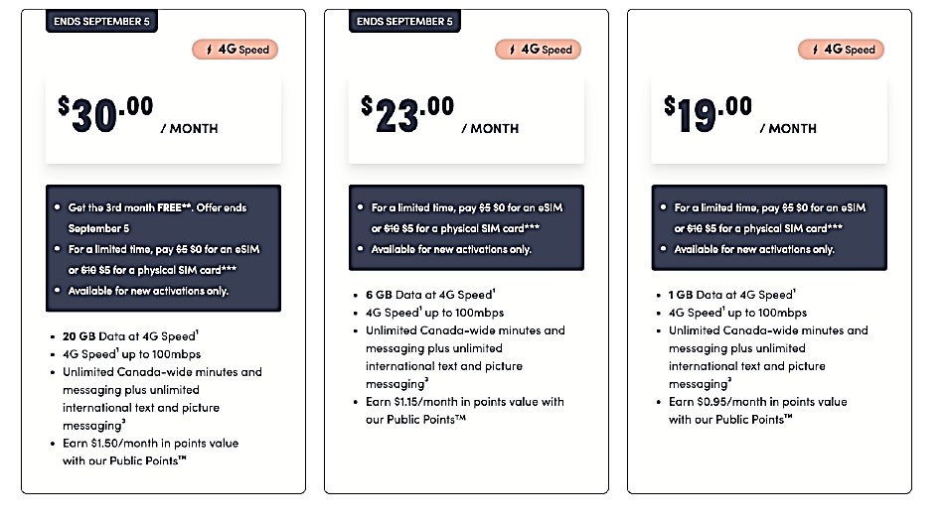**Public Mobile**

# Work Sheet

**Task 1: You need at least 2GB of data and don’t want to spend more than $40.00 per month. Which phone plans meet these criteria?**

Answer:

**______________________________________________________**

**Task 2: The cheapest plan that Koodo offers is $25.00 per month. This does not include data. Calculate the monthly cost you would pay for this phone if you pay for data at a rate of $5.00/GB and you need 2GB each month. Add HST to the total.**

Answer:

**______________________________________________________**

**Task 3: Your supervisor has asked you to find the cheapest phone plan. They use 5GB of data per month. Assume that each cell phone plan charges $5.00 for each additional GB of data beyond what is included in the monthly package. Add HST to the total. You do not want to recommend a plan that has more than 5GB of data because it will not be used. Which cell phone plan would you recommend?**

Answer:

**______________________________________________________**

# Answers

**Task 1: You need at least 2GB of data and don’t want to spend more than $40.00 per month. Which phone plans meet these criteria?**

Answer:

Koodo - $37.50 for 2GB and $39.00 for 50GB

Fido - $37.50 for 2GB and $39.00 for 50GB

Public Mobile - $23.00 for 6GB or $30.00 for 20GB

**Task 2: The cheapest plan that Koodo offers is $25.00 per month. This does not include data. Calculate the monthly cost you would pay for this phone if you pay for data at a rate of $5.00/GB and you need 2GB each month. Add HST to the total.**

Answer:

$25.00 + $10.00 = $35.00

$35.00 x .13 (HST) = $4.55

Total: $35.00 + $4.55 = $39.55

**Task 3: Your supervisor has asked you to find the cheapest phone plan. They use 5GB of data per month. Assume that each cell phone plan charges $5.00 for each additional GB of data beyond what is included in the monthly package. Add HST to the total. You do not want to recommend a plan that has more than 5GB of data because it will not be used. Which cell phone plan would you recommend?**

Answer:

Koodo:

$37.50 for 2GB of data + $15.00 (3 x $5.00 for extra 3GB) = $52.50

$52.50 x 0.13 = $6.83

Total: $52.50 + $6.83 = $59.40 for 5GB of data

Fido

$37.50 for 2GB of data + $15.00 (3 x $5.00 for extra 3GB) = $52.50

$52.50 x 0.13 = $6.83

Total: $52.50 + $6.83 = $59.40 for 5GB of data

Public $19.00 for 1 GB of data + $20.00 ($4 x $5.00 for extra GB) = $39.00

$39.00 x 0.13 = $5.07

Total: $39.00 + $5.07 = $44.07 for 5GB of data

The cheapest plan for 5GB of data is Public Mobile’s $19.00 plan: Total is $44.07 for 5GB of data per month.

# Performance Descriptors

| Levels | Performance Descriptors | Needs Work | Completes task with support from practitioner | Completes task independently |
| --- | --- | --- | --- | --- |
| C1.3 | calculates using numbers expressed as whole numbers, fractions, decimals, percentages and integers |  |  |  |
|  | manages unfamiliar elements (e.g. context, content) to complete the task |  |  |  |
|  | chooses and performs required operations; makes inferences to identify operations |  |  |  |
|  | selects appropriate steps to reach solutions from among options |  |  |  |
|  | identifies a variety of ways to complete the task |  |  |  |
|  | finds, integrates and analyzes numerical information |  |  |  |
|  | uses strategies to check accuracy |  |  |  |

This task: Was successfully completed Needs to be tried again

Learner Comments:

Instructor (print): Learner (print):

**__________________ _________________**