

Task Title: Compare College Employment Rates

# OALCF Cover Sheet – Practitioner Copy

**Learner Name: __________________________________________**

**Date Started: ___________________________________________**

**Date Completed: _________________________________________**

|  |  |  |
| --- | --- | --- |
| **Goal Path:** | Employment | Apprenticeship |
| Secondary School | Post Secondary | Independence |

**Successful Completion:**  Yes No

**Task Description:** The learner will compare graduate satisfaction and employment rates between colleges.

**Main Competency/Task Group/Level Indicator:**

* Find and Use Information/Interpret documents/A2.2
* Understand and Use Numbers/Manage data/C4.1

**Materials Required:**

* Pen/pencil and paper and/or digital device

# Learner Information

Learners on the Post Secondary goal path have a lot to consider when choosing a college. One way to compare colleges is by looking at the Employment Rates of graduates.

Look at “Ontario Colleges Key Performance Indicators”.

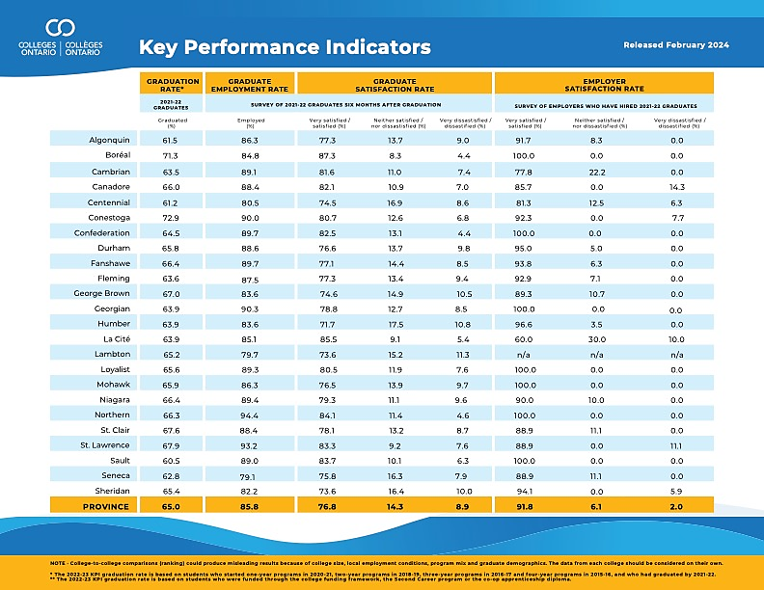

Work Sheet

**Task 1: List the three colleges that have the highest graduate rates for 2021-2022 in order from highest to lowest.**

Answer:

**______________________________________________________**

**Task 2: List the three colleges with the highest graduate employment rates for 2021-2022 in order from highest to lowest.**

Answer:

**______________________________________________________**

**Task 3: Which colleges have an employer satisfaction rate of 100% (very satisfied/satisfied) in 2021-2022?**

Answer:

**______________________________________________________**

# Answers

**Task 1: List the three colleges that have the highest graduate rates for 2021-2022 in order from highest to lowest.**

Answer: Note – Learner may include percentages, but they are not required.

* Conestoga 72.9%
* Boreal 71.3%
* St. Lawrence 67.9%

**Task 2: List the three colleges with the highest graduate employment rates for 2021-2022 in order from highest to lowest.**

Answer: Note – Learner may include percentages, but they are not required.

* Northern 94.4%
* St. Lawrence 93.2%
* Georgian 90.3%

**Task 3: Which colleges have an employer satisfaction rate of 100% (very satisfied/satisfied) in 2021-2022?**

Answer:

* Boreal
* Confederation
* Georgian
* Loyalist
* Mohawk
* Northern
* Sault

# Performance Descriptors

| Levels | Performance Descriptors | Needs Work | Completes task with support from practitioner | Completes task independently |
| --- | --- | --- | --- | --- |
| A2.2 | Extracts information from tables and forms |  |  |  |
|  | Uses layout to locate information |  |  |  |
|  | Makes connections between parts of documents |  |  |  |
|  | Makes low-level inferences |  |  |  |
|  | Begins to identify sources and evaluate information |  |  |  |
| C4.1 | Recognizes values in number and word format |  |  |  |
|  | Identifies and compares quantities of items |  |  |  |
|  | Understands numerical order |  |  |  |
|  | Uses strategies to check accuracy (e.g. estimating, using a calculator, repeating a calculation, using the reverse operation) |  |  |  |

This task: Was successfully completed Needs to be tried again

Learner Comments:

Instructor (print): Learner (print):

**__________________ _________________**