

Task Title: Compare Hotel Room Size

# OALCF Cover Sheet – Practitioner Copy

**Learner Name: __________________________________________**

**Date Started: ___________________________________________**

**Date Completed: _________________________________________**

|  |  |  |
| --- | --- | --- |
| **Goal Path:** | Employment | Apprenticeship |
| Secondary School | Post Secondary | Independence |

**Successful Completion:**  Yes No

**Task Description:** The learner will use floor plans and dimensions to calculate and compare hotel room sizes.

**Main Competency/Task Group/Level Indicator:**

* Understand and Use Numbers/Use measures/C3.2

**Materials Required:**

* Pen/pencil and paper and/or digital device
* Calculator or digital device with calculator function

# Learner Information

When travelling or booking hotel rooms it is important to know the size of the room so you can book the space that you need.

# Work Sheet

**Task 1: Calculate what the square foot difference is between the “Double-Double Suite” and the “King Suite” shown here. Both rooms are 14’ wide. The Double-Double Suite is 35’ long, and the King Suite is 29’ long.**

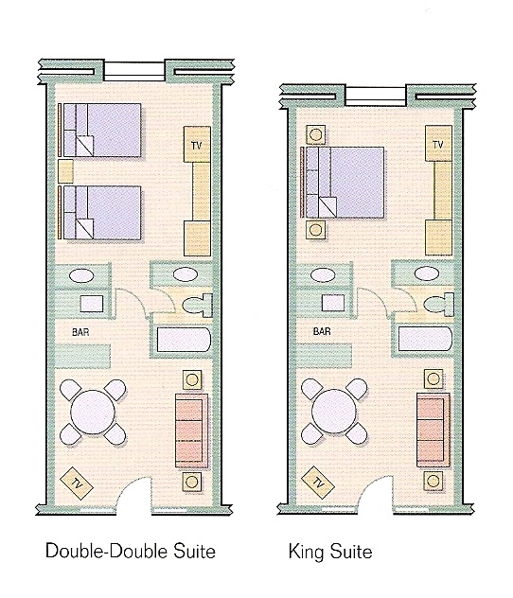

Answer:

**______________________________________________________**

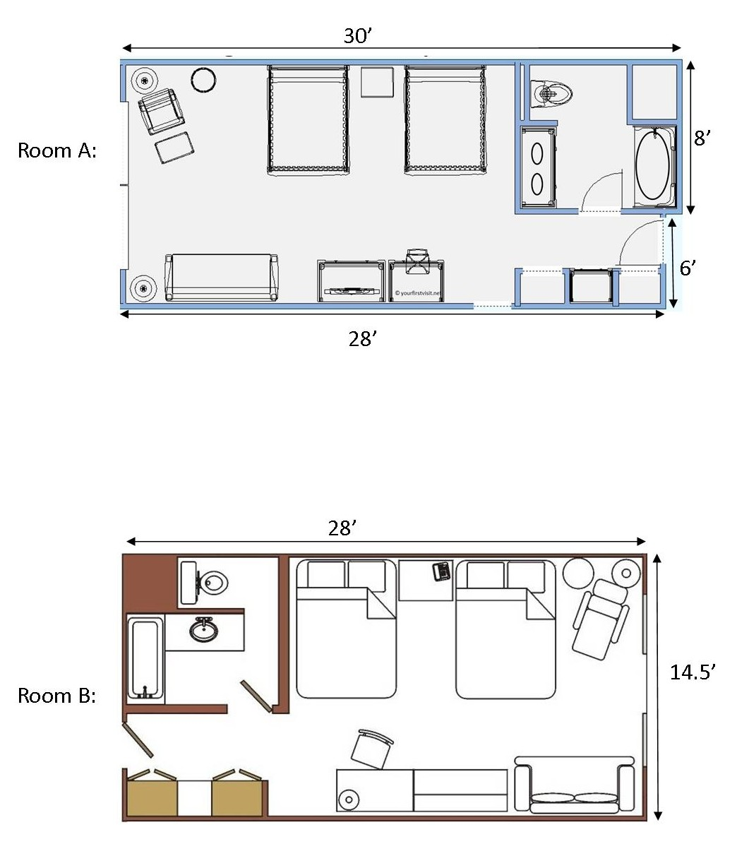**Task 2: Using the floor plans for Room A and Room B, determine which hotel room is larger, and by how many square feet.**

Answer:

**______________________________________________________**

# Answers

**Task 1: Calculate what the square foot difference is between the “Double-Double Suite” and the “King Suite” shown here. Both rooms are 14’ wide. The Double-Double Suite is 35’ long, and the King Suite is 29’ long.**

Answer:

DD Suite: 14’ x 35’ = 490 sq feet

KS Suite: 14’ x 29’ = 406 sq feet

490 – 406 = 84 sq feet

**Task 2: Using the floor plans for Room A and Room B, determine which hotel room is larger, and by how many square feet.**

Answer:

Room A:30’ x 8’ = 240 sq ft

28’ x 6’ = 168 sq ft

240 + 168 =408 sq feet

Room B: 28’ x 14.5’ = 406 sq feet

Room A is 2 square feet larger than Room B.

# Performance Descriptors

| Levels | Performance Descriptors | Needs Work | Completes task with support from practitioner | Completes task independently |
| --- | --- | --- | --- | --- |
| C3.2 | calculates using numbers expressed as whole numbers, fractions, decimals, percentages and integers |  |  |  |
|  | understands and uses formulas for finding the perimeter, area and volume of simple, common shapes |  |  |  |
|  | chooses and performs required operation(s); may make inferences to identify required operation(s) |  |  |  |
|  | selects appropriate steps to solutions |  |  |  |
|  | uses strategies to check accuracy (e.g. estimating, using a calculator, repeating a calculation, using the reverse operation) |  |  |  |

This task: Was successfully completed Needs to be tried again

Learner Comments:

Instructor (print): Learner (print):

**__________________ _________________**

Skill Building Activities

**Links to Online Resources:**

LearningHUB Math Courses: <https://www.learninghub.ca/apps/pages/index.jsp?uREC_ID=1118749&type=d&pREC_ID=1380783>

LearningHUB Course Catalogue: <https://www.learninghub.ca/apps/pages/coursecatalogue>

Khan Academy – Comparing Areas of Rectangles (short video):  
<https://www.khanacademy.org/math/cc-fourth-grade-math/area-perimeter/imp-area-and-perimeter/v/comparing-area>

Khan Academy – Area Problem Questions: <https://www.khanacademy.org/math/cc-fourth-grade-math/area-perimeter/imp-area-and-perimeter/e/area_of_squares_and_rectangles>

WikiHow – Measuring a Room (with pictures): <https://www.wikihow.com/Measure-a-Room>