

Task Title: Compare Store Prices

# OALCF Cover Sheet – Practitioner Copy

**Learner Name: __________________________________________**

**Date Started: ___________________________________________**

**Date Completed: _________________________________________**

|  |  |  |
| --- | --- | --- |
| **Goal Path:** | Employment | Apprenticeship |
| Secondary School | Post Secondary | Independence |

**Successful Completion:**  Yes No

**Task Description:** The learner will compare item costs in two grocery store flyers.

**Main Competency/Task Group/Level Indicator:**

* Understand and Use Numbers/Manage money/C1.1

**Materials Required:**

* Pen/pencil and paper and/or digital device

# Learner Information

Shoppers often compare the cost of grocery items at different stores. This can help people decide where they can get the best deals.

Scan the grocery store flyers for “Bargain Barnie’s” and “Fab Foods”.

**BARGAIN BARNIE’S**

**Sale Prices—September 18-25**

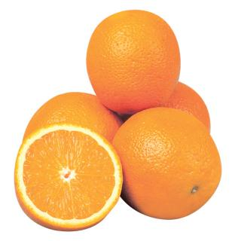 

**Oranges - $5.99/5 lb. bag Dish soap - $2.79/bottle**

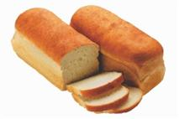 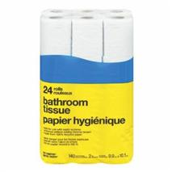**Whole wheat bread Toilet paper -**

**$2.39/loaf $5.79/24 rolls**

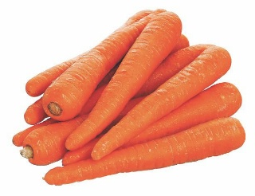 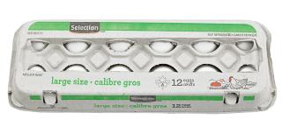

**Carrots - $2.79 /5 lb. bag** **Eggs - $2.39/dozen**

**FAB FOODS**

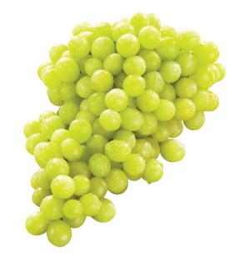**Sale Prices—September 18-27**



**Whole wheat bread - $2.85/loaf Grapes - 89¢/lb.**

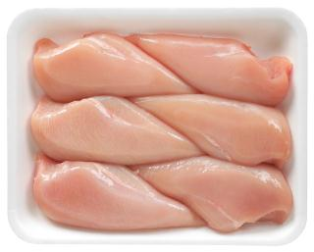 **Chicken breasts - $4.88 /lb Oranges - $6.49/5 lb. bag**

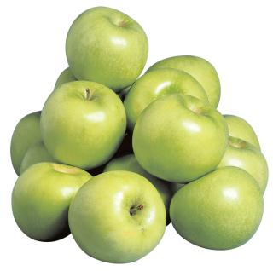

**Apples - $4.99 /5 lb. bag Eggs - $2.85 /dozen**

# Work Sheet

**Task 1: How much would it cost to buy a bag of oranges and a loaf of whole wheat bread at Bargain Barnie’s?**

Answer:

**______________________________________________________**

**Task 2: How much would it cost to buy a bag of oranges and a loaf of whole wheat bread at Fab Foods?**

Answer:

**______________________________________________________**

**Task 3: At which store could a shopper buy the oranges and bread at the lowest cost?**

Answer:

**______________________________________________________**

**Task 4: Calculate the price difference between a carton of eggs purchased at Fab Foods, and one purchased at Bargain Barnie’s.**

Answer:

**______________________________________________________**

# Answers

**Task 1: How much would it cost to buy a bag of oranges and a loaf of whole wheat bread at Bargain Barnie’s?**

Answer: $5.99 + $2.39 = $8.38

**Task 2: How much would it cost to buy a bag of oranges and a loaf of whole wheat bread at Fab Foods?**

Answer: $6.49 + $2.85 = $9.34

**Task 3: At which store could a shopper buy the oranges and bread at the lowest cost?**

Answer: Bargain Barnie’s

**Task 4: Calculate the price difference between a carton of eggs purchased at Fab Foods, and one purchased at Bargain Barnie’s.**

Answer: $2.85 - $2.39 = $0.46

# Performance Descriptors

| Levels | Performance Descriptors | Needs Work | Completes task with support from practitioner | Completes task independently |
| --- | --- | --- | --- | --- |
| C1.1 | adds, subtracts, multiplies and divides whole numbers and decimals |  |  |  |
|  | recognizes values in number and word format |  |  |  |
|  | understands numerical order |  |  |  |
|  | identifies and performs required operation |  |  |  |
|  | follows apparent steps to reach solutions |  |  |  |
|  | interprets and represents costs using monetary symbols and decimals |  |  |  |
|  | uses strategies to check accuracy (e.g. estimating, using a calculator, repeating a calculation, using the reverse operation) |  |  |  |

This task: Was successfully completed Needs to be tried again

Learner Comments:

Instructor (print): Learner (print):

**__________________ _________________**