

Task Title: Comparing Nutritional Labels

# OALCF Cover Sheet – Practitioner Copy

**Learner Name: __________________________________________**

**Date Started: ___________________________________________**

**Date Completed: _________________________________________**

|  |  |  |
| --- | --- | --- |
| **Goal Path:** | Employment | Apprenticeship |
| Secondary School | Post Secondary | Independence |

**Successful Completion:**  Yes No

**Task Description:** The learner will compare Nutrition Facts labels for similar products.

**Main Competency/Task Group/Level Indicator:**

* Find and Use Information/Interpret documents/A2.2
* Communicate Ideas and Information/Write continuous text/B2.1
* Understand and Use Numbers/Manage data/C4.1

**Materials Required:**

* Pen/pencil and paper and/or digital device

# Learner Information

Many people want to compare the nutritional facts on different product labels. This can help someone decide which item to purchase, or learn which product has more or less of a certain nutrient or ingredient.

Scan “Health Canada: Using the Nutrition Facts Table: % Daily Value” and the product labels for

* Product A: Lays Potato Chips
* Product B: Special K Cracker Chips
* Product C: Corn Pops
* Product D: Spoon Size Shredded Wheat

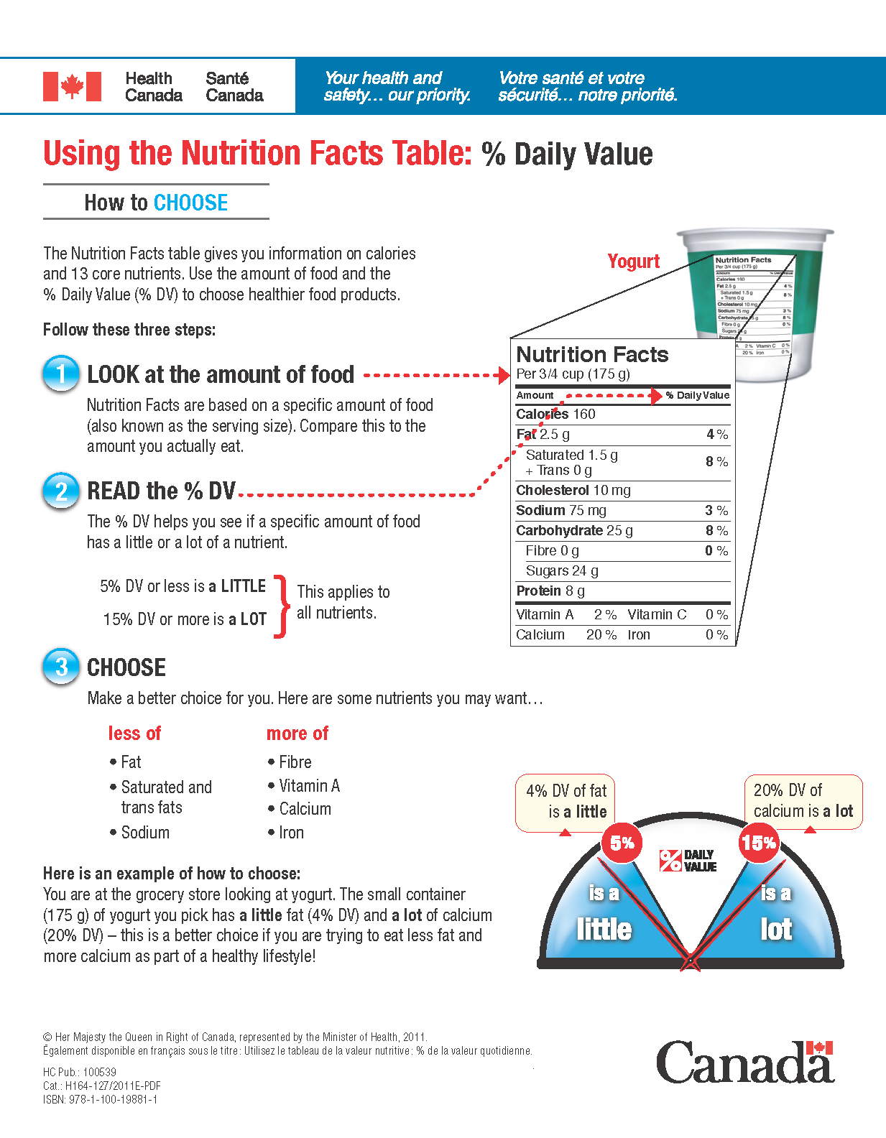

Product A: Lays Potato Chips Product B: Special K Cracker Chips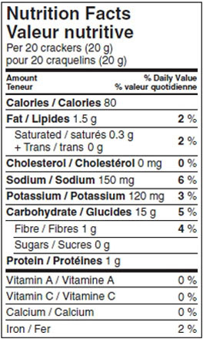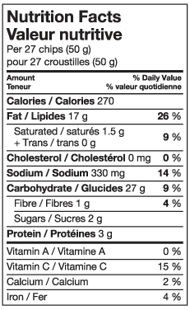

Product C: Corn Pops Product D: Spoon Size Shredded Wheat

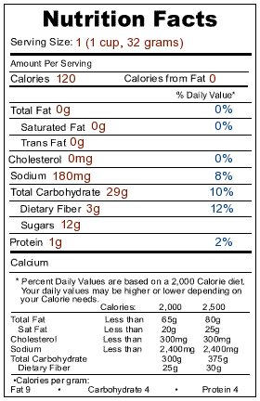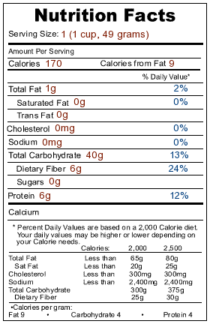

# Work Sheet

**Task 1: Calculate the difference in number of chips and grams between the serving sizes of the two brands of chips, Product A: Lays Potato Chips and Product B: Special K Cracker Chips.**

Answer:

**______________________________________________________**

**Task 2: If you were on a low-sodium diet, which chips should you choose?**

Answer:

**______________________________________________________**

**Task 3: Do either brand of chips have what Health Canada’s Nutrition Facts Table considers a lot of fat? If so, explain which and why you think so?**

Answer:

**______________________________________________________**

**Task 4: Do either brand of chips have what Health Canada’s Nutrition Facts Table considers a little fibre? If so, explain which and why you think so?**

Answer:

**______________________________________________________**

**Task 5: If you were counting calories, which chips would be a better snack? Why?**

Answer:

**______________________________________________________**

**Task 6: Calculate the difference between the two cereals using both cups and weight**.

Answer:

**______________________________________________________**

**Task 7: Eating too much sodium is linked to high blood pressure. Which cereal has the least sodium?**

Answer:

**______________________________________________________**

**Task 8: Do either of the cereals have what Health Canada’s Nutrition Facts Table considers only a little fibre? If so, explain which and why you think so?**

Answer:

**______________________________________________________**

**Task 9: Too much sugar can also be harmful. Which cereal has the least sugar?**

Answer:

**______________________________________________________**

# Answers

**Task 1: Calculate the difference in number of chips and grams between the serving sizes of the two brands of chips, Product A: Lays Potato Chips and Product B: Special K Cracker Chips.**

Answer: 7 chips (difference or 35% more). By weight there is a 30 g difference (A is 150% more than B or 30 g).

**Task 2: If you were on a low-sodium diet, which chips should you choose?**

Answer: B. Special K Cracker Chips (as they have only 6% DV (120 mg) while A. Lays have 14% DV (330 mg)).

**Task 3: Do either brand of chips have what Health Canada’s Nutrition Facts Table considers a lot of fat? If so, explain which and why you think so?**

Answer: A. Lays Potato Chips have 26% DV. 15% DV or more is considered “a lot”.

**Task 4: Do either brand of chips have what Health Canada’s Nutrition Facts Table considers a little fibre? If so, explain which and why you think so?**

Answer: Both products have only 4% DV. 5% DV or less is considered “a little”.

**Task 5: If you were counting calories, which chips would be a better snack? Why?**

Answer: Answers will vary, but learner should have noted that, even taking into account the difference in weight, B. Special K Cracker Chips have much fewer calories (240 calories for 60 cracker chips compared to 270 calories for 50 potato chips).

**Task 6: Calculate the difference between the two cereals using both cups and weight**.

Answer: They are both the same serving size at 1 cup, Product D. Spoon Size Shredded Wheat weighs 17 g (53%) more than C.

**Task 7: Eating too much sodium is linked to high blood pressure. Which cereal has the least sodium?**

Answer: D. Spoon Size Shredded Wheat has no sodium.

**Task 8: Do either of the cereals have what Health Canada’s Nutrition Facts Table considers only a little fibre? If so, explain which and why you think so?**

Answer: No. (They both have more than the 5% DV which is the start point of “a little”. Product D. at 24% DV, actually would be considered “a lot” as it is over 15%).

**Task 9: Too much sugar can also be harmful. Which cereal has the least sugar?**

Answer: D. Spoon Size Shredded Wheat has no sugar, while C. Corn Pops has 12g.

# Performance Descriptors

| Levels | Performance Descriptors | Needs Work | Completes task with support from practitioner | Completes task independently |
| --- | --- | --- | --- | --- |
| A2.2 | performs limited searches using one or two search criteria |  |  |  |
|  | extracts information from tables and form |  |  |  |
|  | uses layout to locate information |  |  |  |
|  | makes connections between parts of documents |  |  |  |
|  | makes low-level inferences |  |  |  |
| B2.1 | writes simple texts to request, remind or inform |  |  |  |
|  | conveys simple ideas and factual information |  |  |  |
|  | uses highly familiar vocabulary |  |  |  |
| C4.1 | adds, subtracts, multiplies and divides whole numbers and decimals |  |  |  |
|  | recognizes values in number and word format |  |  |  |
|  | identifies and compares quantities of items |  |  |  |
|  | understands numerical order |  |  |  |

This task: Was successfully completed Needs to be tried again

Learner Comments:

Instructor (print): Learner (print):

**__________________ _________________**