

# **Task Title: Complete An Insurance Report at Work**

OALCF Cover Sheet – Practitioner Copy

**Learner Name:___________________________________________**

**Date Started:____________________________________________**

**Date Completed: _________________________________________**

**Successful Completion:**  Yes No

|  |  |  |
| --- | --- | --- |
| **Goal Path:** | Employment | Apprenticeship |
| Secondary School | Post Secondary | Independence |

**Task Description:** Use details about an incident at work to complete an insurance report.

**Main Competency/Task Group/Level Indicator:**

* Find and Use Information/Read continuous text/A1.2
* Communicate Ideas and Information/Write continuous text/B2.2
* Communicate Ideas and Information/Complete and create documents/B3.1a
* Understand and Use Numbers/Manage time/C2.1

**Materials Required:**

* Pen/pencil and paper and/or digital device

# Learner Information

Employees are sometimes asked to fill in an insurance report if they witness an accident or incident at work where fire, police or ambulance needed to be called.

Scan the scenarios below.

**Scenario #1**

You operate a drill press in a factory called Kolman. It is located in Barrie on Oak Street at number #41. Your employee number is 256. On January 3rd around 11:15 in the morning, there was a fire at the factory which began in the north corner of the large room that contains your drill press. No one was hurt in the fire, but the factory was closed for repairs for three weeks. It is now the first day of the next month, and you have to fill out a report for the insurance agency. The agency is trying to find out what caused the fire and wants to know what you saw.

**Scenario #2**

Before you left your drill press you saw the following in no particular order:

* an employee throw a cigarette butt accidentally into the vat of wood stain
* the vat of wood stain catch on fire
* smoke quickly fill the room with haze
* a woman employee run to the fire alarm and yell “Fire”
* a foreman wave his arms wildly at a maintenance man
* the maintenance man hit the sprinkler pipes with a long piece of wood
* water from the sprinkler pipes begin to fall
* employees run to the exits on the east side of the building

# Work Sheet

**Task 1: Fill out the top portion of the *Insurance Report* on the next page using the details provided in Scenario #1.**

Answer: No written response required here.

Task completed: Yes:

**Task 2: Complete the “Description of Incident or Accident” section of the *Insurance Report* using the details provided in Scenario #2.**

**These details need to be sorted into a logical order. You can add other details that you think are important if they are not supplied.**

**When writing the description of the incident, use your own words, and write it in a story form, using complete sentences.**

Answer: No written response required here.

Task completed: Yes:

**Insurance Report**

Date of Incident: _______________________ Employee # ___________

Name of Company ______________________________________________

Address: _____________________________________________________

# Street Unit #

_____________________________________________________________

City Province Postal Code

Phone: ______-______-______ Location of incident ___________________

Area code

Description of Incident or Accident (Attach additional paper if necessary)

_____________________________________________________________

_____________________________________________________________

_____________________________________________________________

_____________________________________________________________

_____________________________________________________________

_____________________________________________________________

_____________________________________________________________

_____________________________________________________________

_____________________________________________________________

_____________________________________________________________

Reported by: Signature:

Position: Date:

# Answers

Answers will vary. An example is as follows:

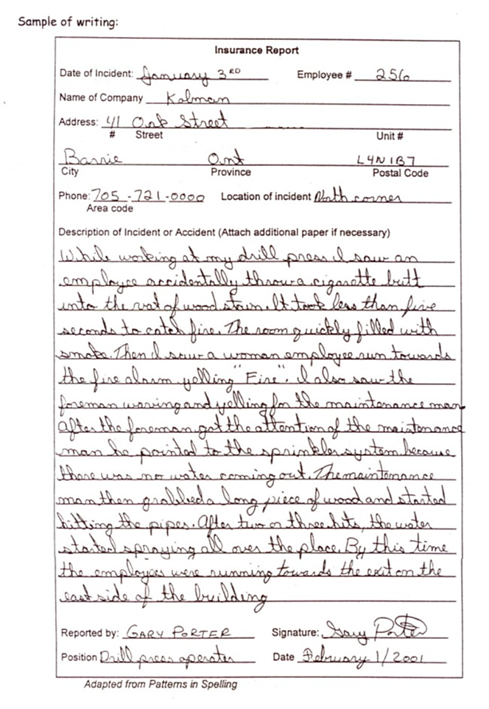

Performance Descriptors

|  |  |  |  |  |
| --- | --- | --- | --- | --- |
| **Levels** | **Performance Descriptors** | **Needs Work** | **Completes task with support from practitioner** | **Completes task independently** |
| A1.2 | scans text to locate information |  |  |  |
|  | locates multiple pieces of information in simple texts |  |  |  |
|  | makes low-level inferences |  |  |  |
|  | makes connections between sentences and between paragraphs in a single text |  |  |  |
|  | reads more complex texts to locate a single piece of information |  |  |  |
| B2.2 | writes texts to explain and describe |  |  |  |
|  | conveys intended meaning on familiar topics for a limited range of purposes and audiences |  |  |  |

|  |  |  |  |  |
| --- | --- | --- | --- | --- |
|  | begins to sequence writing with some attention to organizing principles (e.g. time, importance) |  |  |  |
|  | connects ideas using paragraph structure |  |  |  |
|  | uses limited range of vocabulary and punctuation appropriate to the task |  |  |  |
|  | begins to select words and tone appropriate to the task |  |  |  |
|  | begins to organize writing to communicate effectively |  |  |  |
| B3.1a | makes a direct match between what is requested and what is entered |  |  |  |
|  | makes entries using familiar vocabulary |  |  |  |
| C2.1 | recognizes values in number and word format |  |  |  |
|  | understands and uses common date formats |  |  |  |
|  | represents dates and times using standard conventions |  |  |  |

This task: Was successfully completed Needs to be tried again

Learner Comments:

Instructor (print): Learner Signature:

**_______________________ _____________________**