

Task Title: Complete a Money Order Form

# OALCF Cover Sheet – Practitioner Copy

**Learner Name:___________________________________________**

**Date Started (m/d/yyyy):__________________________________**

**Date Completed (m/d/yyyy): _______________________________**

**Successful Completion:**  Yes No

|  |  |  |
| --- | --- | --- |
| **Goal Path:** | Employment | Apprenticeship |
| Secondary School | Post Secondary | Independence |

**Task Description:** Read to complete a money order.

**Main Competency/Task Group/Level Indicator:**

* Find and Use Information/Read continuous text/A1.2
* Find and Use Information/Interpret documents/A2.2
* Understand and Use Numbers/Manage money/C1.2

**Performance Descriptors:** See chart on last page

**Materials Required:**

* Paper and Pen and/or digital device

# Learner InformationMoney Order of Bank of Montreal

There are times when purchases cannot be paid for by cheque or credit card. An option is to get a money order from places like a bank or a post office. A money order is guaranteed by the bank, like a certified cheque.

Scan the blank money order.

# Work Sheet

**Task 1: What is the name of the bank listed on the money order?**

Answer:

**______________________________________________________**

**Task 2: Where is the bank located in Toronto?**

Answer:

**_____________________________________________________**

**Task 3: What is the maximum amount of money you can send using   
 the money order?**

Answer:

**______________________________________________________**

**Task 4:** **What type of dollars are paid by the money order?**

Answer:

**______________________________________________________**

You have ordered birthday cards and wrapping paper from a mail order company catalogue. The company is Regent Gifts. This company does not accept cash or personal cheques. They only accept a credit card or money order as payment.

You do not have a credit card, so you must pay using a money order. The bank charges $7.50 to issue a money order.

**Task 5: If the birthday cards cost $12.99 (tax included) and the wrapping paper cost $15.99 (tax included), what is the total amount you must pay the bank?**

Answer:

**______________________________________________________**

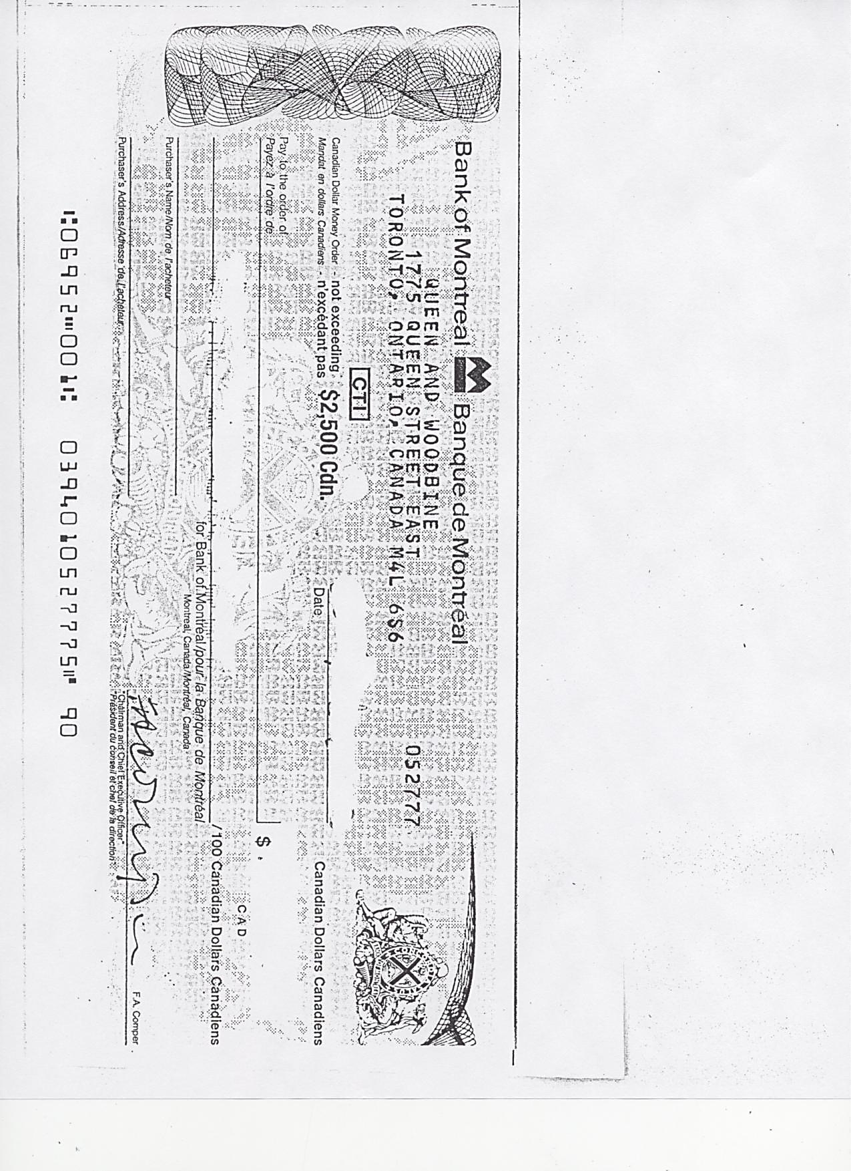**Task 6: Complete the money order by filling in all the blanks. Write in the total amount to be paid as well.**

**(Note: When you actually purchase a money order, the bank or post office fills in the amount to be paid.)**

Answer:



# Answers

**Task 1: What is the name of the bank listed on the money order?**

Answer: Bank of Montreal

**Task 2: Where is the bank located in Toronto?**

Answer: 1775 Queen Street East (Queen & Woodbine)

**Task 3: What is the maximum amount of money you can send using the money order?**

Answer:$ 2500.00 Canadian

**Task 4:** **What type of dollars are paid by the money order?**

Answer: Canadian Funds

**Task 5: If the birthday cards cost $12.99 (tax included) and the wrapping paper cost $15.99 (tax included), what is the total amount you must pay the bank?**

Answer: 12.99 + 15.95 + 7.50 = $ 36.44

**Task 6:** **Complete the money order by filling in all the blanks. Write in the total amount to be paid as well.**

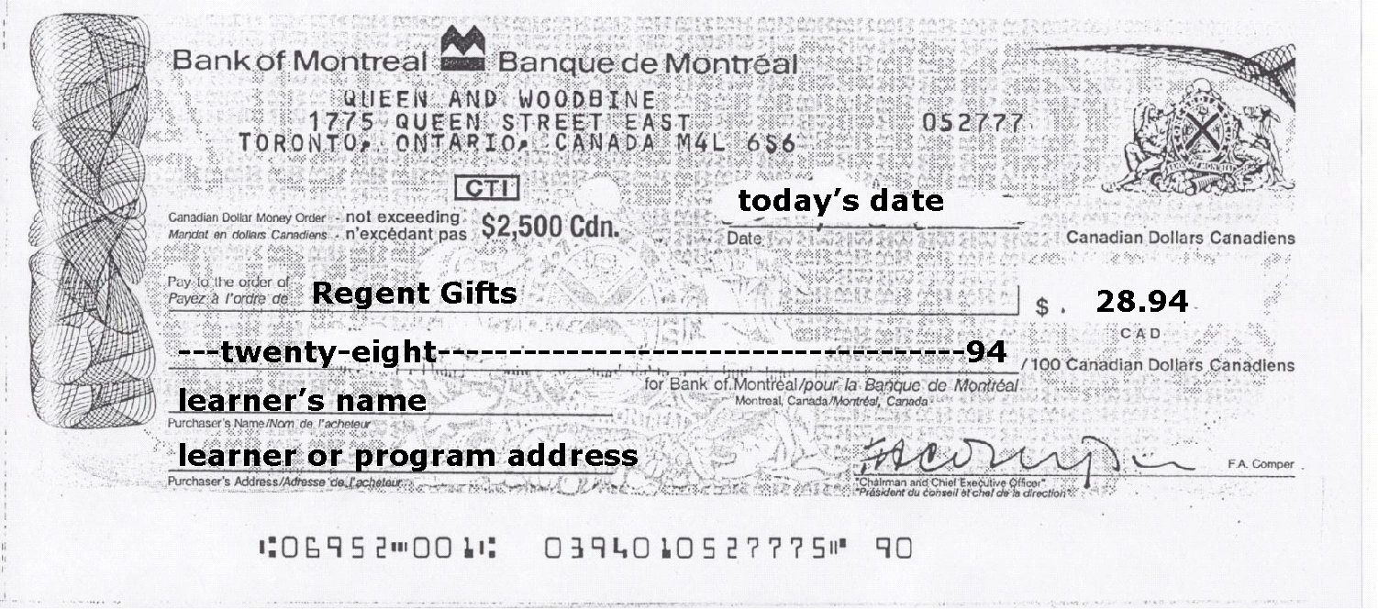

# Performance Descriptors

|  |  |  |  |  |
| --- | --- | --- | --- | --- |
| **Levels** | **Performance Descriptors** | **Needs Work** | **Completes task with support from practitioner** | **Completes task independently** |
| A1.2: | Scans text |  |  |  |
|  | Makes low-level inferences |  |  |  |
| A2.1: | Scans to locate specific details |  |  |  |
|  | Interprets brief text and common symbols |  |  |  |
|  | Makes low-level inferences |  |  |  |
| C1.1: | Adds, subtracts, multiplies and divides whole numbers and decimals |  |  |  |
|  | Interprets and represents costs using monetary symbols and decimals |  |  |  |
|  | Represents costs and rates using monetary symbols, decimals and percentages. |  |  |  |
|  | Uses strategies to check accuracy (e.g. estimating, using a calculator, repeating a calculation, using the reverse operation) |  |  |  |

This task: Was successfully completed Needs to be tried again

Learner Comments:

Instructor (print): Learner (print):

________________________ _______________________