

Task Title: Completing a Bank Deposit Form

# OALCF Cover Sheet – Practitioner Copy

**Learner Name: __________________________________________**

**Date Started: ___________________________________________**

**Date Completed: _________________________________________**

| **Goal Path:** | Employment | Apprenticeship |
| --- | --- | --- |
| Secondary School | Post Secondary | Independence |

**Successful Completion:**  Yes No

**Task Description:** Learner will complete a bank deposit form on behalf of a workplace.

**Main Competency/Task Group/Level Indicator:**

* Communicate Ideas and Information/Complete and create documents/B3.2a
* Understand and Use Numbers/Manage money/C1.1

**Materials Required:**

* Pen/pencil and paper and/or digital device
* Calculator or digital device with calculator function

# Learner Information

Many workplaces make daily or weekly deposits at a credit union or bank. A deposit form/slip needs to be carefully filled out in advance.

Review the blank “Account Deposit Slip” for *Any Company*.

**Account Deposit Slip**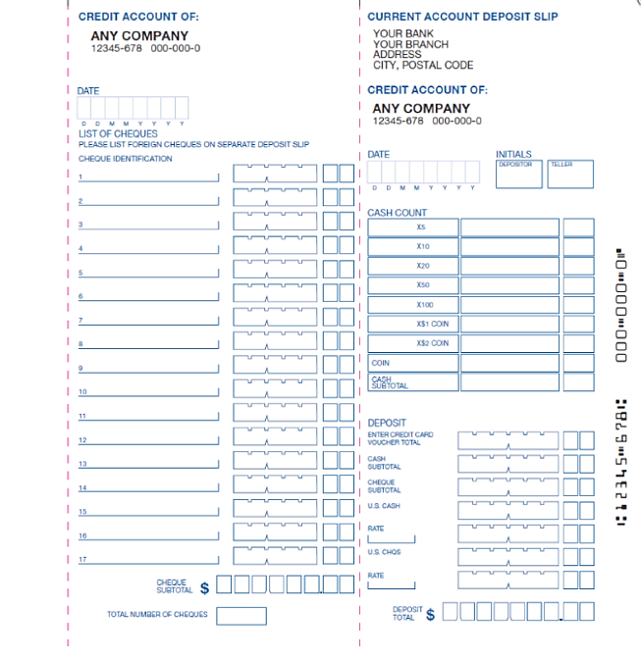

# Work Sheet

**Task 1: Complete the deposit slip using the following information:**

* **Date: September 22 2024**
* **Depositor Name: Abir Bahir**
* **Cheque: Joanna Smith $53.00**
* **Cheque: Michael Johnson $82.50**
* **Cash:**
  + **28 Loonies**
  + **61 Toonies**
  + **25 - $5**
  + **36 - $10**
  + **121 - $20**
  + **3 - $50**
  + **1 - $100**

Answer: No written response required here.

Task completed: Yes: No:

**Task 2: Calculate the total deposited and fill in the form.**

Answer: No written response required here.

Task completed: Yes: No:

# Answers

**Task 1:** **Complete the deposit slip using the following information:**

* **Date: September 22 2024**
* **Depositor Name: Abir Bahir**
* **Cheque: Joanna Smith $53.00**
* **Cheque: Michael Johnson $82.50**
* **Cash:**
  + **28 Loonies**
  + **61 Toonies**
  + **25 - $5**
  + **36 - $10**
  + **121 - $20**
  + **3 - $50**
  + **1 - $100**

Answer: See completed form below.

**Task 2: Calculate the total deposited and fill in the form.**

Answer: See completed form below.

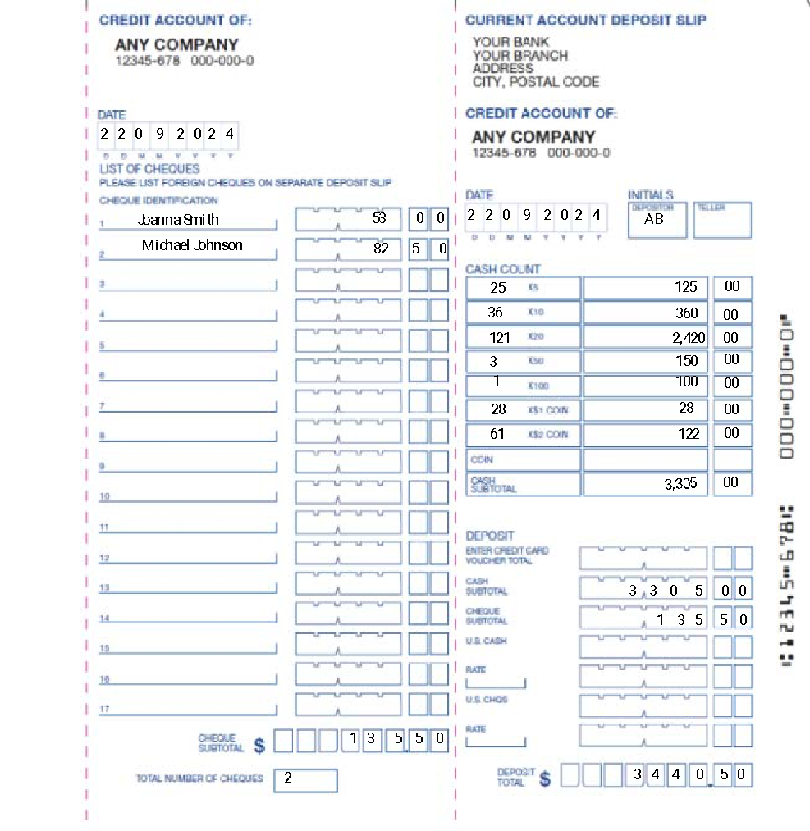

# Performance Descriptors

| Levels | Performance Descriptors | Needs Work | Completes task with support from practitioner | Completes task independently |
| --- | --- | --- | --- | --- |
| B3.2a | uses layout to determine where to make entries |  |  |  |
|  | begins to make some inferences to decide what information is needed, where and how to enter the information |  |  |  |
|  | makes entries using a limited range of vocabulary |  |  |  |
|  | follows instructions on documents |  |  |  |
| C1.1 | adds, subtracts, multiplies and divides whole numbers and decimals |  |  |  |
|  | recognizes values in number and word format |  |  |  |
|  | interprets and represents costs using monetary symbols and decimals |  |  |  |
|  | uses strategies to check accuracy (e.g. estimating, using a calculator, repeating a calculation, using the reverse operation) |  |  |  |



This task: Was successfully completed Needs to be tried again

Learner Comments:

Instructor (print): Learner (print):

**__________________ _________________**