

Task Title: Contact North Brochure

OALCF Cover Sheet – Practitioner Copy

Learner Name: __________________________________________
Date Started: ___________________________________________
Date Completed: _________________________________________

Goal Path: | Employment | Apprenticeship
Secondary School | Post Secondary | Independence
Successful Completion: Yes No

Task Description: The learner will find information in a Contact North brochure.
Main Competency/Task Group/Level Indicator:
- Find and Use Information/Read continuous text/A1.2

Materials Required:
- Pen/pencil and paper and/or digital device

Learner Information
Brochures give us important information about a product or service. This often includes what the company or organization can offer and how to contact them for more information.

Scan both pages of the “Contact North” brochure.

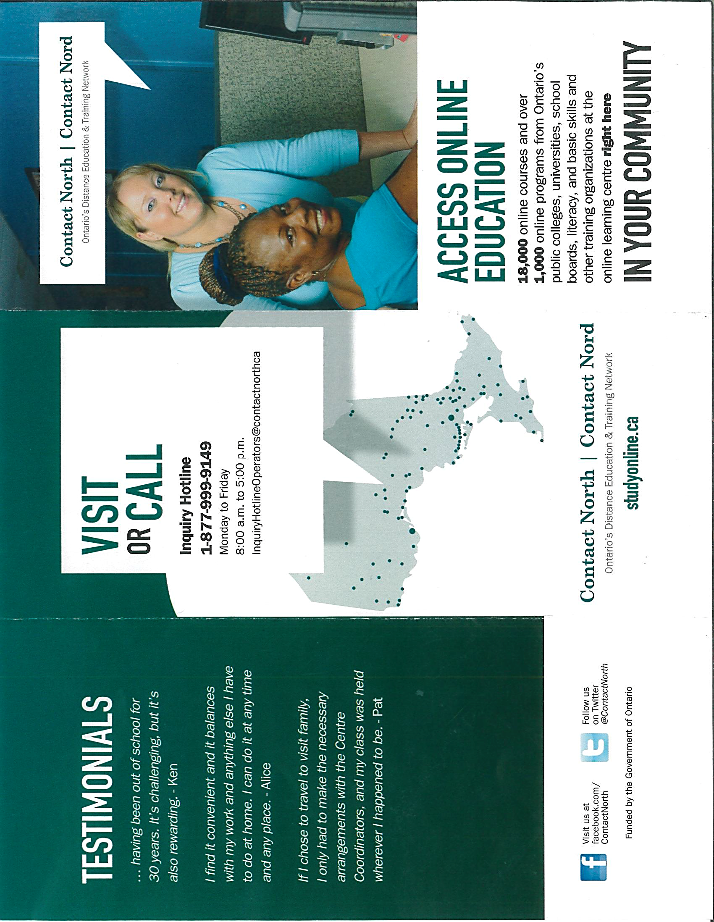

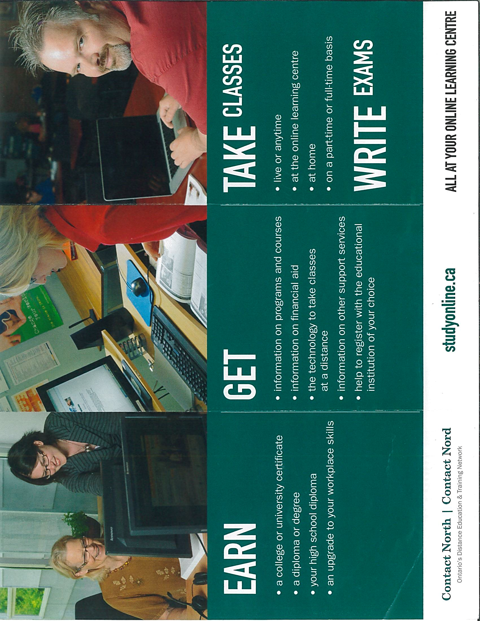

Work Sheet
Task 1: What phone number would you call for the Inquiry Hotline?
Answer:
_____________________________________________________
Task 2: What website address would a student use to get information on courses offered?
Answer:

______________________________________________________
Task 3: List two types of information someone can get from the website.
Answer:

______________________________________________________
Task 4: Contact North has many offices in Ontario. How would a student find the centre nearest to them?
Answer:

______________________________________________________

Answers
Task 1: What phone number would you call for the Inquiry Hotline?
Answer: 1-877-999-9149

Task 2: What website address would a student use to get information on courses offered?
Answer: studyonline.ca

Task 3: List two types of information someone can get from the website.
Answer: Any two of
- Information on programs and courses
- Information on financial aid
- Information on other support services

Task 4: Contact North has many offices in Ontario. How would a student find the centre nearest to them?
Answer: Email or call the inquiry hotline or go to the studyonline.ca website.

Performance Descriptors
Levels | Performance Descriptors | Needs Work | Completes task with support from practitioner | Completes task independently
A1.2 | scans text to locate information
 | locates multiple pieces of information in simple texts
 | follows the main events of descriptive, narrative and informational texts
 | obtains information from detailed reading
 | begins to identify sources and evaluate information

This task: Was successfully completed Needs to be tried again
Learner Comments:

Instructor (print): Learner (print):
__________________ _________________

