

Task Title: Cooking Frozen Foods

# OALCF Cover Sheet – Practitioner Copy

**Learner Name: __________________________________________**

**Date Started: ___________________________________________**

**Date Completed: _________________________________________**

|  |  |  |
| --- | --- | --- |
| **Goal Path:** | Employment | Apprenticeship |
| Secondary School | Post Secondary | Independence |

**Successful Completion:**  Yes No

**Task Description:** The learner will read heating directions for a frozen pizza.

**Main Competency/Task Group/Level Indicator:**

* Find and Use Information/Interpret documents/A2.1
* Understand and Use Numbers/Manage time/C2.1

**Materials Required:**

* Pen/pencil and paper and/or digital device
* Timer (e.g. digital watch with timer function, kitchen timer, timer function on a smartphone)

# Learner Information

Frozen food instructions ensure that people can properly heat the food to the correct temperature. This is important because undercooked frozen food can make people sick.

Scan the frozen pizza “Baking Directions”.

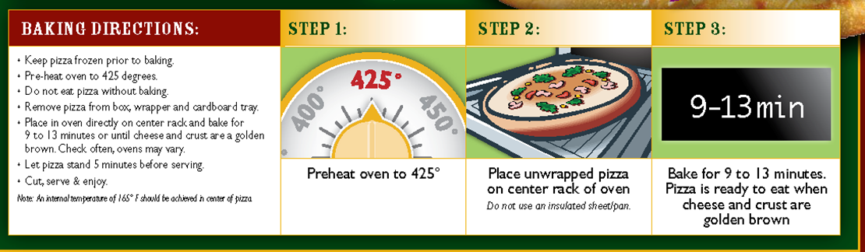

# Work Sheet

**Task 1: List the steps you should take before putting the frozen pizza into the oven:**

Answer:

**______________________________________________________**

**Task 2: What should you put the frozen pizza on in the oven?**

Answer:

**______________________________________________________**

**Task 3: Set a timer for the amount of time you should cook the pizza before checking to see if it’s done. How many minutes did you set it for?**

Answer:

**______________________________________________________**

**Task 4: How will you know that the pizza is cooked completely?**

Answer:

**______________________________________________________**

**Task 5: According to the baking directions, what should you do once you take the pizza out of the oven?**

Answer:

**______________________________________________________**

# Answers

**Task 1: List the steps you should take before putting the frozen pizza into the oven:**

Answer:

1. Preheat oven to 425 degrees
2. Remove pizza from box
3. Remove pizza from wrapper
4. Remove pizza from cardboard tray

**Task 2: What should you put the frozen pizza on in the oven?**

Answer: Place pizza directly on the oven rack

**Task 3: Set a timer for the amount of time you should cook the pizza before checking to see if it’s done. How many minutes did you set it for?**

Answer: Timer should be set for 9 minutes (shortest cooking time), as most people would check cooking at this point. However, anywhere between 9 and 13 minutes would be acceptable as a range is given.

**Task 4: How will you know that the pizza is cooked completely?**

Answer: Cheese and crust will be golden brown.

**Task 5: According to the baking directions, what should you do once you take the pizza out of the oven?**

Answer: Let the pizza stand for 5 minutes before serving.

# Performance Descriptors

| Levels | Performance Descriptors | Needs Work | Completes task with support from practitioner | Completes task independently |
| --- | --- | --- | --- | --- |
| A1.1 | reads short texts to locate a single piece of information |  |  |  |
|  | decodes words and makes meaning of sentences in a single text |  |  |  |
|  | follows simple, straightforward instructional texts |  |  |  |
| A2.1 | scans to locate specific details |  |  |  |
|  | interprets brief text and common symbols |  |  |  |
|  | locates specific details in simple documents, such as labels and signs |  |  |  |
|  | identifies how lists are organized |  |  |  |
| C2.1 | measures time using common instruments, such as clocks, timers and stopwatches |  |  |  |
|  | chooses appropriate units of measurement (e.g. hours, minutes, seconds) |  |  |  |
|  | follows apparent steps to reach solutions |  |  |  |

This task: Was successfully completed Needs to be tried again

Learner Comments:

Instructor (print): Learner (print):

**__________________ _________________**