

Task Title: Create A Collage

# OALCF Cover Sheet – Practitioner Copy

**Learner Name: __________________________________________**

**Date Started: ___________________________________________**

**Date Completed: _________________________________________**

|  |  |  |
| --- | --- | --- |
| **Goal Path:** | Employment | Apprenticeship |
| Secondary School | Post Secondary | Independence |

**Successful Completion:**  Yes No

**Task Description:** The learner will create a collage (e.g. vision board).

**Main Competency/Task Group/Level Indicator:**

* Communicate Ideas and Information/B.4

**Materials Required:**

* Paper or Bristol board
* Magazines, newspapers and flyers for cutting pictures and words
* If possible (and desired), personal photographs
* Craft supplies: wrapping paper, ribbon, buttons, stickers, etc.
* Glue and/or tape
* Scissors

# Notes for Instructors/Practitioners

# This task will require a variety of craft materials.

This task may also require the learner to gather photos and other items beforehand. You may wish to introduce this task in advance so the learner has enough time to gather materials.

# A sample rubric is included at the end, though this is a B4 task so it will not be assessed for complexity. You may wish to review the rubric with your learner before they complete their collage so they understand the expectations and evaluation criteria.

# Learner Information

Creating a collage is a unique way to express oneself. Creating a collage is a way to show ideas, observations, or feelings using photos, pictures, craft items, and/or words. Collages that show a dream or goal can be posted on a wall to inspire you every day.

Look at the Sample Collage.

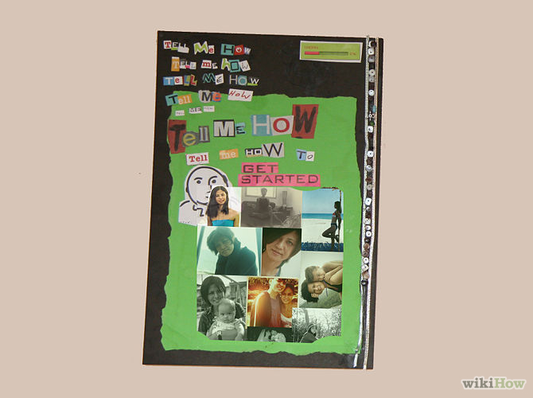

# Work Sheet

**Task 1: Let yourself dream of the life you would choose if there were no obstacles. Gather photos, pictures, words, or craft items that show this dream. Create a collage to display your idea.**

Answer: No written response required here.

Task completed: Yes:

# Answers

As with any creative work, marking a collage or piece of artwork can present challenges. The instructor may wish to develop their own rubric to share with the learner, outlining the basic requirements for the piece, such as number of photos used and features expected (e.g. Use both photos and words). Check-mark rubrics can be particularly effective for creative work.

Expressing oneself creatively produces vulnerability. In order for learners to feel comfortable with creating artwork in the classroom, a climate of trust and confidentiality must be established between instructor and learner. Sensitive or controversial topics must be handled with care. The instructor may wish to institute a consistent marking period for creative work, allowing for a day or two to consider the work before making any comment. The instructor’s considered written or oral response (feedback) to creative work is often more important to the learner than the mark or grade. Feedback should be designed not only to assess the work but to encourage the creative spirit.

**Sample Rubric: Create a Collage**

|  |  |  |  |
| --- | --- | --- | --- |
| **Expectation** | **Complete** | **Partially Complete** | **Needs Work** |
| Had a theme /or  Showed a dream or goal |  |  |  |
| Well-thought out to display an idea, dream, or goal |  |  |  |
| Pictures or items used to add to the theme or idea |  |  |  |
| Learner satisfied that the collage expressed their idea |  |  |  |

# Performance Descriptors

| Levels | Performance Descriptors | Needs Work | Completes task with support from practitioner | Completes task independently |
| --- | --- | --- | --- | --- |
| B.4 | express oneself creatively, such as by writing journal entries, telling a story, and creating art |  |  |  |

This task: Was successfully completed Needs to be tried again

Learner Comments:

Instructor (print): Learner (print):

**__________________ _________________**