

Task Title: Create a Scale Drawing for Landscaping

# OALCF Cover Sheet – Practitioner Copy

**Learner Name: __________________________________________**

**Date Started: ___________________________________________**

**Date Completed: _________________________________________**

|  |  |  |
| --- | --- | --- |
| **Goal Path:** | Employment | Apprenticeship |
| Secondary School | Post Secondary | Independence |

**Successful Completion:**  Yes No

**Task Description:** Create a scale drawing for a front yard landscaping project.

**Main Competency/Task Group/Level Indicator:**

* Understand and Use Numbers/Use measures/C3.3

**Materials Required:**

* Pen/pencil and paper and/or digital device
* Ruler
* 8 ½ by 11 grid paper

# Learner Information

Scale drawings are used on the job in many different jobs. Some of those include landscaping, designing interiors of homes, laying pipe for construction and various building projects. Scale drawings may also be used by people when building or renovating homes and gardens.

# Work Sheet

**Task 1: Create a scale drawing of a front yard using grid paper. The grid scale of front yard – 1” to 8’ and the yard is 40’ deep and 32’ wide.**

**Task 1a) Draw one tree in each of the following locations:**

* **corner of the northwest side of the property**
* **center of the property**
* **corner of the northeast side of the property**

**Task 1b) Draw one garden in each of the following locations:**

* **around the centre tree, 2 feet wide**
* **along one-half the width of the southwest side of the property, 5 feet wide**

**Task 1c) Label all objects on the scale drawing.**

Answer:

Task completed: Yes: No:

# Answers

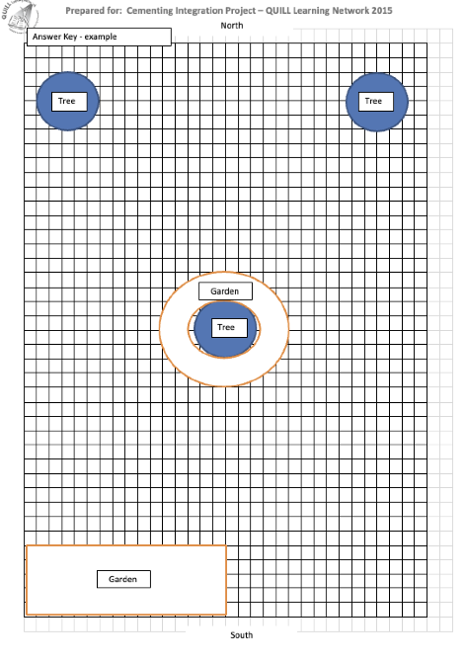**Example of drawing to scale:**

# Performance Descriptors

| Levels | Performance Descriptors | Needs Work | Completes task with support from practitioner | Completes task independently |
| --- | --- | --- | --- | --- |
| C3.3 | calculates using numbers expressed as whole numbers, fractions, decimals, percentages and integers |  |  |  |
|  | manages unfamiliar elements (e.g. context, content) to complete tasks |  |  |  |
|  | chooses and performs required operations; makes inferences to identify required operations |  |  |  |
|  | selects appropriate steps to solutions from among options |  |  |  |
|  | interprets, represents and converts measures using whole numbers, decimals, percentages, ratios and fractions |  |  |  |
|  | uses strategies to check accuracy (e.g. estimating, using a calculator, repeating a calculation, using the reverse operation) |  |  |  |

This task: Was successfully completed Needs to be tried again

Learner Comments:

Instructor (print): Learner (print):

**__________________ _________________**