

Task Title: Diluting a Cleaning Product Using a Ratio

# OALCF Cover Sheet – Practitioner Copy

**Learner Name: __________________________________________**

**Date Started: ___________________________________________**

**Date Completed: _________________________________________**

|  |  |  |
| --- | --- | --- |
| **Goal Path:** | Employment | Apprenticeship |
| Secondary School | Post Secondary | Independence |

**Successful Completion:**  Yes No

**Task Description:** The learner will use ratio and proportion to calculate mixtures and final products.

**Main Competency/Task Group/Level Indicator:**

* Understand and Use Numbers/Use measures/C3.2

**Materials Required:**

* Pen/pencil and paper and/or digital device
* Calculator or digital device with calculator function

# Learner Information

Cleaners use products that need to be mixed using ratio and proportion.

Scan the “**AllChem Glass Cleaner Concentrate”** label.

**DESCRIPTION**

A uniquely formulated glass cleaning compound developed to penetrate and dissolve dirt and oily stains from glass and mirrors. A special blend of surfactants and wetting agents provide excellent cleaning without streaking. This is a heavy-duty institutional formula which offers quick cleaning for all types of applications.

**DIRECTIONS**

This product is a highly concentrated cleaner and should be diluted before use. Dilute 1-part AllChem Glass Cleaner Concentrate with 10 parts water for a ready to use product. Spray an even mist onto surface, wipe over entire area then buff dry. For best results, use a lint free towel or cloth to wipe surface clean and use a second cloth to polish. Discard towels or cloths when they become heavily soiled. Sponges may be used for large areas, followed by drying with a squeegee or paper towels.

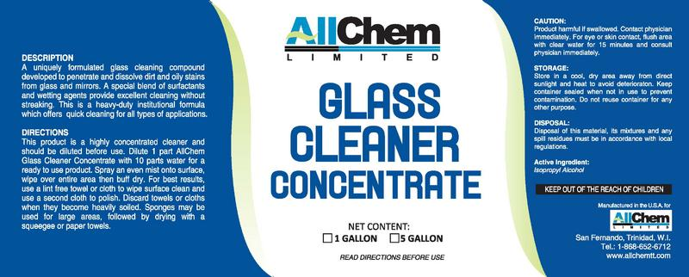

**CAUTION**

Product harmful if swallowed. Contact physician immediately. For eye or skin contact, flush area with clear water for 15 minutes and consult physician immediately.

**STORAGE**

Store in a cool, dry area away from direct sunlight and heat to avoid deterioration. Keep container sealed when not in use to prevent contamination. Do not reuse container for any other purpose.

**DISPOSAL**

Disposal of this material, its mixtures and any spill residues must be in accordance with local regulations.

**ACTIVE INGREDIENT**

Isopropyl Alcohol

**KEEP OUT OF REACH OF CHILDREN**

# Work Sheet

**Task 1: Calculate how much water is required to dilute 250mL of AllChem Glass Cleaner concentrate.**

Answer:

**______________________________________________________**

**Task 2: Calculate how much AllChem Glass Cleaner concentrate is required if 1.45L of water is used.**

Answer:

**______________________________________________________**

**Task 3: Calculate how much undiluted AllChem Glass Cleaner is needed to fill a 500mL spray bottle with mixed solution.**

Answer:

**______________________________________________________**

**Task 4: If 1000mL of AllChem Glass Cleaner concentrate is used, calculate how much solution (water and cleaner) is made.**

Answer:

**______________________________________________________**

# Answers

**Task 1: Calculate how much water is required to dilute 250mL of AllChem Glass Cleaner concentrate.**

Answer:

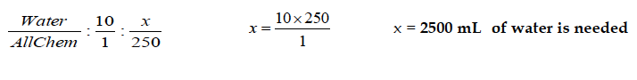

**Task 2: Calculate how much AllChem Glass Cleaner concentrate is required if 1.45L of water is used.**

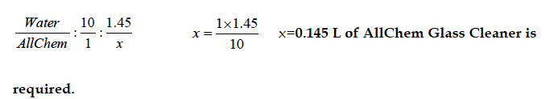Answer:

**Task 3: Calculate how much undiluted AllChem Glass Cleaner is needed to fill a 500mL spray bottle with mixed solution.**

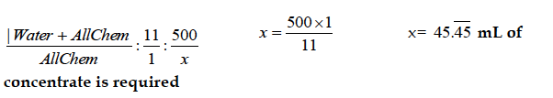Answer:

**Task 4: If 1000mL of AllChem Glass Cleaner concentrate is used, calculate how much solution (water and cleaner) is made.**

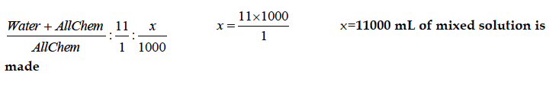Answer:

# Performance Descriptors

| Levels | Performance Descriptors | Needs Work | Completes task with support from practitioner | Completes task independently |
| --- | --- | --- | --- | --- |
| C3.2 | calculates using numbers expressed as whole numbers, fractions, decimals, percentages and integers |  |  |  |
|  | understands and uses ratio and proportion |  |  |  |
|  | interprets and applies rates (e.g. km/hr) and ratios (e.g. map scales) |  |  |  |

This task: Was successfully completed Needs to be tried again

Learner Comments:

Instructor (print): Learner (print):

**__________________ _________________**

Skill Building Activities

**Links to Online Resources:**

Khan Academy Ratio Word Problems: <https://www.khanacademy.org/math/cc-sixth-grade-math/cc-6th-ratios-prop-topic/cc-6th-equivalent-ratios/e/ratio_word_problems>

Khan Academy Ratios and Rates: <https://www.khanacademy.org/math/pre-algebra/pre-algebra-ratios-rates>

What Does Dilutions Mean?: <https://www.housekeepingchannel.com/hcp_365-Dilution>