

Task Title: Documentation for Personal Support Workers

# OALCF Cover Sheet – Practitioner Copy

**Learner Name: __________________________________________**

**Date Started: ___________________________________________**

**Date Completed: _________________________________________**

|  |  |  |
| --- | --- | --- |
| **Goal Path:** | Employment | Apprenticeship |
| Secondary School | Post Secondary | Independence |

**Successful Completion:**  Yes No

**Task Description:** The learner will review documentation requirements followed by Personal Support Workers in Ontario.

**Main Competency/Task Group/Level Indicator:**

* Find and Use Information/Read continuous text/A1.2

**Materials Required:**

* Pen/pencil and paper and/or digital device

# Learner Information

As regulated health professionals, Personal Support Workers (PSWs) must document their activities with patients.

Read “Documentation: Standards for Personal Support Workers”.

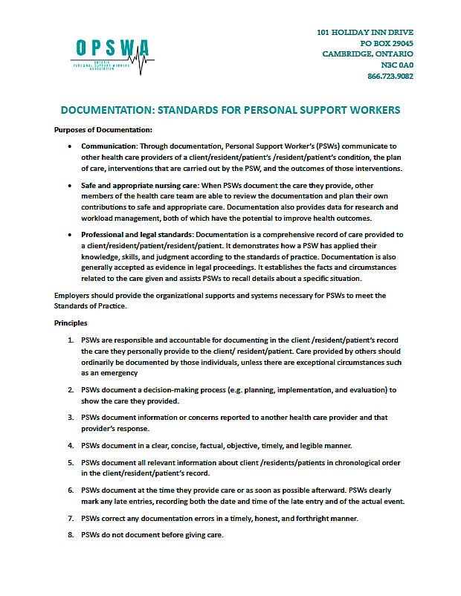

# 

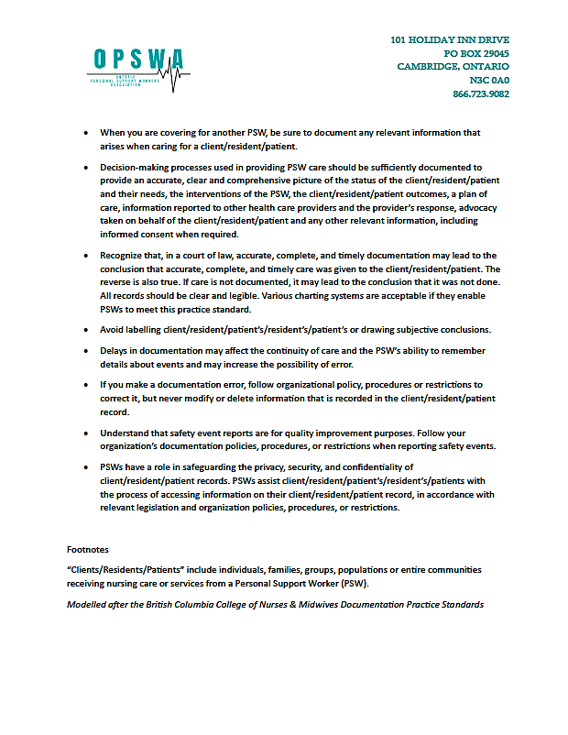

# Work Sheet

**Task 1: List four things that are communicated through PSW documentation.**

Answer:

**______________________________________________________**

**Task 2: Who is responsible for providing the systems needed for PSWs to meet their Standards of Practice?**

Answer:

**______________________________________________________**

**Task 3: How are the principles of documentation standards applied differently in organizations that use electronic patient records?**

Answer:

**______________________________________________________**

**Task 4: What is the risk in a court of law if documentation has not been done correctly?**

Answer:

_____________________________________________________________

**Task 5: When does a PSW complete a safety event report?**

Answer:

**______________________________________________________**

# Answers

**Task 1: List four things that are communicated through PSW documentation.**

Answer:

* Communicate to other health care providers the client’s condition
* Communicate the plan of care
* Communicate interventions that are carried out by the PSW
* Communicate the outcomes of those interventions

**Task 2: Who is responsible for providing the systems needed for PSWs to meet their Standards of Practice?**

Answer: Employers.

**Task 3: How are the principles of documentation standards applied differently in organizations that use electronic patient records?**

Answer: The same documentation principles apply, although there will be different strategies to record data, and to ensure privacy, security, and confidentiality.

**Task 4: What is the risk in a court of law if documentation has not been done correctly?**

Answer: If care is not documented, it may be concluded that care was not given in an accurate, complete and timely manner.

**Task 5: When does a PSW complete a safety event report?**

Answer: PSWs complete a safety report (sometimes called an incident report) after a fall or something similar.

# Performance Descriptors

| Levels | Performance Descriptors | Needs Work | Completes task with support from practitioner | Completes task independently |
| --- | --- | --- | --- | --- |
| A1.2 | scans text to locate information |  |  |  |
|  | locates multiple pieces of information in simple texts |  |  |  |
|  | makes low-level inferences |  |  |  |
|  | makes connections between sentences and between paragraphs in a single text |  |  |  |
|  | reads more complex texts to locate a single piece of information |  |  |  |
|  | follows the main events of descriptive, narrative and informational texts |  |  |  |
|  | obtains information from detailed reading |  |  |  |
|  | begins to identify sources and evaluate information |  |  |  |

This task: Was successfully completed Needs to be tried again

Learner Comments:

Instructor (print): Learner (print):

**__________________ _________________**