

Task Title: Filling out a Tenant Maintenance Request Form

# OALCF Cover Sheet – Practitioner Copy

**Learner Name: __________________________________________**

**Date Started: ___________________________________________**

**Date Completed: _________________________________________**

|  |  |  |
| --- | --- | --- |
| **Goal Path:** | Employment | Apprenticeship |
| Secondary School | Post Secondary | Independence |

**Successful Completion:**  Yes No

**Task Description:** The Learner will fill out a maintenance request form (Landlord and Tenant Board of Ontario Form 6) asking for repairs to be completed in an apartment.

**Main Competency/Task Group/Level Indicator:**

* Communicate Ideas and Information/Write continuous text/B2.2
* Communicate Ideas and Information /Complete and create documents/B3.2a

**Materials Required:**

* Pen/pencil and paper and/or digital device

# Learner Information

# When renting an apartment, sometimes things need to be repaired or replaced by the landlord. If a landlord is not responding to maintenance requests, a renter may need to complete and submit a form to the Landlord and Tenant Board of Ontario so that repairs can be completed.

Review the “Tenant Application about Maintenance FORM T6: Part 1 and Part 2”.

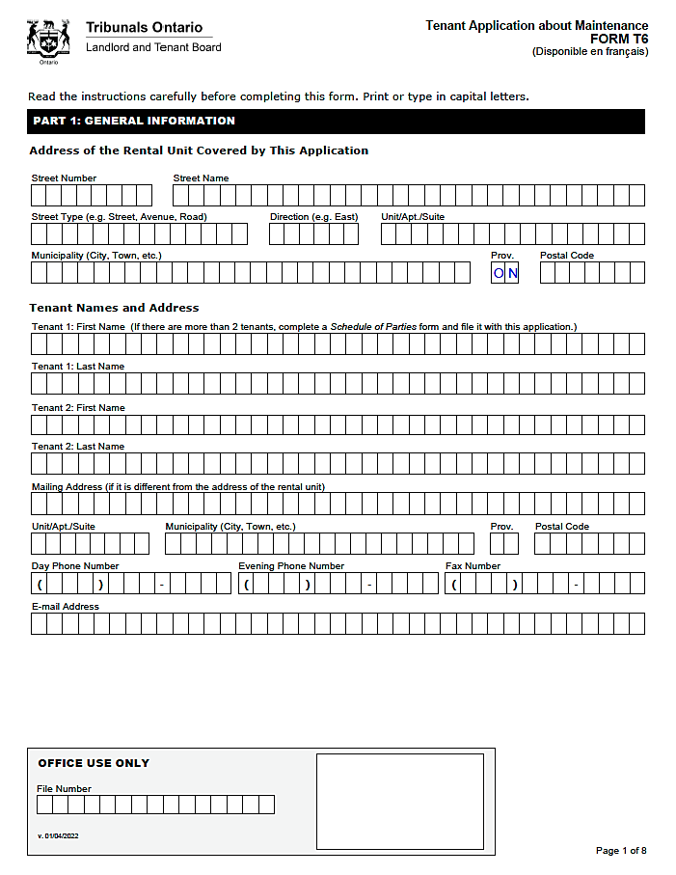

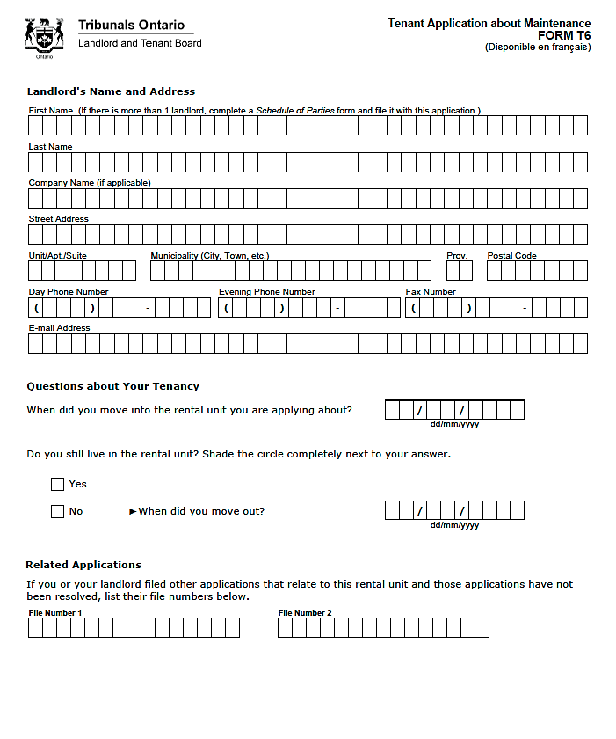

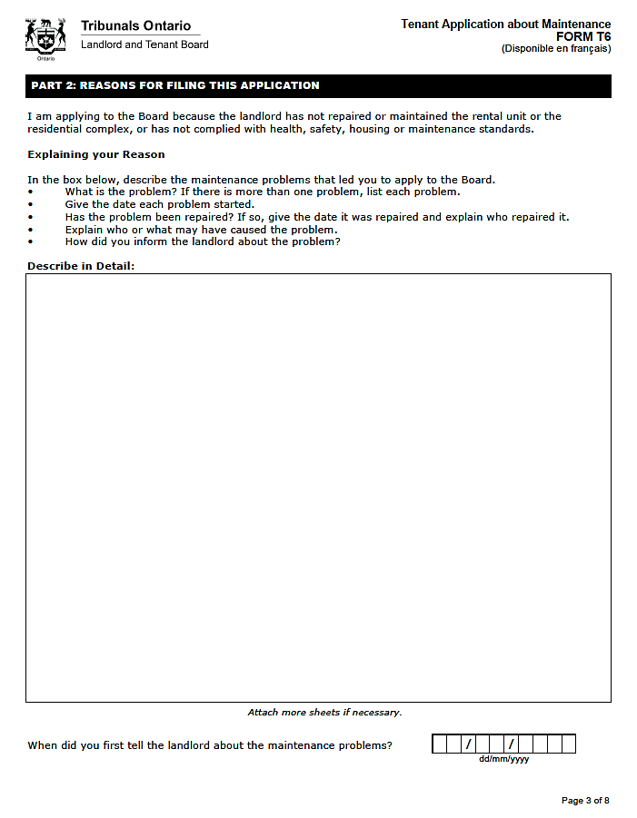

# Work Sheet

**Task 1: Complete the Tenant Application about Maintenance FORM T6 provided.**

**Complete Part 1 using the following information:**

* Address of the Rental Unit: Your address
* Tenant Names and Addresses: Your name and address
* Landlord’s Name and Address: Your Instructor’s name and the address of the learning centre
* You moved into the rental unit on January 1, 2024 and you still live in the rental unit
* There are no related applications

**Complete Part 2 using the following information:**

* The bathroom sink has been leaking since you moved in.
* Water drips constantly, even when the faucet is turned off.
* You have talked to the landlord to see if this can be repaired.
* You have called and emailed several times over the last few months.
* There is mold growing on the bathroom floor and the wall underneath the sink.
* You have been taking pictures of the damage.
* You are concerned about the water damage and the mold.
* Mold can cause health problems and damage belongings.

Answer: No written response required here.

Task completed: Yes:

# Answers

Answers will vary. Part 2 should include a description of the problem and damage to the apartment.

# Performance Descriptors

| Levels | Performance Descriptors | Needs Work | Completes task with support from practitioner | Completes task independently |
| --- | --- | --- | --- | --- |
| B2.2 | Writes texts to explain and describe |  |  |  |
|  | Begins to sequence writing with some attention to organizing principles (e.g. time, importance) |  |  |  |
|  | Uses limited range of vocabulary and punctuation appropriate to the task |  |  |  |
|  | Begins to select words and tone appropriate to the task |  |  |  |
|  | Begins to organize writing to communicate effectively |  |  |  |
| B3.2a | uses layout to determine where to make entries |  |  |  |
|  | begins to make some inferences to decide what information is needed, where and how to enter the information |  |  |  |
|  | makes entries using a limited range of vocabulary |  |  |  |
|  | follows instructions on documents |  |  |  |

This task: Was successfully completed Needs to be tried again

Learner Comments:

Instructor (print): Learner (print):

**__________________ _________________**