

Task Title: Finding Nutritional Information Online

# OALCF Cover Sheet – Practitioner Copy

**Learner Name: __________________________________________**

**Date Started: ___________________________________________**

**Date Completed: _________________________________________**

|  |  |  |
| --- | --- | --- |
| **Goal Path:** | Employment | Apprenticeship |
| Secondary School | Post Secondary | Independence |

**Successful Completion:**  Yes No

**Task Description:** The learner will find and compare nutritional information about coffee items in the Tim Horton’s Nutritional Guide.

**Main Competency/Task Group/Level Indicator:**

* Find and Use Information/Interpret documents/A2.2
* Understand and Use Numbers/Manage data/C4.1

**Materials Required:**

* Pen/pencil and paper or computer/digital device

# Learner Information

On restaurant websites, nutritional information is posted about the food and drinks that are sold. This is useful for people who have allergies or other dietary restrictions.

Scan “Tim Horton’s Nutritional Information for Coffee Beverages”.

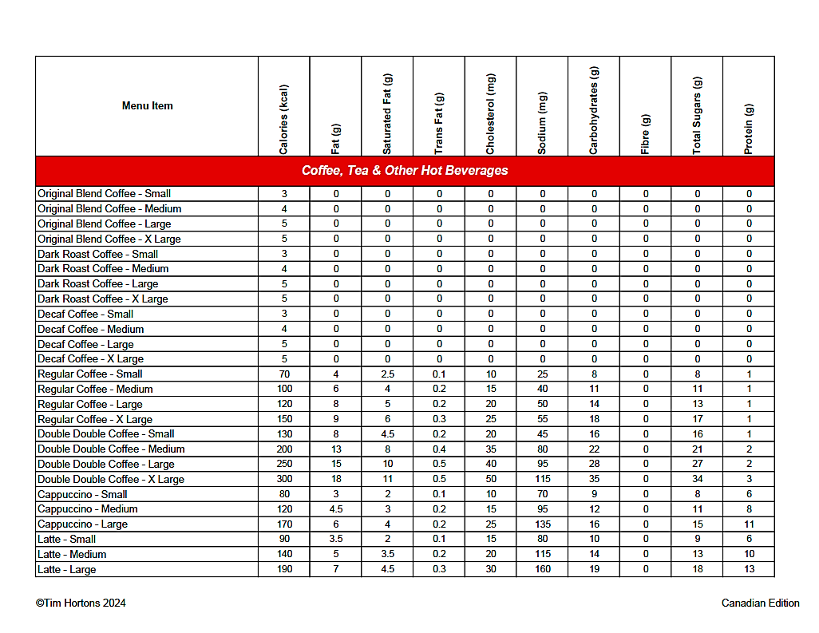**Tim Horton’s Nutritional Information for Coffee Beverages**

# Work Sheet

**Task 1: You are comparing original blend coffee, dark roast coffee, decaf coffee, regular coffee, and double double coffee. Which options have zero grams of sugar?**

Answer:

**______________________________________________________**

**Task 2: Which has fewer grams of carbohydrates - a small cappuccino or a small latte?**

Answer:

**______________________________________________________**

**Task 3: Which drink has the most protein?**

Answer:

**______________________________________________________**

**Task 4: Which large drink option would you purchase if you wanted the fewest calories (kcal)?**

Answer:

**______________________________________________________**

# Answers

**Task 1: You are comparing original blend coffee, dark roast coffee, decaf coffee, regular coffee, and double double coffee. Which options have zero grams of sugar?**

Answer: Original blend coffee, dark roast coffee and decaf coffee

**Task 2: Which has fewer grams of carbohydrates - a small cappuccino or a small latte?**

Answer: Small cappuccino. Small cappuccino (9 grams of carbohydrates); small lattee (10 grams of carbohydrates).

**Task 3: Which drink has the most protein?**

Answer: Large latte (13 grams of protein)

**Task 4: Which large drink option would you purchase if you wanted the fewest calories (kcal)?**

Answer: Large original blend, dark roast or decaf coffee

# Performance Descriptors

| Levels | Performance Descriptors | Needs Work | Completes task with support from practitioner | Completes task independently |
| --- | --- | --- | --- | --- |
| A2.2 | performs limited searches using one or two search criteria |  |  |  |
|  | extracts information from tables and forms |  |  |  |
|  | uses layout to locate information |  |  |  |
|  | makes connections between parts of documents |  |  |  |
|  | makes low-level inferences |  |  |  |
| C4.1 | identifies and compares quantities of items |  |  |  |

This task: Was successfully completed Needs to be tried again

Learner Comments:

Instructor (print): Learner (print):

**__________________ _________________**