

Task Title: Follow a Flow Chart

# OALCF Cover Sheet – Practitioner Copy

**Learner Name: __________________________________________**

**Date Started: ___________________________________________**

**Date Completed: _________________________________________**

|  |  |  |
| --- | --- | --- |
| **Goal Path:** | Employment | Apprenticeship |
| Secondary School | Post Secondary | Independence |

**Successful Completion:**  Yes No

**Task Description:** Use a flowchart to follow the process of an Amazon book order.

**Main Competency/Task Group/Level Indicator:**

* Find and Use Information/Interpret documents/A2.3

**Materials Required:**

* Pen/pencil and paper and/or digital device

# Learner Information

# Flow charts are often used by companies to help their customers understand the steps in a process that might be difficult to follow.

# Scan the “**Amazon Book Order Process**”.

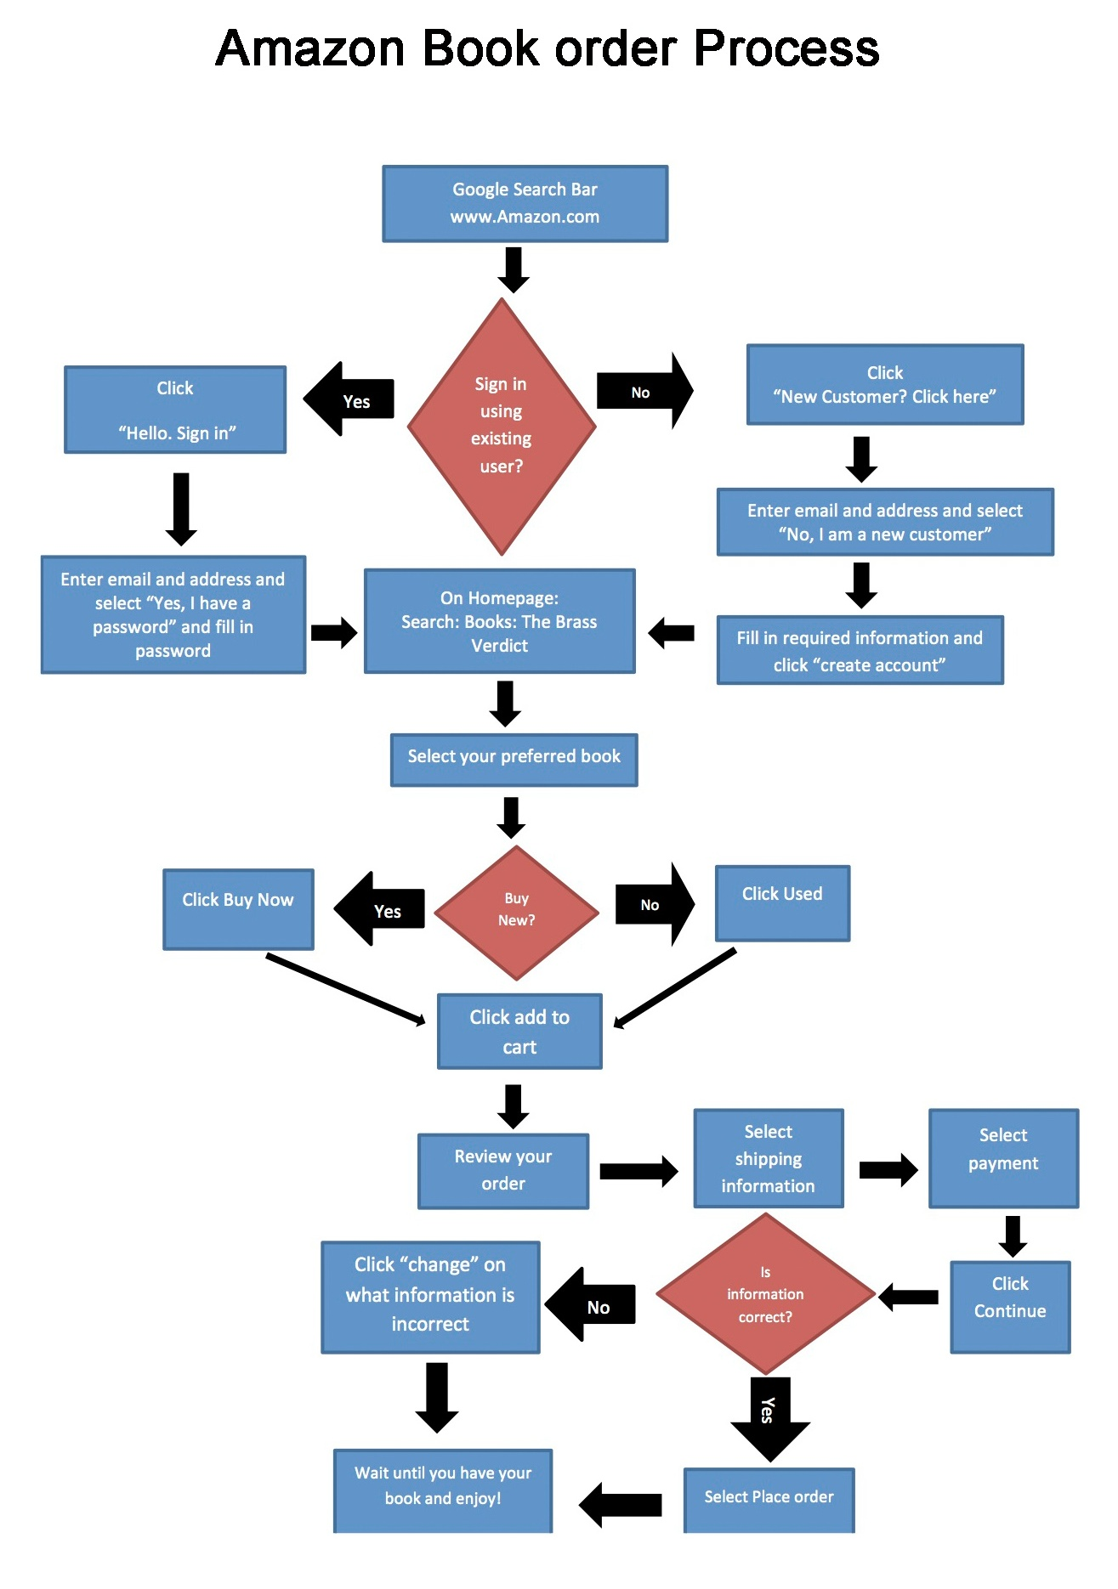

# Work Sheet

**Task 1: What will you click if you are not an existing Amazon user?**

Answer:

**______________________________________________________**

**Task 2: What search criteria will you use when searching for a book?**

Answer:

**______________________________________________________**

**Task 3: Which choice do you need to make directly after you have selected your preferred book?**

Answer:

**______________________________________________________**

**Task 4: What will you click if you notice your address information is incorrect after selecting payment?**

Answer:

**______________________________________________________**

# Answers

**Task 1: What will you click if you are not an existing Amazon user?**

Answer: New Customer

1. Follow flowchart to “Sign in using existing user?”
2. “No”
3. Click “New Customer? Click here”

**Task 2: What search criteria will you use when searching for a book?**

Answer: Follow flowchart to “On Homepage: Search: Books: The Brass Verdict”

**Task 3: Which choice do you need to make directly after you have selected your preferred book?**

Answer: New or Used

1. Follow flowchart to “Select your preferred book”
2. “Buy New?”
3. “Yes” or “No”
4. Choose New (buy now) or Used

**Task 4: What will you click if you notice your address information is incorrect after selecting payment?**

Answer: Click “change” on address information

1. Follow flowchart to “Select payment”
2. “Click Continue”
3. “Is information correct?”
4. “No”
5. Click “change” on the what the information is incorrect

# Performance Descriptors

| Levels | Performance Descriptors | Needs Work | Completes task with support from practitioner | Completes task independently |
| --- | --- | --- | --- | --- |
| A2.3 | manages unfamiliar elements (e.g. vocabulary, context, topic) to complete tasks |  |  |  |
|  | integrates several pieces of information from documents |  |  |  |
|  | uses layout to locate information |  |  |  |
|  | identifies the purpose and relevance of documents |  |  |  |
|  | makes inferences and draws conclusions from information displays |  |  |  |

This task: Was successfully completed Needs to be tried again

Learner Comments:

Instructor (print): Learner (print):

**__________________ _________________**