

Task Title: Follow Instructions to Make a Cake

from a Cake Mix

# OALCF Cover Sheet – Practitioner Copy

**Learner Name:___________________________________________**

**Date Started:____________________________________________**

**Date Completed: _________________________________________**

|  |  |  |
| --- | --- | --- |
| **Goal Path:** | Employment | Apprenticeship |
| Secondary School | Post Secondary | Independence |

**Successful Completion:**  Yes No

**Task Description:** Learner will read and follow instructions from a cake mix.

**Main Competency/Task Group/Level Indicator:**

* Find and Use Information/Read continuous text/A1.1
* Find and Use Information/Interpret documents/A2.1
* Communicate Ideas and Information/Interact with others/B1.1
* Understand and Use Numbers/Manage time/C2.1
* Understand and Use Numbers/Use measures/C3.1

**Materials Required:**

* Measuring cups and measuring spoons
* Cake pan
* Kitchen timer

# Learner Information

Read the cake mix instructions.

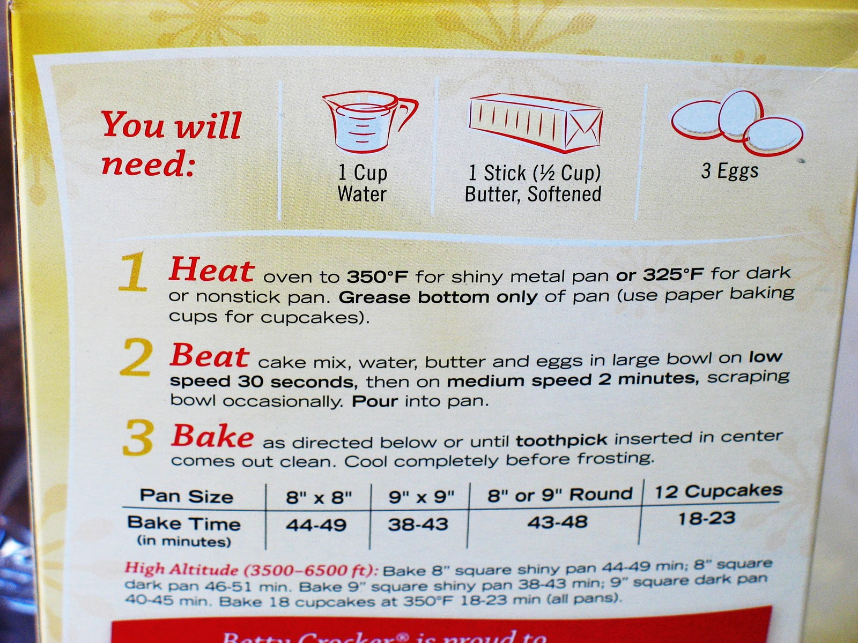

# Work Sheet

**Task 1: What three ingredients along with the cake mix will you need to make the cake?**

Answer:

**______________________________________________________**

**Task 2: What part of the cake pan should you grease?**

Answer:

**______________________________________________________**

**Task 3: How many cupcakes can you make with this cake mix?**

Answer:

**______________________________________________________**

**Task 4: What temperature should you set your oven to if you are using a non-stick pan?**

Answer:

**______________________________________________________**

**Task 5: If the cupcakes only take 18 minutes to cook, what time will the cupcakes be ready if it is 3:30p.m. when they go into the oven?**

Answer:

**______________________________________________________**

**Task 6: Show your instructor which measuring item you would use to measure the water.**

Answer: No written response required here.

Task completed: Yes No

_____________________________________________________________

**Task 7: Show your instructor how far you would fill the measuring item with the water to follow the instructions on the cake mix.**

Answer: No written response required here.

Task completed: Yes No

_____________________________________________________________

**Task 8:** **Set the timer for the amount of time you would mix the cake batter at medium speed.**

Answer: No written response required here.

Task completed: Yes No

_____________________________________________________________

**Task 9:** **Measure the length and width of the cake pan. Determine how long you should bake the cake and set the timer for that amount of time.**

Answer: No written response required here.

Task completed: Yes No

_____________________________________________________________

**Task 10:** **Explain (orally) in your own words how to make the cake.**

Answer: No written response required here.

Task completed: Yes No

_____________________________________________________________

# Answers

**Task 1: What three ingredients along with the cake mix will you need to make the cake?**

Answer: water, butter, eggs.

**Task 2: What part of the cake pan should you grease?**

Answer: bottom only.

**Task 3: How many cupcakes can you make with this cake mix?**

Answer: 12

**Task 4: What temperature should you set your oven to if you are using a non-stick pan?**

Answer: 325⁰ F

**Task 5: If the cupcakes only take 18 minutes to cook, what time will the cupcakes be ready if it is 3:30p.m. when they go into the oven?**

Answer: 3:48p.m.

**Tasks 6-9:**

Answer: These are action items that the Learner must do using the props that have been provided/identified under Materials Required.

**Task 10:**

Answer: This task requires the learner to explain to the instructor how to make the cake. The Instructor can read the instructions on the cake to determine if the learner’s explanation is correct.

# Performance Descriptors

| Levels | Performance Descriptors | Needs Work | Completes task with support from practitioner | Completes task independently |
| --- | --- | --- | --- | --- |
| A1.1 | Reads short texts to locate a single piece of information |  |  |  |
|  | Decodes words and makes meaning of sentences in a single text |  |  |  |
|  | Follows simple, straightforward instructional texts |  |  |  |
| A2.1 | Scans to locate specific details |  |  |  |
|  | Interprets brief text and common symbols |  |  |  |
|  | Identifies how lists are organized |  |  |  |
| B1.1 | Chooses appropriate language in exchanges with clearly defined purposes |  |  |  |
|  | Gives short, straightforward instructions or directions |  |  |  |
|  | Speaks or signs clearly in a focused and organized way |  |  |  |
| C2.1 | Identifies and performs required operation |  |  |  |
|  | Measures time using common instruments, such as clocks, timers and stopwatches |  |  |  |
|  | Interprets and represents time using whole numbers, decimals (e.g. .25, .5) and simple common fractions (e.g. ½, ¼ hour) |  |  |  |
| C3.1 | Measures length, width, liquid volume and temperature |  |  |  |
|  | Uses common measuring tools |  |  |  |
|  | Understands numerical order |  |  |  |
|  | Begins to interpret integers (e.g. temperature, elevation) |  |  |  |
|  | Identifies and performs required operation |  |  |  |
|  | Interprets and represents measures using whole numbers, decimals and simple, common fractions (e.g. ¼ ½) |  |  |  |

This task: Was successfully completed Needs to be tried again

Learner Comments:

Instructor (print): Learner (print):

**__________________ _________________**