

Task Title: Food Service Worker Program Requirements

# OALCF Cover Sheet – Practitioner Copy

**Learner Name: __________________________________________**

**Date Started: ___________________________________________**

**Date Completed: _________________________________________**

|  |  |  |
| --- | --- | --- |
| **Goal Path:** | Employment | Apprenticeship |
| Secondary School | Post Secondary | Independence |

**Successful Completion:**  Yes No

**Task Description:** The learner will review the program requirements for a College Food Service Worker in Healthcare program to become more knowledgeable.

**Main Competency/Task Group/Level Indicator:**

* Find and Use Information/Read continuous text/A1.2

**Materials Required:**

* Pen/pencil and paper and/or digital device

# Learner Information

People interested in working in hospitals or long-term care facilities may take courses that focus on serving food in health care settings. Many Ontario colleges offer these programs.

Scan the “Georgian Food Service Worker” program information.

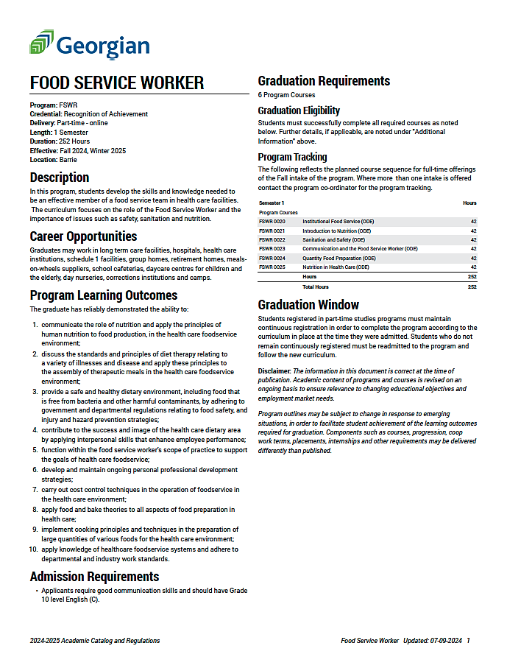

# Work Sheet

**Task 1: How many total hours are required for completion of the Food Service Worker program?**

Answer:

**______________________________________________________**

**Task 2: List five places where graduates may be employed after graduation.**

Answer:

**______________________________________________________**

**Task 3: What are the admissions requirements for this program?**

Answer:

**______________________________________________________**

**Task 4: Food service workers in healthcare settings often purchase food in bulk to save money and to make recipes in large batches. Which two learning outcomes align with these reasons for bulk purchases of food?**

Answer:

**______________________________________________________**

# Answers

**Task 1: How many total hours are required for completion of the Food Service Worker program?**

Answer: 252 hours (6 courses x 42 hours each)

**Task 2: List five places where graduates may be employed after graduation.**

Answer: Any five of: long term care facilities, hospitals, health care institutions, schedule 1 facilities, group homes, retirement homes, meals-on-wheels suppliers, school cafeterias, daycare centres, day nurseries, corrections institutions, camps.

**Task 3: What are the admissions requirements for this program?**

Answer: Good communication skills and Grade 10 level English (C).

**Task 4: Food service workers in healthcare settings often purchase food in bulk to save money and to make recipes in large batches. Which two learning outcomes align with these reasons for bulk purchases of food?**

Answer:

* Carry out cost control techniques in the operation of foodservice in the healthcare environment
* Implement cooking principles and techniques in the preparation of large quantities of various foods

# Performance Descriptors

| Levels | Performance Descriptors | Needs Work | Completes task with support from practitioner | Completes task independently |
| --- | --- | --- | --- | --- |
| A1.2 | scans text to locate information |  |  |  |
|  | locates multiple pieces of information in simple texts |  |  |  |
|  | reads more complex texts to locate a single piece of information |  |  |  |
|  | follows the main events of descriptive, narrative and informational texts |  |  |  |
|  | obtains information from detailed reading |  |  |  |
|  |  |  |  |  |

This task: Was successfully completed Needs to be tried again

Learner Comments:

Instructor (print): Learner (print):

**__________________ _________________**