

Task Title: Grocery Store Job Application

# OALCF Cover Sheet – Practitioner Copy

**Learner Name: __________________________________________**

**Date Started: ___________________________________________**

**Date Completed: _________________________________________**

| **Goal Path:** | Employment | Apprenticeship |
| --- | --- | --- |
| Secondary School | Post Secondary | Independence |

**Successful Completion:**  Yes No

**Task Description:** The learner will enter basic information into a job application form.

**Main Competency/Task Group/Level Indicator:**

* Find and Use Information/Interpret documents/A2.2
* Communicate Ideas and Information/Complete and create documents/B3.1a

**Materials Required:**

* Pen/pencil and/or digital device

# Learner Information

Many companies ask prospective employees to fill out a job application. For stores with multiple shifts or departments, people may be asked to select times they are available for work or departments that interest them.

Scan the “Zehrs Application Form”.

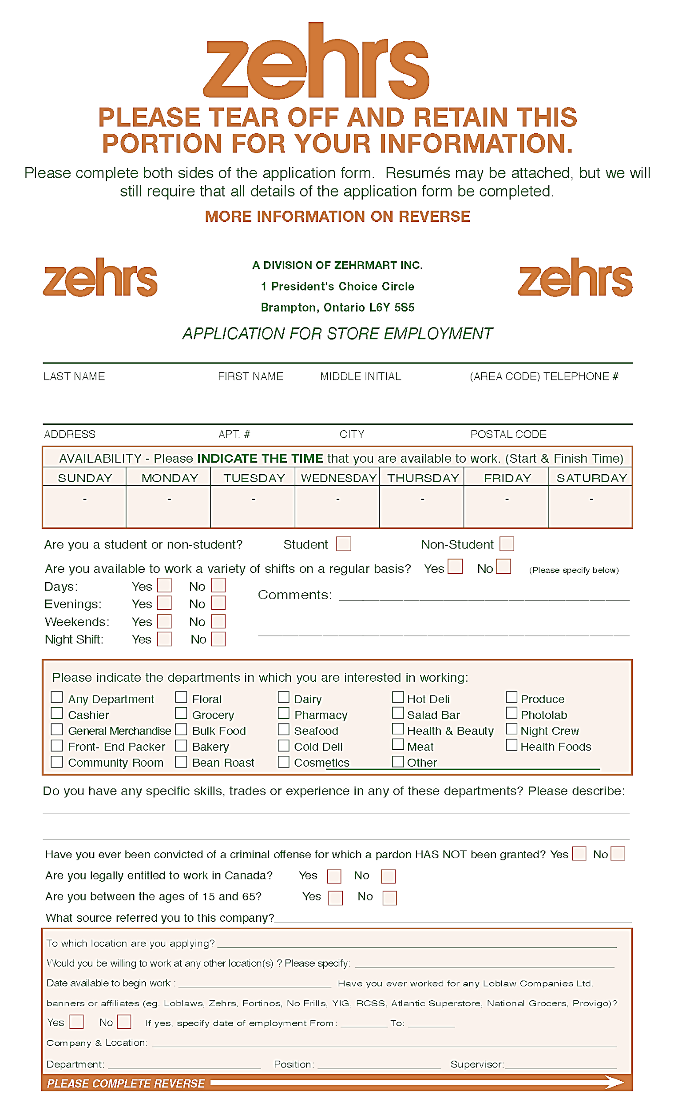

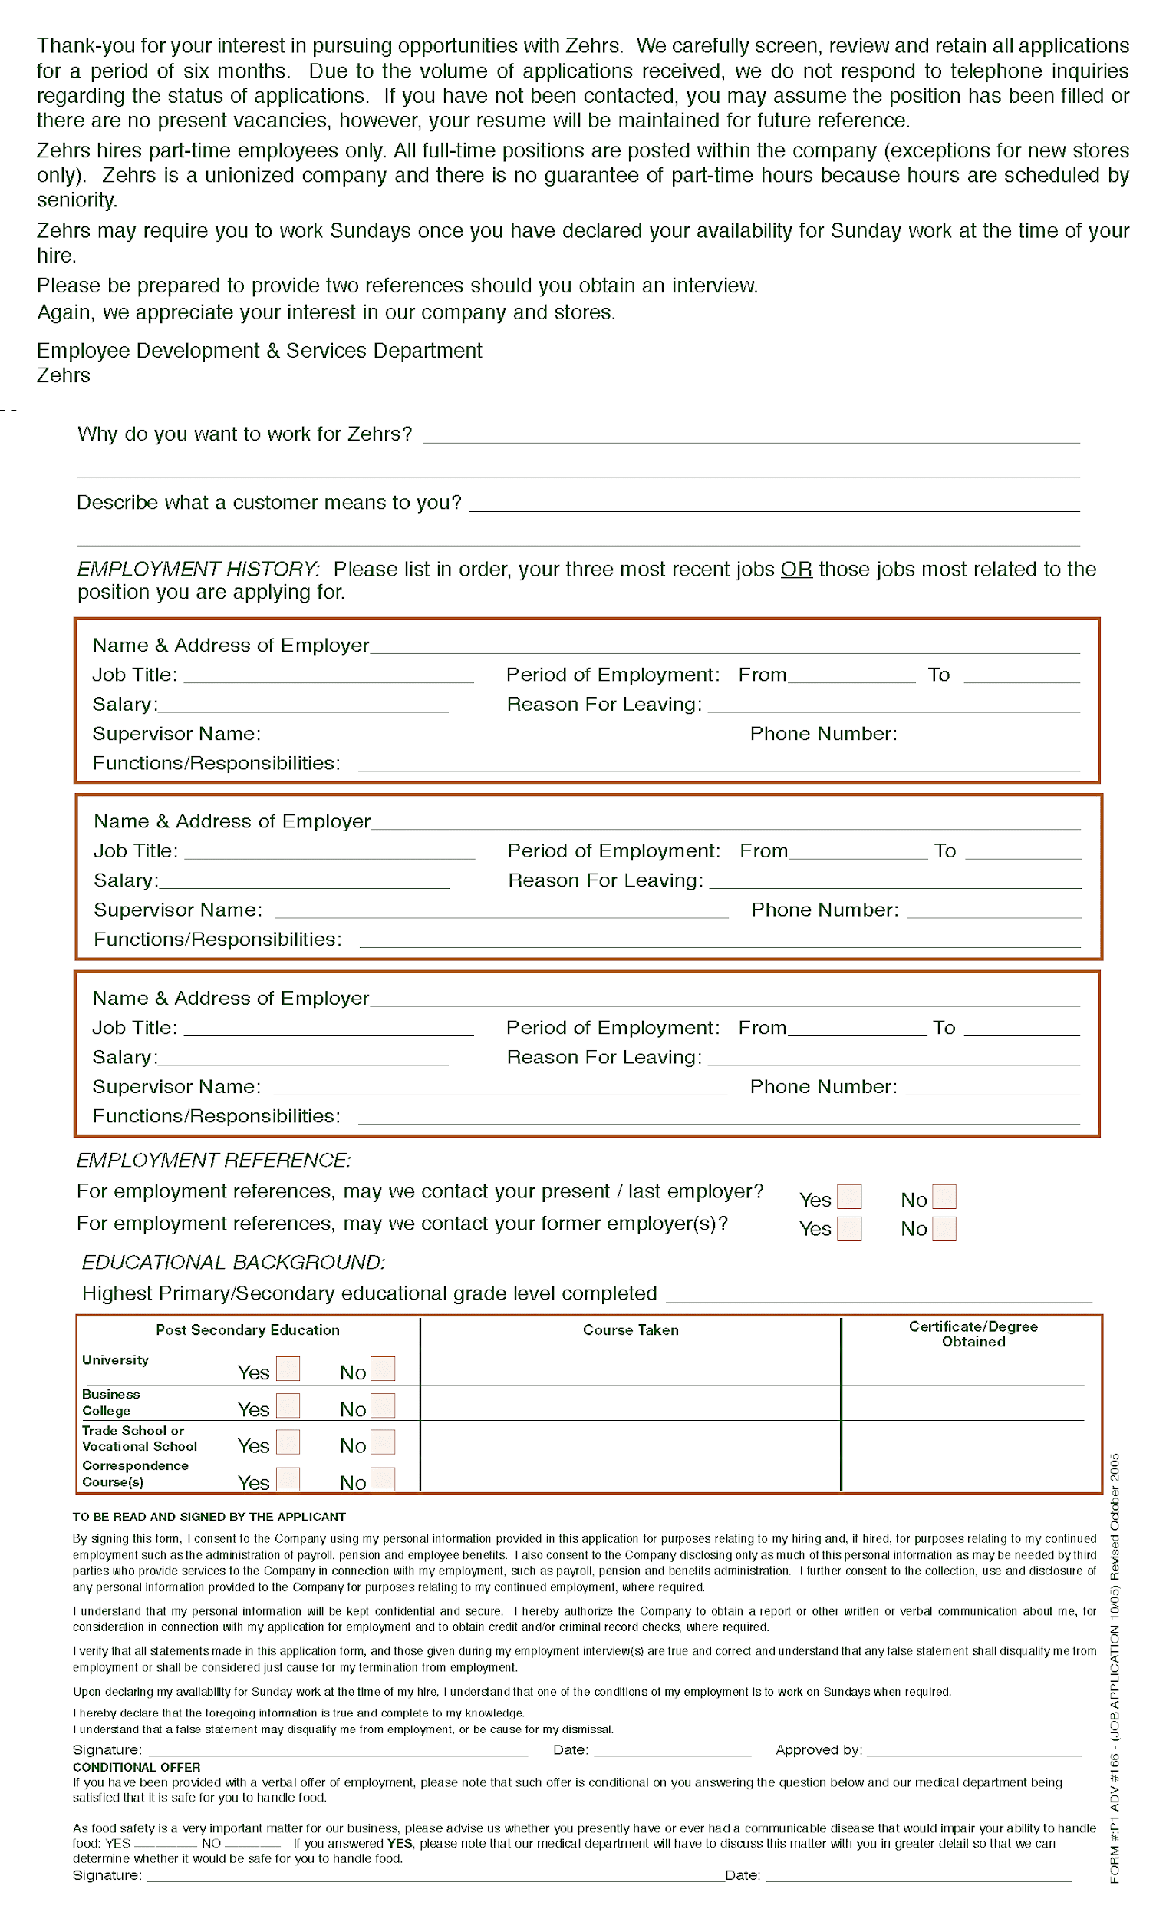

# Work Sheet

**Task 1: Fill out the following sections of the application form using your own information, availability and preferences:**

* **Name, phone number and address**
* **Shift availability**
* **Departments of interest (select at least two)**
* **Previous experience**
* **Educational background**

**If you are uncomfortable using your own information, fill out the application form using the following information:**

* **Andrea Thompson, 519-555-1234, 246 Main Street Goderich Ontario N2Z 121**
* **Available to work: Saturday and Sunday 8am-5pm**
* **Not available to work a variety of shifts**
* **Interested in: Seafood, cold deli, meat**
* **Previous work experience at a local coffee shop preparing food and serving customers**
* **High School completion (OSSD) in 2023**

Answer: No written response required here.

Task completed: Yes:

# Answers

Answers will vary. Ensure the learner has correctly entered their information into the appropriate sections of the application form.

# Performance Descriptors

| Levels | Performance Descriptors | Needs Work | Completes task with support from practitioner | Completes task independently |
| --- | --- | --- | --- | --- |
| A2.2 | Uses layout to locate information |  |  |  |
|  | Makes connections between parts of documents |  |  |  |
|  | Makes low-level inferences |  |  |  |
| B3.1a | Makes a direct match between what is requested and what is entered |  |  |  |
|  | Makes entries using familiar vocabulary |  |  |  |



This task: Was successfully completed Needs to be tried again

Learner Comments:

Instructor (print): Learner (print):

**__________________ _________________**