

Task Title: Guidelines for Alcohol Use Infographic

# OALCF Cover Sheet – Practitioner Copy

**Learner Name: __________________________________________**

**Date Started: ___________________________________________**

**Date Completed: _________________________________________**

|  |  |  |
| --- | --- | --- |
| **Goal Path:** | Employment | Apprenticeship |
| Secondary School | Post Secondary | Independence |

**Successful Completion:**  Yes No

**Task Description:** The learner will locate information about alcohol consumption guidelines in a Government of Canada infographic.

**Main Competency/Task Group/Level Indicator:**

* Find and Use Information/Interpret documents/A2.2

**Materials Required:**

* Pen/pencil and paper and/or digital device

# Learner Information

In 2023, the Canadian Government updated the guidelines for safe alcohol consumption. It is important for everyone to understand the new guidelines and learn how consuming alcohol can increase health risks including cancer.

Scan “Drinking Less is Better”.

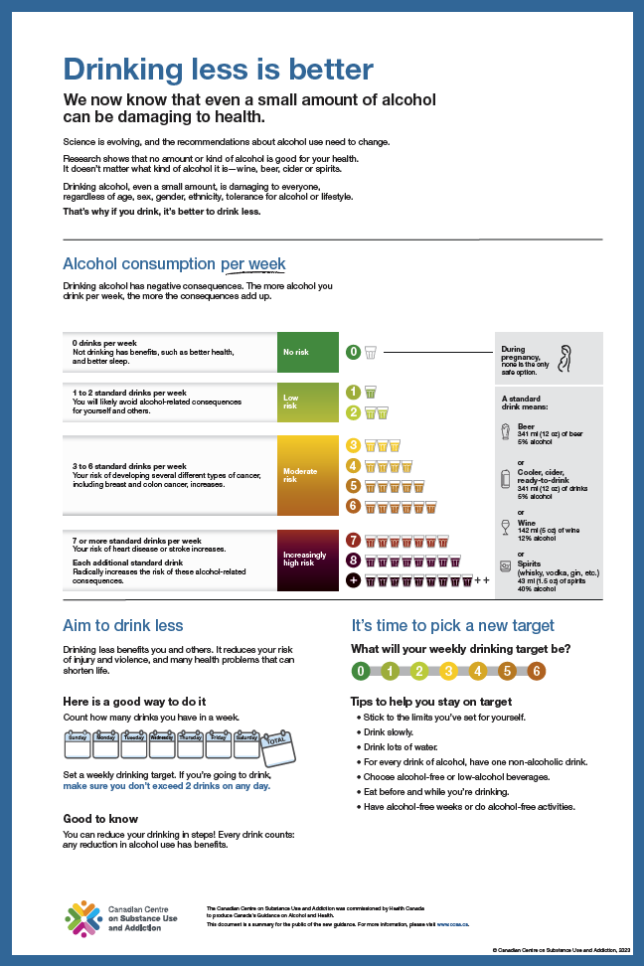

# Work Sheet

**Task 1: How many drinks per week is considered low risk?**

Answer:

**______________________________________________________**

**Task 2: What is a standard drink of wine?**

Answer:

**______________________________________________________**

**Task 3: List the increased risks for someone at a moderate risk level.**

Answer:

**______________________________________________________**

**Task 4: List five tips for maintaining a healthy weekly drinking target.**

Answer:

**______________________________________________________**

# Answers

**Task 1: How many drinks per week is considered low risk?**

Answer: One or two standard drinks per week

**Task 2: What is a standard drink of wine?**

Answer: 142 ml (5oz) of 12% alcohol wine

**Task 3: List the increased risks for someone at a moderate risk level.**

Answer: Your risk of developing several types of cancer, including breast and colon cancer, increases.

**Task 4: List five tips for maintaining a healthy weekly drinking target.**

Answer: Any five of

* stick to the limits you’ve set for yourself
* drink slowly
* drink lots of water
* for every drink of alcohol, have one non-alcoholic drink
* choose alcohol-free or low-alcohol beverages
* eat before and while you’re drinking
* have alcohol-free weeks or do alcohol-free activities

# Performance Descriptors

| Levels | Performance Descriptors | Needs Work | Completes task with support from practitioner | Completes task independently |
| --- | --- | --- | --- | --- |
| A2.2 | performs limited searches using one or two search criteria |  |  |  |
|  | extracts information from tables and forms |  |  |  |
|  | uses layout to locate information |  |  |  |
|  | makes connections between parts of documents |  |  |  |
|  | makes low-level inferences |  |  |  |
|  | begins to identify sources and evaluate information |  |  |  |

This task: Was successfully completed Needs to be tried again

Learner Comments:

Instructor (print): Learner (print):

**__________________ _________________**