

Task Title: Hairdresser Client Profile Form

# OALCF Cover Sheet – Practitioner Copy

**Learner Name: __________________________________________**

**Date Started: ___________________________________________**

**Date Completed: _________________________________________**

|  |  |  |
| --- | --- | --- |
| **Goal Path:** | Employment | Apprenticeship |
| Secondary School | Post Secondary | Independence |

**Successful Completion:**  Yes No

**Task Description:** Update a client form at a hair salon.

**Main Competency/Task Group/Level Indicator:**

* Find and Use Information/Interpret documents/A2.2
* Communicate Ideas and Information/Complete and create documents/B3.2a
* Understand and Use Numbers/Manage time/C2.1
* Understand and Use Numbers/Use measures/C3.2

**Materials Required:**

* Pen/pencil and paper and/or digital device
* Calculator or digital device with calculator function

# Learner Information

# Hairstylists create client profiles for new clients and update the information as needed. They also keep a record of what was done at each visit.

# Scan the “**Client Profile**” for the Hair Boutique.

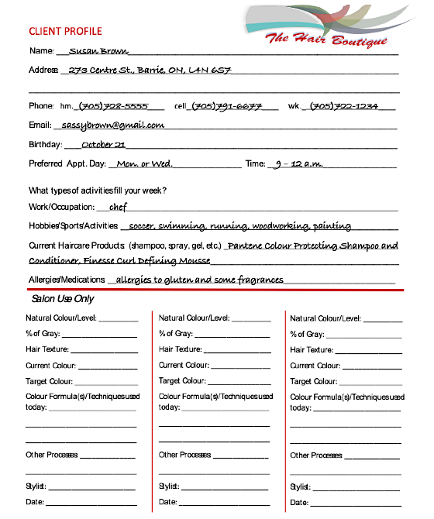

# Work Sheet

**Task 1: The client, Susan Brown, recently started working in a new restaurant. Update her work number to (705) 726-2323.**

Answer:

Task completed successfully: Yes: No:

____________________________________________________________

**Task 2: Why do you think it would be important to know about a client’s allergies and medications?**

Answer:

**______________________________________________________**

**Task 3: Susan Brown currently has light ash brown hair and has come in for a colour touch up on her roots. Her stylist, Janet Smith, knows that Susan’s natural hair colour is very dark brown (level 3) and about ¼ of her hair has gone gray. The formula that Janet uses for Susan is 30 ml of developing lotion to 30 ml of 9NA Light Natural Ash Brown colour. Susan’s hair texture is coarse.**

**Using this information, complete one of the “Salon Use Only” columns in the Client Profile.**

Answer:

Task completed successfully: Yes: No:

**______________________________________________________**

**Task 4: If the stylist put Susan’s colour on at 9:30 a.m. and it needed to stay on for 45 minutes, what time would the stylist rinse Susan’s hair?**

Answer:

**______________________________________________________**

**Task 5: The ratio for a semi-permanent colour is 2:1 (developer : colour). How much developer would the stylist add to 20 ml of colour?**

Answer:

**______________________________________________________**

# Answers

**Task 1: The client, Susan Brown, recently started working in a new restaurant. Update her work number to (705) 726-2323.**

Answer: Work phone number should be crossed out and updated with the new number.

**Task 2: Why do you think it would be important to know about a client’s allergies and medications?**

Answer: A client could have an allergic reaction to products used in their hair or to refreshments that may be served. Some medications may also affect hair condition.

**Task 3: Susan Brown currently has light ash brown hair and has come in for a colour touch up on her roots. Her stylist, Janet Smith, knows that Susan’s natural hair colour is very dark brown (level 3) and about ¼ of her hair has gone gray. The formula that Janet uses for Susan is 30 ml of developing lotion to 30 ml of 9NA Light Natural Ash Brown colour. Susan’s hair texture is coarse.**

**Using this information, complete one of the “Salon Use Only” columns in the Client Profile.**

Answer: Information should be filled in under one of the colour columns at the bottom of the form.

**Task 4: If the stylist put Susan’s colour on at 9:30 a.m. and it needed to stay on for 45 minutes, what time would the stylist rinse Susan’s hair?**

Answer: 10:15am

**Task 5: The ratio for a semi-permanent colour is 2:1 (developer : colour). How much developer would the stylist add to 20 ml of colour?**

Answer: 40mL of developer

# Performance Descriptors

| Levels | Performance Descriptors | Needs Work | Completes task with support from practitioner | Completes task independently |
| --- | --- | --- | --- | --- |
| A2.2 | performs limited searches using one or two search criteria |  |  |  |
|  | uses layout to locate information |  |  |  |
|  | makes low-level inferences |  |  |  |
| B3.2a | uses layout to determine where to make entries |  |  |  |
|  | begins to make some inferences to decide what information is needed, where and how to enter the information |  |  |  |
|  | makes entries using a limited range of vocabulary |  |  |  |
| C2.1 | adds, subtracts, multiplies and divides whole numbers and decimals |  |  |  |
|  | understands chronological order |  |  |  |
|  | identifies and performs required operation |  |  |  |
| C3.2 | understands and uses ratio and proportion |  |  |  |
|  | interprets, represents and converts measures using whole numbers, decimals, percentages, ratios and simple, common fractions (e.g. ½, ¼) |  |  |  |

This task: Was successfully completed Needs to be tried again

Learner Comments:

Instructor (print): Learner (print):

**__________________ _________________**