

Task Title: Identify and Schedule Activities

# OALCF Cover Sheet – Practitioner Copy

**Learner Name: __________________________________________**

**Date Started: ___________________________________________**

**Date Completed: _________________________________________**

|  |  |  |
| --- | --- | --- |
| **Goal Path:** | Employment | Apprenticeship |
| Secondary School | Post Secondary | Independence |

**Successful Completion:**  Yes No

**Task Description:** The learner will review a recreation timetable then identify and schedule activities.

**Main Competency/Task Group/Level Indicator:**

* Understand and Use Numbers/Manage time/C2.3

**Materials Required:**

* Pen/pencil and paper and/or digital device

# Learner Information

When choosing community activities and sports for a family or individual, the activity schedule must be reviewed.

Scan the “FHCA Schedule” and the “Calendar for Year 2025 (Canada)”.

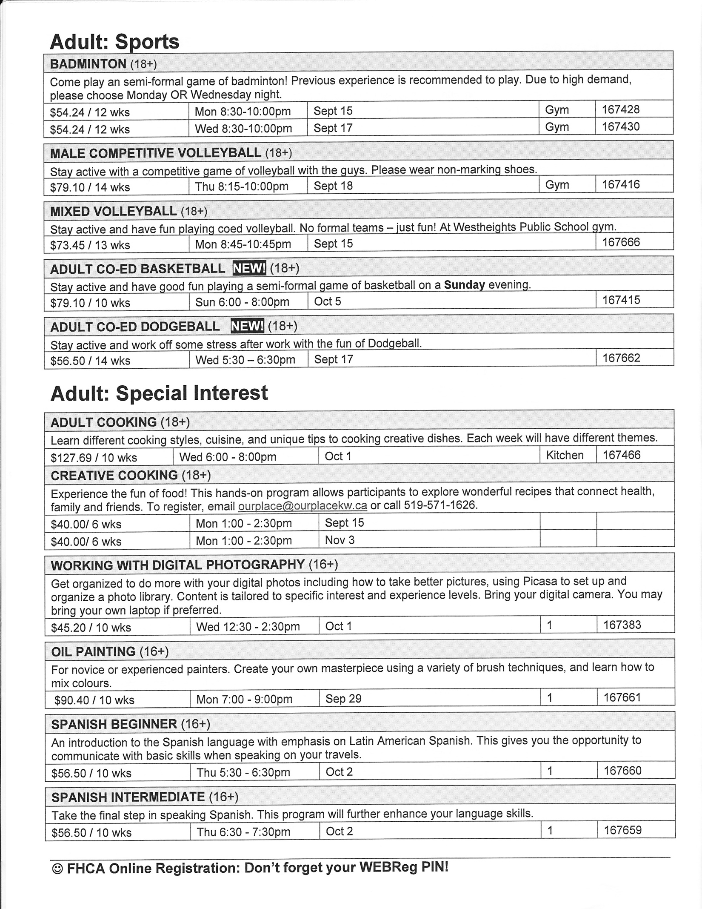**FCHA Schedule**

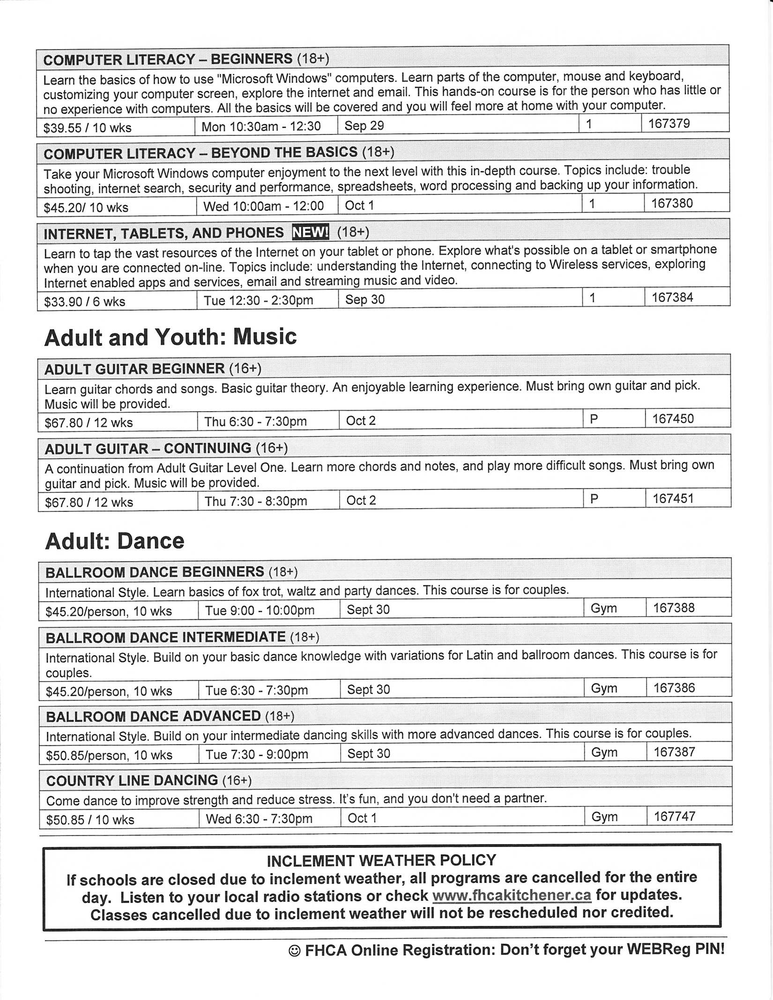

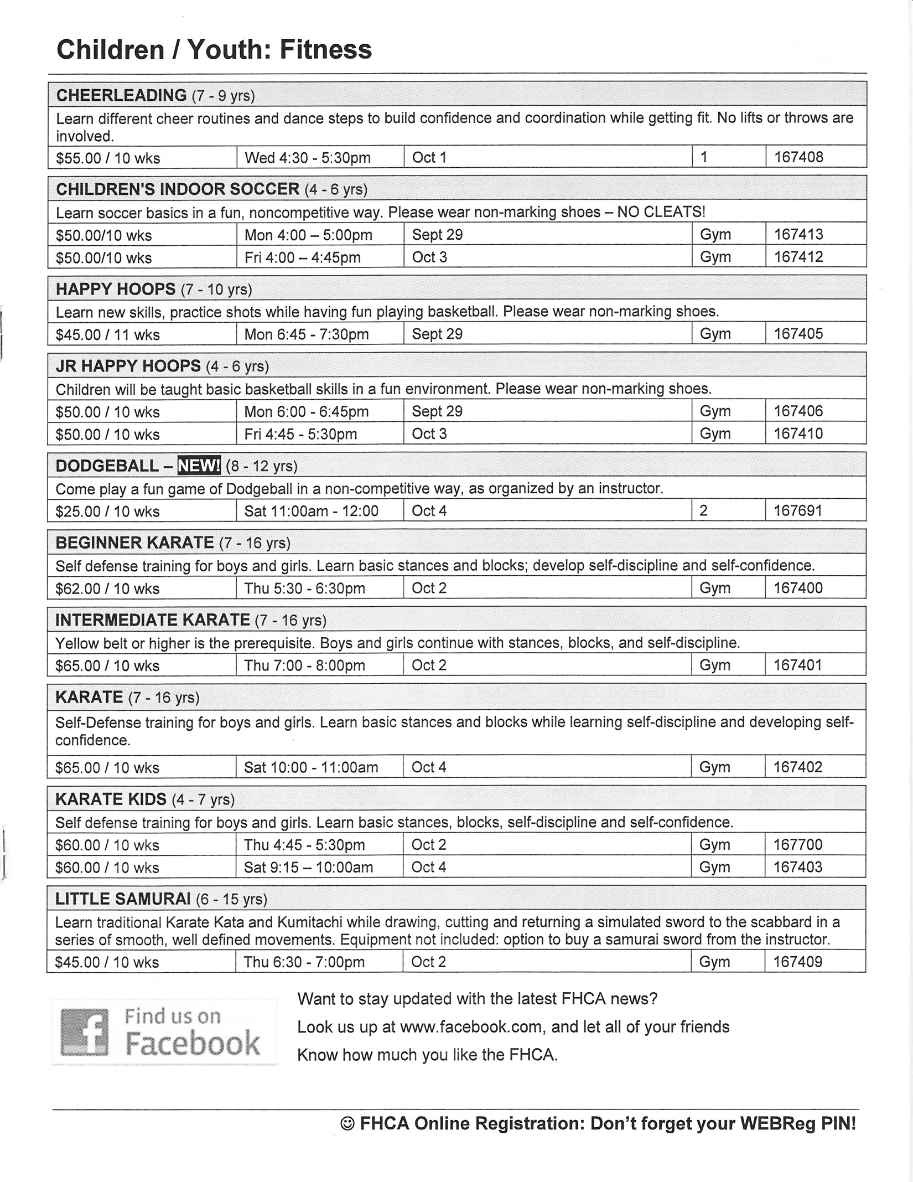

# 

# Work Sheet

**Task 1: Doug wants to play Badminton, but his shift at work will be 1pm to 9pm, Monday to Friday beginning on December 7th. Which Badminton session will Doug be able to sign up for if he wishes to attend all 12 weeks?**

Answer:

**______________________________________________________**

**Task 2: Linda works Sunday to Thursday from 1500 hours to 2300 hours. Given her work schedule, which Adult Special Interest classes could she attend?**

Answer:

**______________________________________________________**

**Task 3: Saidah is interested in taking a cooking course. She can’t start a program until after September 18th and needs it to end before December 7th. Which cooking course can Saidah register for?**

Answer:

**______________________________________________________**

**Task 4: Fatima’s 5-year-old son lives with her during the week, and with his dad on the weekends starting Fridays at 5:00pm. Her son wants to take Happy Hoops and Karate Kids. Fatima wants to make sure she can take him to classes and pick him up. In which classes should she register her son?**

Answer:

**______________________________________________________**

Answers

**Task 1: Doug wants to play Badminton, but his shift at work will be 1pm to 9pm, Monday to Friday beginning on December 7th. Which Badminton session will Doug be able to sign up for if he wishes to attend all 12 weeks?**

Answer: Monday evening badminton ends on December 1 (12-week session beginning on September 15). Wednesday evening badminton ends on December 3 (12-week session beginning on September 17). Doug can register for either session and still be able to attend all classes before his work schedule changes.

**Task 2: Linda works Sunday to Thursday from 1500 hours to 2300 hours. Given her work schedule, which Adult Special Interest classes could she attend?**

Answer: Linda can only attend classes that end before 3pm. These include

* Creative Cooking
* Working with Digital Photography
* Computer Literacy – Beginners
* Computer Literacy – Beyond the Basics
* Internet, Tablets and Phones

**Task 3: Saidah is interested in taking a cooking course. She can’t start a program until after September 18th and needs it to end before December 7th. Which cooking course can Saidah register for?**

Answer: The Adult Cooking class.

**Task 4: Fatima’s 5-year-old son lives with her during the week, and with his dad on the weekends starting Fridays at 5:00pm. Her son wants to take Happy Hoops and Karate Kids. Fatima wants to make sure she can take him to classes and pick him up. In which classes should she register her son?**

Answer: Jr Happy Hoops on Mondays and Karate Kids on Thursdays.

# Performance Descriptors

| Levels | Performance Descriptors | Needs Work | Completes task with support from practitioner | Completes task independently |
| --- | --- | --- | --- | --- |
| C2.3 | calculates using numbers expressed as whole numbers, fractions, decimals and percentages |  |  |  |
|  | manages unfamiliar elements (e.g. context, content) to complete tasks |  |  |  |
|  | makes estimates |  |  |  |
|  | chooses and performs required operations; makes inferences to identify required operations |  |  |  |
|  | selects appropriate steps to reach solutions from amongst options |  |  |  |
|  | identifies a variety of ways to complete tasks |  |  |  |
|  | finds, integrates and analyzes numerical information |  |  |  |
|  | organizes and displays numerical information (e.g. Gantt chart, schedules) |  |  |  |
|  | uses strategies to check accuracy (e.g. estimating, using a calculator, repeating a calculation, using the reverse operation) |  |  |  |

This task: Was successfully completed Needs to be tried again

Learner Comments:

Instructor (print): Learner (print):

**__________________ _________________**