

Task Title: Identify Peak Production Periods on Line Graph

# OALCF Cover Sheet – Practitioner Copy

**Learner Name: __________________________________________**

**Date Started: ___________________________________________**

**Date Completed: _________________________________________**

|  |  |  |
| --- | --- | --- |
| **Goal Path:** | Employment | Apprenticeship |
| Secondary School | Post Secondary | Independence |

**Successful Completion:**  Yes No

**Task Description:** The learner will interpret line graphs that compare sales in Canada and the United States over several months.

**Main Competency/Task Group/Level Indicator:**

* Understand and Use Numbers/Manage data/C4.2

**Materials Required:**

* Pen/pencil and paper and/or digital device

# Learner Information

Data can be shown in many different ways. Line graphs are a common way data can be shown.

Scan “Figure 1: Same-store sales”.

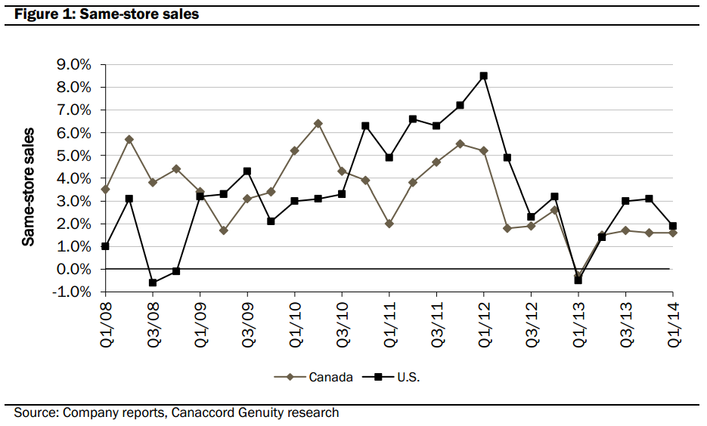

This line graph shows the percentage change in sales for two Tim Horton’s stores. One is in Canada and one is in the United States. This graph tracks sales by quarter between 2008 and 2014.

# Work Sheet

**Task 1: In which quarter and year did the Canadian store experience the best sales?**

Answer:

**______________________________________________________**

**Task 2: Calculate the percentage difference between the best sales month and the worst sales month for the Canadian store.**

Answer:

**______________________________________________________**

**Task 3a: Did the Canadian or American store experience the largest drop in percent sales within one year?**

**Task 3b: What was this percent difference?**

Answer:

**______________________________________________________**

**Task 4a: What is the percent difference in sales from the start of the graph (Q1/08) to the end of the graph (Q1/14) for the Canadian store?**

**Task 4b: What is the percent difference in sales from the start of the graph (Q1/08) to the end of the graph (Q1/14) for the American store?**

Answer:

**______________________________________________________**

# Answers

**Task 1: In which quarter and year did the Canadian store experience the best sales?**

Answer: Q2/10

**Task 2: Calculate the percentage difference between the best sales month and the worst sales month for the Canadian store.**

Answer: Best Sales: 6.5% Worst Sales: -0.8% = 7.3%. This could vary by 0.3 to 0.6%. Check their work to see what they decided were the best and worst sale percentages and that it is just not a mistake in using negative integers.

**Task 3a: Did the Canadian or American store experience the largest drop in percent sales within one year?**

**Task 3b: What was this percent difference?**

Answer:

3a) US Store (between Q1 2012 and Q1 2013) had a peak sale percent of 8.5% and a low sale percent of -0.5%.

3b) The total percent sales difference was 9.0% (see explanation for Task 2 answer in case of variance)

**Task 4a: What is the percent difference in sales from the start of the graph (Q1/08) to the end of the graph (Q1/14) for the Canadian store?**

**Task 4b: What is the percent difference in sales from the start of the graph (Q1/08) to the end of the graph (Q1/14) for the American store?**

Answer:

4a) 2008 = 3.5% and 2014 = 1.7%. The difference is 1.8%

4b) 2008 = 1% and 2014 = 1.9%. The difference is 0.9%.

Note: These numbers could vary by about 0.5% depending on how the graph is read. Check the learner’s calculation of difference between the two points as they read them.

# Performance Descriptors

| Levels | Performance Descriptors | Needs Work | Completes task with support from practitioner | Completes task independently |
| --- | --- | --- | --- | --- |
| C4.2 | calculates using numbers expressed as whole numbers, fractions, decimals, percentages and integers |  |  |  |
|  | makes estimates |  |  |  |
|  | interprets rates (e.g. crime rates) and ratios (e.g. shots-on-net to goals) |  |  |  |
|  | chooses and performs required operation(s); may make inferences to identify required operation(s) |  |  |  |
|  | selects appropriate steps to solutions |  |  |  |
|  | recognizes patterns and begins to identify trends in data (e.g. population, crime, demographic, inventory, injury) |  |  |  |

This task: Was successfully completed Needs to be tried again

Learner Comments:

Instructor (print): Learner (print):

**__________________ _________________**