

Task Title: Interpreting General Notes and Building Codes

# OALCF Cover Sheet – Practitioner Copy

**Learner Name: __________________________________________**

**Date Started: ___________________________________________**

**Date Completed: _________________________________________**

|  |  |  |
| --- | --- | --- |
| **Goal Path:** | Employment | Apprenticeship |
| Secondary School | Post Secondary | Independence |

**Successful Completion:**  Yes No

**Task Description:** The learner will read and interpret General Notes and building code information to answer questions about construction requirements.

**Main Competency/Task Group/Level Indicator:**

* Find and Use Information/Interpret documents/A2.2

**Materials Required:**

* Pen/pencil and paper and/or digital device

# Learner Information

Tradespeople are required to comply with Ontario Building Code standards when completing their work. This ensures that buildings meet safety and other standards determined by the province of Ontario.

Contractors and/or tradespeople might encounter a General Notes page attached to a blueprint for a project. General Notes usually contain information about building codes that would not necessarily be shown or detailed on drawings or blueprints but are important to the project.

Scan “QUILL Learning Network - General Notes, GN1.01”.

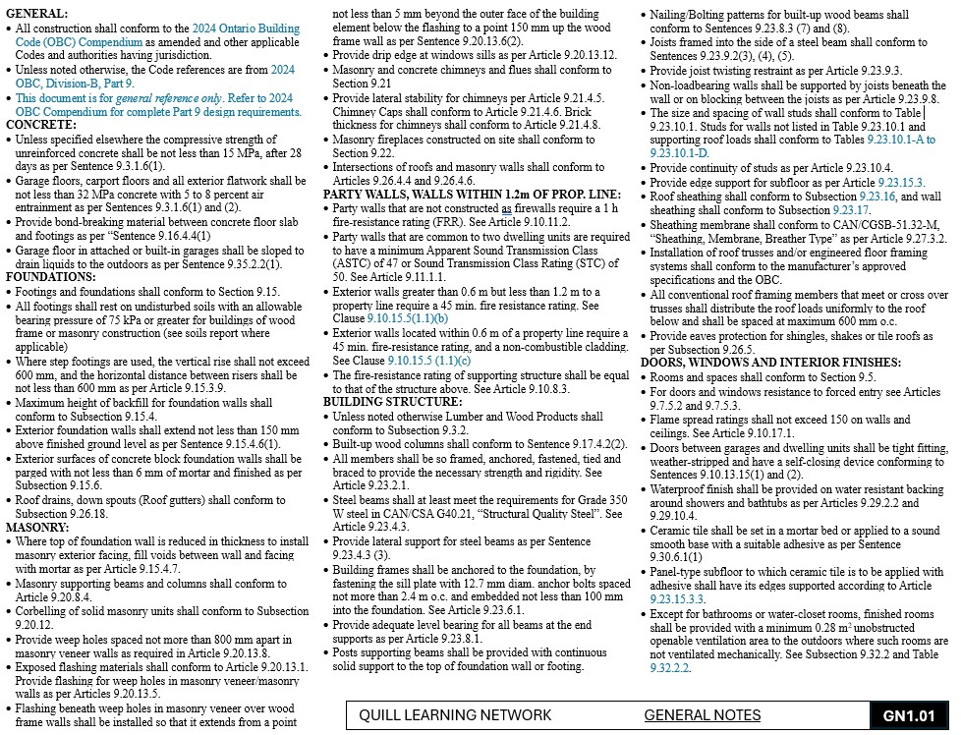

Work Sheet

**Task 1: What does OBC stand for and what version is referenced in the General Notes?**

Answer:

**______________________________________________________**

**Task 2: Which Canadian Standard from the Canadian Standards Association (CAN/CSA) lists the requirements for structural steel and what is the building code reference number?**

Answer:

**______________________________________________________**

**Task 3: What are the anchoring requirements for Building Frames and the building code reference number?**

Answer:

**______________________________________________________**

**Task 4: How should non-loadbearing wall partitions be supported? Include the building code reference number.**

Answer:

**______________________________________________________**

**Task 5: What is the maximum spacing required for all conventional roof framing members that meet or cross over trusses?**

Answer:

**______________________________________________________**

**Task 6: What is the minimum compressive strength of concrete used in Part 9 construction? Include the building code reference number.**

Answer:

**______________________________________________________**

**Task 7: List three areas where concrete would be required to meet a minimum strength of 32 MPA. Include the building code reference number.**

Answer:

**______________________________________________________**

Answers

**Task 1: What does OBC stand for and what version is referenced in the General Notes?**

Answer: Ontario Building Code, 2024 OBC, Division – B, Part 9

**Task 2: Which Canadian Standard from the Canadian Standards Association (CAN/CSA) lists the requirements for structural steel and what is the building code reference number?**

Answer: CAN/CSA G40.21 “Structural Quality Steel” as per 9.23.4.3 of the 2024 OBC (*Located under “Building Structure” heading.)*

**Task 3: What are the anchoring requirements for Building Frames and the building code reference number?**

Answer: Building frames shall be anchored to the foundation, by fastening the sill plate with 12.7 mm diameter anchor bolts spaced not more than 2.4 m o.c. (on center) and embedded not less than 100 mm into the foundation as per 9.23.6.1 of the 2024 OBC. (*Located under “Building Structure” heading.*)

**Task 4: How should non-loadbearing wall partitions be supported? Include the building code reference number.**

Answer: The wall shall be supported by joists or on blocking beneath the joists as per 9.23.9.8 of the 2024 OBC. (*Located under “Building Structure” heading.*)

**Task 5: What is the maximum spacing required for all conventional roof framing members that meet or cross over trusses?**

Answer: Maximum of 600 mm o.c. (on center) (*Located under “Building Structure heading.*)

**Task 6: What is the minimum compressive strength of concrete used in Part 9 construction? Include the building code reference number.**

Answer: Not less than 15 MPA after 28 days as per Sentence 9.3.1.6(1) of the 2024 OBC (*Located under “Concrete” heading.*)

**Task 7: List three areas where concrete would be required to meet a minimum strength of 32 MPA. Include the building code reference number.**

Answer: Garage Floors, carport floors, and exterior flatwork as per 9.3.1.6(1) and (2) of the 2024 OBC. (*Located under “Concrete” heading.*)

# Performance Descriptors

| Levels | Performance Descriptors | Needs Work | Completes task with support from practitioner | Completes task independently |
| --- | --- | --- | --- | --- |
| A2.2 | Performs limited searches using one or two search criteria |  |  |  |
|  | Extracts information from tables and forms |  |  |  |
|  | Uses layout to locate information |  |  |  |
|  | Makes connections between parts of documents |  |  |  |
|  | Makes low-level inferences |  |  |  |
|  | Begins to identify sources and evaluate information |  |  |  |

This task: Was successfully completed Needs to be tried again

Learner Comments:

Instructor (print): Learner (print):

**__________________ _________________**