

Task Title: Make a Card

# OALCF Cover Sheet – Practitioner Copy

**Learner Name: __________________________________________**

**Date Started: ___________________________________________**

**Date Completed: _________________________________________**

|  |  |  |
| --- | --- | --- |
| **Goal Path:** | Employment | Apprenticeship |
| Secondary School | Post Secondary | Independence |

**Successful Completion:**  Yes No

**Task Description:** The learner will make a Thank You card for a guest speaker in a class.

**Main Competency/Task Group/Level Indicator:**

* Communicate Ideas and Information/Write continuous text/B2.1
* Communicate Ideas and Information/B4

**Materials Required:**

* Pen/pencil, coloured pencils and/or markers and paper and/or digital device

# Learner Information

Guest speakers or presenters come to classrooms to share information. Some speakers are there to talk about your next steps or to talk to you about community events. It is important to thank speakers by writing a Thank You card. Sometimes, those cards are designed by the students themselves.

Scan the “Sample Thank You Card Template”.

**Sample Thank You Card Template**

Outside of Card

Inside of Card

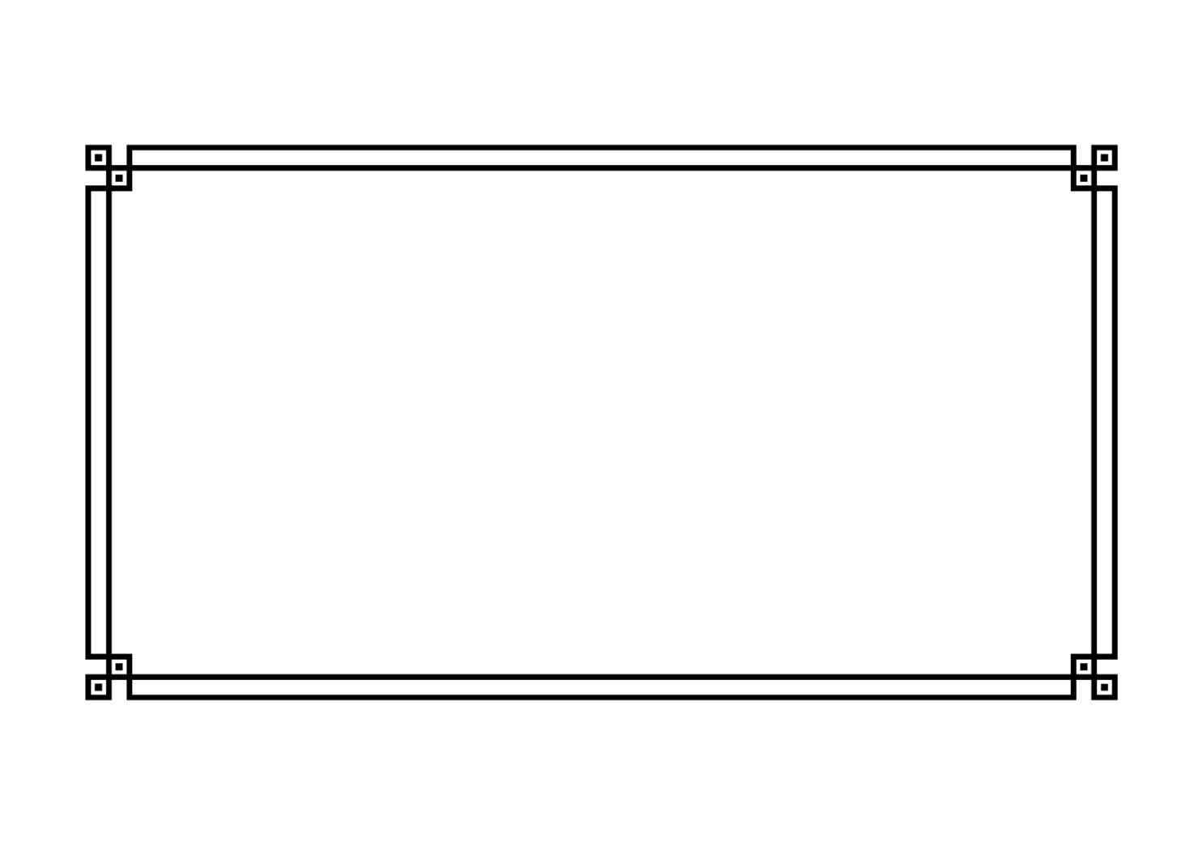

# Work Sheet

**Task 1: Using the template below (or a separate piece of paper folded in half), design a Thank You card for a guest speaker who has come to your classroom. You may use coloured pencils or markers. Write at least three sentences on the inside of the card.**

Answer:

# Answers

Answers will vary.

Performance Descriptors

| Levels | Performance Descriptors | Needs Work | Completes task with support from practitioner | Completes task independently |
| --- | --- | --- | --- | --- |
| B2.1 | Writes simple texts to request, remind, or information |  |  |  |
|  | Conveys simple ideas and factual information |  |  |  |
|  | Uses sentence structure, upper and lower case, and basic punctuation |  |  |  |
| B4 | Express oneself creatively |  |  |  |

This task: Was successfully completed Needs to be tried again

Learner Comments:

Instructor (print): Learner (print):

**__________________ _________________**