

Task Title: Medicine Label

# OALCF Cover Sheet – Practitioner Copy

**Learner Name: __________________________________________**

**Date Started: ___________________________________________**

**Date Completed: _________________________________________**

|  |  |  |
| --- | --- | --- |
| **Goal Path:** | Employment | Apprenticeship |
| Secondary School | Post Secondary | Independence |

**Successful Completion:**  Yes No

**Task Description:** Read a medicine label and interpret directions and correct dosage.

**Main Competency/Task Group/Level Indicator:**

* Find and Use Information/Interpret documents/A2.2
* Understand and Use Numbers/Manage time/C2.1
* Understand and Use Numbers/Use measures/C3.1

**Materials Required:**

* Pen/pencil and paper and/or digital device
* Calculator or digital device with calculator function (optional)

# Learner Information

Many people need to accurately read and dispense medication for their work and in their daily lives.

Scan the “Adult Robitussin” cough medicine label.

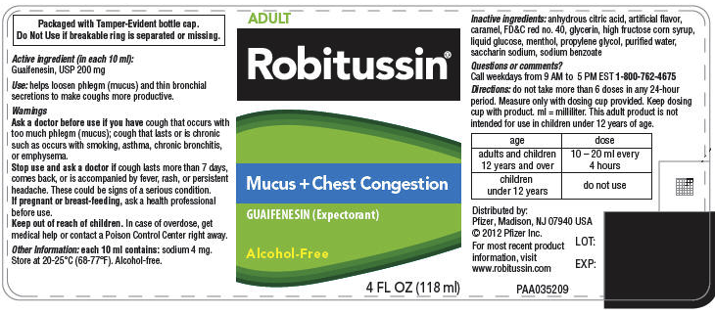

# Work Sheet

**Task 1: What is this medication used for?**

Answer:

**______________________________________________________**

**Task 2: When should someone see a doctor or seek advice from a healthcare professional?**

Answer:

**______________________________________________________**

**Task 3: At what temperature should this medicine be stored?**

Answer:

**______________________________________________________**

**Task 4: What is the maximum dosage for an adult in a 24-hour period?**

Answer:

**______________________________________________________**

**Task 5: What is the maximum dosage for a child under 12 in a 24-hour period?**

Answer:

**______________________________________________________**

**Task 6: If you give someone a dose of this medication at 10:30am, what is the earliest time you can give another dose? Assume the person has not yet reached the maximum dosage within a 24-hour period.**

Answer:

**______________________________________________________**

# Answers

**Task 1: What is this medication used for?**

Answer: “helps loosen phlegm (mucus) and thin bronchial secretions to make coughs more productive” or “mucus + chest congestion” or “expectorant”.

**Task 2: When should someone see a doctor or seek advice from a healthcare professional?**

Answer: If the cough lasts more than 7 days, comes back, or is accompanied by fever, rash, or persistent headache. If pregnant or breast-feeding, ask a healthcare professional before use.

**Task 3: At what temperature should this medicine be stored?**

Answer: 20-25 degrees Celsius (68-77 degrees Farenheit)

**Task 4: What is the maximum dosage for an adult in a 24-hour period?**

Answer: Maximum 6 doses in a 24-hour period. An adult dose is 10-20mL every 4 hours = 60-120mL maximum (6 doses over a 24-hour period).

**Task 5: What is the maximum dosage for a child under 12 in a 24-hour period?**

Answer: Zero. This medication is not suitable for children under 12.

**Task 6: If you give someone a dose of this medication at 10:30am, what is the earliest time you can give another dose? Assume the person has not yet reached the maximum dosage within a 24-hour period.**

Answer: 2:30pm

# Performance Descriptors

| Levels | Performance Descriptors | Needs Work | Completes task with support from practitioner | Completes task independently |
| --- | --- | --- | --- | --- |
| A2.2 | extracts information from tables and forms |  |  |  |
|  | uses layout to locate information |  |  |  |
|  | makes connections between parts of documents |  |  |  |
|  | makes low-level inferences |  |  |  |
| C2.1 | adds, subtracts, multiplies, and divides whole number and decimals |  |  |  |
|  | recognizes values in number and word format |  |  |  |
|  | interprets and represents time using whole numbers, decimals (e.g. .25, .5) and simple common fractions (e.g. ½, ¼ hour) |  |  |  |
|  | identifies and performs required operation |  |  |  |
| C3.1 | adds and subtracts whole number measurements |  |  |  |
|  | interprets and represents measures using whole numbers, decimals and simple, common fractions (e.g. ½, ¼) |  |  |  |
|  | interprets and represents measures using symbols and abbreviations |  |  |  |
|  | follows apparent steps to reach solutions |  |  |  |

This task: Was successfully completed Needs to be tried again

Learner Comments:

Instructor (print): Learner (print):

**__________________ _________________**