

Task Title: Millwright Maintenance Schedule

# OALCF Cover Sheet – Practitioner Copy

**Learner Name: __________________________________________**

**Date Started: ___________________________________________**

**Date Completed: ________________________________________**

|  |  |  |
| --- | --- | --- |
| **Goal Path:** | Employment | Apprenticeship |
| Secondary School | Post Secondary | Independence |

**Successful Completion:**  Yes No

**Task Description:**

The learner will scan a document and follow written instructions to perform tasks related to using a schedule in a workplace.

**Main Competency/Task Group/Level Indicator:**

* Find and Use Information/Read continuous text/A1.2
* Find and Use Information/Interpret documents/A2.1

**Materials Required:**

* Pen/pencil and paper

Learner Information

Millwrights follow a schedule to perform required maintenance in the workplace. This helps them to schedule and manage time.

Scan the **Millwright Weekly Maintenance Schedule.**

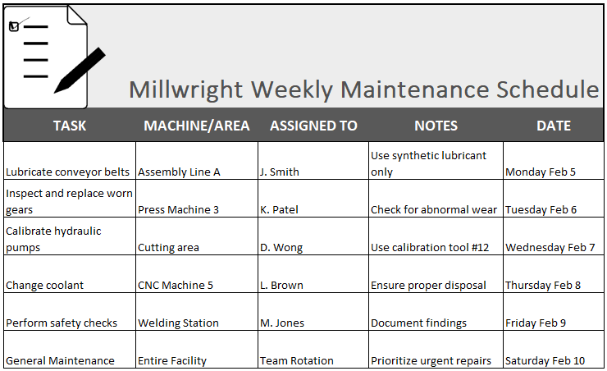

# Work Sheet

**Task 1: On what date is the coolant changed?**

Answer:

**______________________________________________________**

**Task 2: Which tool is required on Wednesday, February 7?**

Answer:

**______________________________________________________**

**Task 3: What maintenance task involves lubrication and what type of lubricant should be used?**

Answer:

**______________________________________________________**

**Task 4: Where is Friday’s important safety task scheduled to take place, and what should be done with the findings?**

Answer:

**______________________________________________________**

**Task 5: If urgent repair is needed, on which maintenance day is it scheduled?**

Answer:

**______________________________________________________**

Answers

**Task 1: On what date is the coolant changed?**

Answer: Thursday Feb 8

**______________________________________________________**

**Task 2: Which tool is required on Wednesday, February 7?**

Answer: Calibration tool #12

**______________________________________________________**

**Task 3: What maintenance task involves lubrication and what type of lubricant should be used?**

Answer: Lubricate conveyor belts / Synthetic lubricant

**______________________________________________________**

**Task 4: Where is Friday’s important safety task scheduled to take place, and what should be done with the findings?**

Answer: Welding Station / Document the findings

**______________________________________________________**

**Task 5: If urgent repair is needed, on which maintenance day is it scheduled?**

Answer: Saturday Feb 10

**______________________________________________________**

# Performance Descriptors

| Levels | Performance Descriptors | Needs Work | Completes task with support from practitioner | Completes task independently |
| --- | --- | --- | --- | --- |
| A1.2 | Scans text to locate information |  |  |  |
|  | Locates multiple pieces of information in simple texts |  |  |  |
| A2.1 | Scans to locate specific details |  |  |  |
|  | Locates specific details in simple documents, such as labels and signs |  |  |  |
|  | Identifies how lists are organized (e.g. sequential, chronological, alphabetical) |  |  |  |

This task: Was successfully completed Needs to be tried again

Learner Comments:

Instructor (print): Learner (print):

_______________________ _______________________