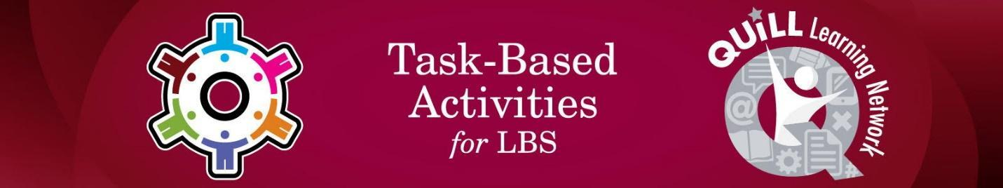

Task Title: Passing on a Message to Relay Information

# OALCF Cover Sheet – Practitioner Copy

**Learner Name: __________________________________________**

**Date Started: ___________________________________________**

**Date Completed: _________________________________________**

|  |  |  |
| --- | --- | --- |
| **Goal Path:** | Employment | Apprenticeship |
| Secondary School | Post Secondary | Independence |

**Successful Completion:**  Yes No

**Task Description:** The learner will be given a verbal message to pass on to another person.

**Main Competency/Task Group/Level Indicator:**

* Communicate Ideas and Information/Interact with others/B1.1
* Manage Learning/E.1

**Materials Required:**

* Pen/pencil and paper and/or digital device

# Notes for Instructors/Practitioners

Develop a message that can be relayed by your learner to someone else. The message should be no more than two or three sentences in length. Ensure there are two key points to the message. For example: “Please tell John that break is going to be five minutes early today. This is because we have a guest speaker coming to the classroom to talk about employment supports.”

This task works well with multiple learners in a classroom. However, the learner can give the message back to you as the instructor if you are not using this task in a group setting.

# Learner Information

# Recording messages accurately is important in work and in our daily lives.

# Work Sheet

**Task 1: Listen to the message your instructor gives you. You may write down the message if it’s easier for you to remember.**

Answer: No written response required here.

Task completed: Yes: No:

**Task 2: Give the message to another learner (or back to your instructor) verbally or by signing.**

Answer: No written response required here.

Task completed: Yes: No:

**Task 3: Talk to your instructor about what they observed or heard.**

Answer: No written response required here.

Task completed: Yes: No:

**Task 4: Fill out the learner self-evaluation.**

**Learner Self-Evaluation:**

1. I was able to read and understand the instructions. Yes □ No □
2. I was able to listen to the message. Yes □ No □
3. I was able to understand the message. Yes □ No □
4. I was able to give the message to the right person. Yes □ No □
5. The person was able to understand my message. Yes □ No □

Other Comments:

# Answers

Answers will vary.

# Performance Descriptors

| Levels | Performance Descriptors | Needs Work | Completes task with support from practitioner | Completes task independently |
| --- | --- | --- | --- | --- |
| B1.1 | conveys information on familiar topics |  |  |  |
|  | shows an awareness of factors such as social, linguistic and cultural differences that affect interactions in brief exchanges with others |  |  |  |
|  | chooses appropriate language in exchanges with clearly defined purposes |  |  |  |
|  | participates in short, simple exchanges |  |  |  |
|  | speaks or signs clearly in a focused and organized way |  |  |  |
| E.1 | sets short-term goals |  |  |  |
|  | identifies steps required to achieve goals |  |  |  |
|  | begins to monitor progress towards achieving goals |  |  |  |
|  | begins to identify ways to remember information and reinforce learning |  |  |  |
|  | begins to monitor own learning |  |  |  |

This task: Was successfully completed Needs to be tried again

Learner Comments:

Instructor (print): Learner (print):

**__________________ _________________**