

Task Title: Payday Loans and Cash Advances

# OALCF Cover Sheet – Practitioner Copy

**Learner Name: __________________________________________**

**Date Started: ___________________________________________**

**Date Completed: _________________________________________**

|  |  |  |
| --- | --- | --- |
| **Goal Path:** | Employment | Apprenticeship |
| Secondary School | Post Secondary | Independence |

**Successful Completion:**  Yes No

**Task Description:** The learner will calculate the true costs of payday loans and cash advances.

**Main Competency/Task Group/Level Indicator:**

* Find and Use Information/Interpret documents/A2.2
* Understand and Use Numbers/Manage money/C1.2

**Materials Required:**

* Pen/pencil and paper and/or digital device
* Calculator or digital device with calculator function (optional)

# Learner Information

Sometimes when people are running short on money due to sudden expenses, they will get a payday loan or cash advance.

Scan the “Cost of Borrowing” and “How much will $300 cost you for two weeks?”

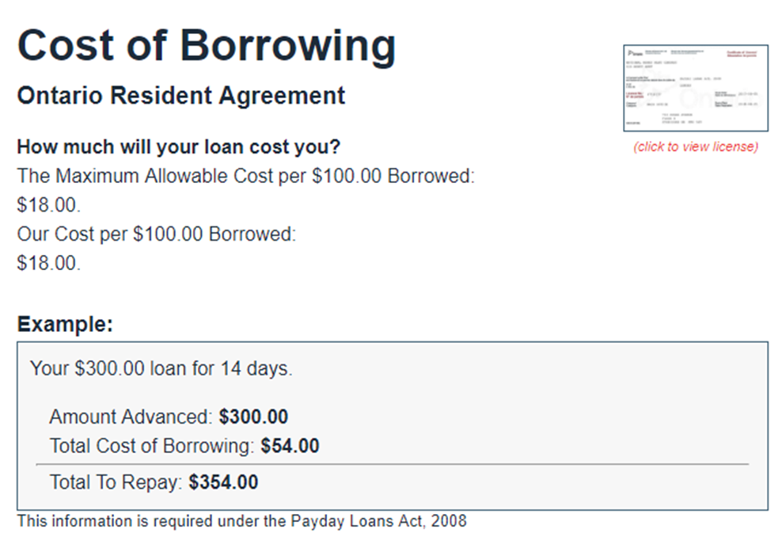

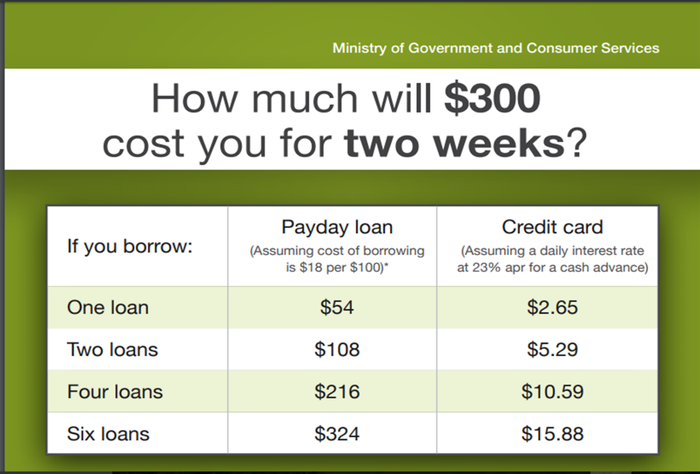

# Work Sheet

**Task 1: If a customer takes out a $300 pay day loan for 14 days, how much will they have to pay back in total?**

Answer:

**______________________________________________________**

**Task 2: A customer takes out a $100 cash advance and will pay it back in 14 days. Calculate the total amount the customer would have to pay back.**

Answer:

**______________________________________________________**

**Task 3: A customer takes out a $400 pay day loan for 2 weeks. Calculate the interest they would pay at the end of the 2 weeks.**

Answer:

**______________________________________________________**

# Answers

**Task 1: If a customer takes out a $300 pay day loan for 14 days, how much will they have to pay back in total?**

Answer: $300 (original loan) + $54 interest = $354

**Task 2: A customer takes out a $100 cash advance and will pay it back in 14 days. Calculate the total amount the customer would have to pay back.**

Answer: $100 (cash advance) + $18 interest = $118

**Task 3: A customer takes out a $400 pay day loan for 2 weeks. Calculate the interest they would pay at the end of the 2 weeks.**

Answer: 4 x $18 = $72 interest

# Performance Descriptors

| Levels | Performance Descriptors | Needs Work | Completes task with support from practitioner | Completes task independently |
| --- | --- | --- | --- | --- |
| A2.2 | performs limited searches using one or two search criteria |  |  |  |
|  | extracts information from tables and forms |  |  |  |
|  | uses layout to locate information |  |  |  |
|  | makes connections between parts of documents |  |  |  |
| C1.2 | calculates using numbers expressed as whole numbers, fractions, decimals, percentages and integers |  |  |  |
|  | chooses and performs required operations; makes inferences to identify operations |  |  |  |
|  | selects appropriate steps to reach solutions |  |  |  |
|  | represents costs and rates using monetary symbols, decimals, and percentages |  |  |  |
|  | uses strategies to check accuracy |  |  |  |

This task: Was successfully completed Needs to be tried again

Learner Comments:

Instructor (print): Learner (print):

**__________________ _________________**