

Task Title: Preparations Before Pouring Concrete

# OALCF Cover Sheet – Practitioner Copy

**Learner Name: __________________________________________**

**Date Started: ___________________________________________**

**Date Completed: _________________________________________**

|  |  |  |
| --- | --- | --- |
| **Goal Path:** | Employment | Apprenticeship |
| Secondary School | Post Secondary | Independence |

**Successful Completion:**  Yes No

**Task Description:** The learner will use texts and charts to interpret materials that are needed, or steps that must be undertaken, when pouring concrete.

**Note:** This task assumes some prior knowledge of construction.

**Main Competency/Task Group/Level Indicator:**

* Find and Use Information/Read continuous text/A1.2
* Find and Use Information/Interpret documents/A2.2
* Communicate Ideas and Information/Write continuous text/B2.1
* Understand and Use Numbers/Use measures/C3.3
* Use Digital Technology/D.2

**Materials Required:**

* Pen/pencil and paper
* Computer or digital device
* Calculator or digital device with calculator function

Learner Information

Carpenters build forms to hold concrete. They also review waterstop and rebar information to make decisions about materials to be used before the concrete is poured. This helps them estimate the amounts of materials required.

Scan the “Waterstop Chart”, “Concrete Formwork Computations” and “Rebar Information”.

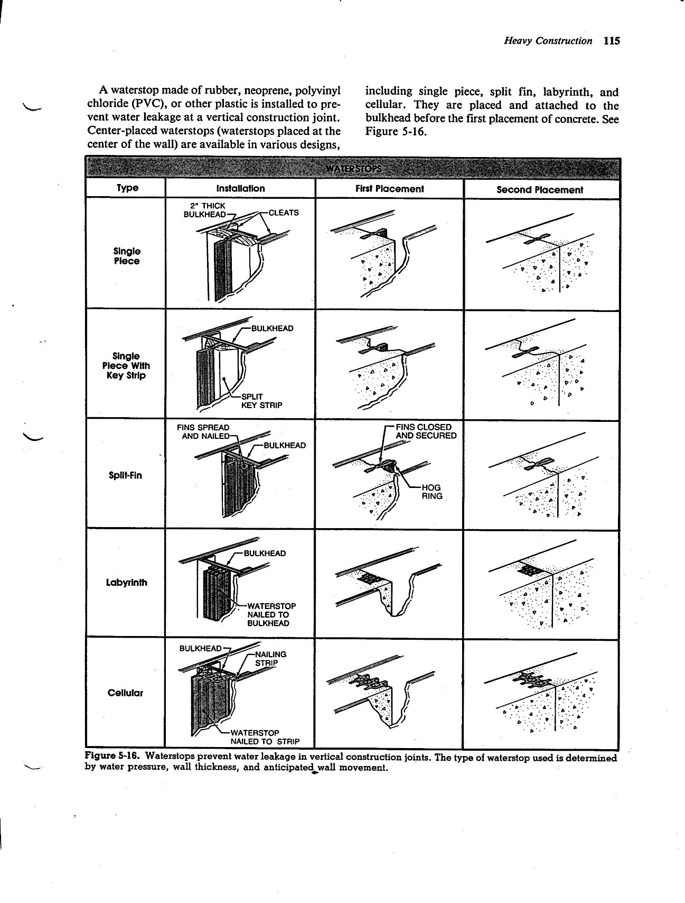**Waterstop Chart**

**Concrete Formwork Computations**

Form Materials and Concrete Quantity Takeoff

Estimating form materials and concrete is a rough calculation of the amount of form materials and volume of concrete required for a specific construction project. Professional estimators commonly estimate the form materials and concrete for heavy construction projects. On small construction projects, such as construction of foundation footings and walls for a residence, the estimating is performed by the contractor or job supervisor.

Form Materials Quantity Takeoff

Form materials are estimated separately for each section of the concrete work. When estimating, dimensions of the form materials are rounded to the next highest foot increment before calculations are performed. For example, the dimension of a wall section measuring 5’ 4½” is rounded to 6’.

When estimating plywood form components, the total surface area of the forms is determined by multiplying the length of the forms by the height. When estimating dimensional lumber such as planks, studs, walers, braces, and stakes, the total length of the lumber is calculated.

Waste occurs when form components are cut from standardized sizes of form materials. Estimators add 5% to 15% of the total amount of form materials to compensate for waste. Underestimation of form materials results in a delay in form construction.

Sheathing

Sheathing is the form material in direct contact with the concrete. Plywood or 2” thick members are used as sheathing for foundation and pier footing forms. Foundation walls are sheathed with plywood reinforced with studs and/or walers, or 2” thick members reinforced with cleats and strongbacks.

**Rebar Information**

Reinforcing Steel

A concrete wall is subject to both compressive and lateral pressures. Concrete without reinforcement has a great deal of compressive resistance to vertical loads, but far less resistance to lateral loads. The lateral resistance of concrete walls is strengthened by placing *rebars* (steel reinforcing bars) in the walls. This combination is commonly referred to as *reinforced concrete construction*.

Rebars are steel bars with ridges and a rough surface. The uneven surface helps bond the concrete to the steel. Standard size rebars range from ⅜” to 2¼” in diameter and are identified n=by numbers from #3 to #18. The diameter of the rebar is found by multiplying the number designation by ⅛”. For example, a #6 rebar is 6/8” or ¾”, in diameter. The size of the rebars required for a wall, as well as their placement and spacing, is shown in section view drawings of prints.

|  |  |  |  |  |  |  |
| --- | --- | --- | --- | --- | --- | --- |
| **STANDARD REBAR SIZES** | | | | | | |
| **Bar Size Designation** | **Weight Per Foot** | | **Diameter** | | **Cross-Sectional Area Squared** | |
| LB | KG | IN. | CM | IN. | CM |
| #3 | 0.376 | 0.171 | 0.375 | 0.953 | 0.11 | 0.71 |
| #4 | 0.668 | 0.303 | 0.500 | 1.270 | 0.20 | 1.29 |
| #5 | 1.043 | 0.473 | 0.625 | 1.588 | 0.31 | 2.00 |
| #6 | 1.502 | 0.681 | 0.750 | 1.905 | 0.44 | 2.84 |
| #7 | 2.044 | 0.927 | 0.875 | 2.223 | 0.60 | 3.87 |
| #8 | 2.670 | 1.211 | 1.000 | 2.540 | 0.79 | 5.10 |
| #9 | 3.400 | 1.542 | 1.128 | 2.865 | 1.00 | 6.45 |
| #10 | 4.303 | 1.952 | 1.270 | 3.336 | 1.27 | 8.19 |
| #11 | 5.313 | 2.410 | 1.410 | 3.581 | 1.56 | 10.07 |
| #14 | 7.650 | 3.470 | 1.693 | 4.300 | 2.25 | 14.52 |
| #18 | 13.600 | 6.169 | 2.257 | 5.733 | 4.00 | 25.81 |

# Work Sheet

**Task 1: Use the Waterstops Chart to complete these tasks.**

1. **Where are center-placed waterstops attached before the concrete is placed?**

Answer:

**_________________________________________________**

1. **What is done to the fins of a Split-fin waterstop at the First Placement stage?**

Answer:

**__________________________________________________**

1. **Name one factor in determining the type of waterstop to be used to prevent water leakage at a vertical joint of concrete.**

Answer:

**__________________________________________________**

**Task 2: Conduct an internet keyword search for “walers” and “strongbacks”. In your own words, write a definition for both terms.**

Answer:

_____________________________________________________________

**Scan the “Concrete Formwork Computations” document.**

**Task 3: To compensate for waste, what is the estimated range of lumber in linear feet, to be ordered if 107.5 linear feet of lumber is required to form a concrete project? Note: “linear feet” means the length of the material.**

Answer:

_____________________________________________________________

**Task 4: Plywood may be used for sheathing. What forms require sheathing?**

Answer:

______________________________________________________

Scan the Rebar Information document.

**Task 5: What can be done to improve concrete’s lateral load resistance?**

Answer:

_____________________________________________________________

**Task 6:** **Where will the carpenter find the information about placing and spacing of rebars?**

Answer:

_____________________________________________________________

**Task 7: Rebar 2.223 cm in diameter is required to provide lateral strength to the concrete to be poured for a structure. What size of rebar is to be used?**

Answer:

_____________________________________________________________

Answers

**Task 1: Use the Waterstops Chart to complete these tasks.**

1. **Where are center-placed waterstops attached before the concrete is placed?**Answer: bulkhead
2. **What is done to the fins of a Split-fin waterstop at the First Placement stage?**

Answer: The fins are closed and sealed.

1. **Name one factor in determining the type of waterstop to be used to prevent water leakage at a vertical joint of concrete.**

Answer: The answer should be one of the following factors:

* + water pressure
  + wall thickness
  + anticipated wall movement

**Task 2: Conduct an internet keyword search for “walers” and “strongbacks”. In your own words, write a definition for both terms.**

Answer: Answers will vary. ‘Straight’ or ‘straighten’ should be included within the definitions. Walers definition should include ‘horizontal’ and ‘support’; strongbacks definition should include ‘frame’ or ‘beam’ or ‘girder’ and ‘stiffen’, ‘support’ or ‘reinforce’. Both provide support to formwork that will hold the concrete.

**Scan the “Concrete Formwork Computations” document.**

**Task 3: In order to compensate for waste, what is the estimated range of lumber in linear feet, to be ordered if 107.5 linear feet of lumber is required to form a concrete project?**Answer: Realize 107.5 should be rounded to 108. Calculate 5% of 108 and add this to 108. Repeat for 15%. These results are the range of lumber, in linear feet, to be ordered for the project.

108 x 5% = 108 x .05 = 5.4

108 + 5.4 = 113.4

Round 113.4 up to 114. This is the lower range.

108 x 15% = 108 x .15 = 16.2

108 + 16.2 = 124.2

Round 124.2 up to 125. This is the upper range.

The range of lumber to be ordered for the project is 114 to 125 linear feet.

**Task 4: Plywood may be used for sheathing. What forms require sheathing?**

Answer: Foundation and pier footing

**Scan the Rebar Information document.**

**Task 5: What can be done to improve concrete’s lateral load resistance?**

Answer: By placing rebars in the walls

**Task 6:** **Where will the carpenter find the information about placing and spacing of rebars?**

Answer: In section view drawings of prints

**Task 7: Rebar 2.223 cm in diameter is required to provide lateral strength to the concrete to be poured for a structure. What size of rebar is to be used?**

Answer: #7

# Performance Descriptors

| Levels | Performance Descriptors | Needs Work | Completes task with support from practitioner | Completes task independently |
| --- | --- | --- | --- | --- |
| A1.2 | Scans text to locate information |  |  |  |
|  | Locates multiple pieces of information in simple texts |  |  |  |
|  | Makes low-level inferences |  |  |  |
|  | Makes connections between sentences and between paragraphs in a single text |  |  |  |
| A2.2 | Performs limited searches using one or two search criteria |  |  |  |
|  | Extracts information from tables and forms |  |  |  |
|  | Uses layout to locate information |  |  |  |
|  | Makes connections between parts of documents |  |  |  |
|  | Makes low-level inferences |  |  |  |
| B2.1 | Writes simple texts to request, remind or inform |  |  |  |
|  | Conveys simple ideas and factual information |  |  |  |
|  | Demonstrates a limited understanding of sequence |  |  |  |
|  | Uses sentence structure, upper and lower case and basic punctuation |  |  |  |
|  | Uses highly familiar vocabulary |  |  |  |
| C3.3 | calculates using numbers expressed as whole numbers, fractions, decimals, percentages and integers |  |  |  |
|  | manages unfamiliar elements (e.g. context, content) to complete tasks |  |  |  |
|  | makes estimates involving many factors where precision is required |  |  |  |
|  | chooses and performs required operations; makes inferences to identify required operations |  |  |  |
|  | interprets, represents and converts measures using whole numbers, decimals, percentages, ratios and fractions |  |  |  |
| D.2 | Begins to identify sources and evaluate information |  |  |  |
|  | Performs simple searches using keywords (e.g. internet, software help menu) |  |  |  |

This task: Was successfully completed Needs to be tried again

Learner Comments:

Instructor (print): Learner (print):

**__________________ _________________**