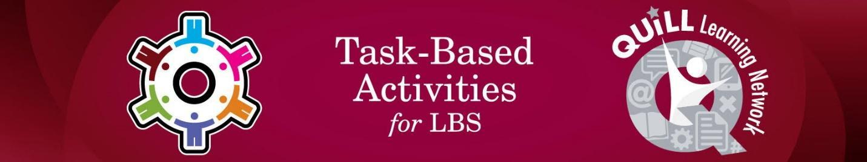

Task Title: Prescription Drug Labels

# OALCF Cover Sheet – Practitioner Copy

**Learner Name: __________________________________________**

**Date Started: ___________________________________________**

**Date Completed: _________________________________________**

|  |  |  |
| --- | --- | --- |
| **Goal Path:** | Employment | Apprenticeship |
| Secondary School | Post Secondary | Independence |

**Successful Completion:**  Yes No

**Task Description:** The learner will interpret warning labels that are commonly found on prescription medication.

**Main Competency/Task Group/Level Indicator:**

* Find and Use Information/Interpret documents/A2.1
* Manage Learning/E.1

**Materials Required:**

* Pen/pencil and paper and/or digital device

# Learner Information

Prescription medications often have warning labels about how or when to take the medication. Warnings may also include information about possible drug interactions or side effects.

Scan “Prescription Safety Labels”.

**Prescription Safety Labels**

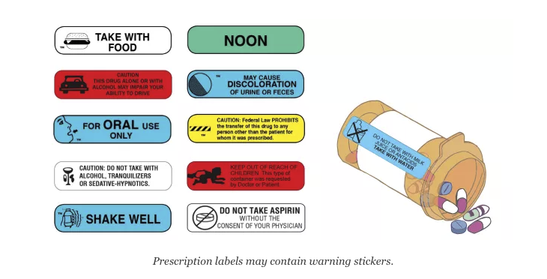

# Work Sheet

**Task 1: Bill is taking medication that cannot be taken on an empty stomach and cannot be taken with alcohol. Circle the two labels that indicate these restrictions.**

Answer: Task completed: Yes:

**______________________________________________________**

**Task 2: Lisa is giving medication to her child that must be taken by mouth. Place a star next to the label that gives this instruction.**

Answer: Task completed: Yes:

**______________________________________________________**

**Task 3: Jamal takes his medication once a day with lunch. Which two labels give these instructions?**

Answer:

**______________________________________________________**

**Task 4: Complete the Learner Self-Reflection.**

Answer:

**Learner Self-Reflection**

I could understand most of the labels. Yes No

I used the pictures to help me decide what some Yes No

of the labels mean.

I recognized and was able to read most of the words. Yes No

I was able to figure out unknown words. Yes No

I was able to make a connection between the labels Yes _ No   
and the questions I was asked.

Answers

**Task 1: Bill is taking medication that cannot be taken on an empty stomach and cannot be taken with alcohol. Circle the two labels that indicate these restrictions.**

Answer: “Take with food” and “Caution: Do not take with alcohol, tranquilizers or sedative-hypnotics” should be circled.

**Task 2: Lisa is giving medication to her child that must be taken by mouth. Place a star next to the label that gives this instruction.**

Answer: “For oral use only” should have a star next to it.

**Task 3: Jamal takes his medication once a day with lunch. Which two labels give these instructions?**

Answer: “Take with food” and “noon”.

**Task 4: Complete the Self-Reflection.**

Answer: Answers will vary and will inform the learner’s understanding of prescription labels.

# Performance Descriptors

| Levels | Performance Descriptors | Needs Work | Completes task with support from practitioner | Completes task independently |
| --- | --- | --- | --- | --- |
| A2.1 | scans to locate specific details |  |  |  |
|  | interprets brief text and common symbols |  |  |  |
|  | locates specific details in simple documents, such as labels and signs |  |  |  |
| E.1 | begins to monitor own learning |  |  |  |

This task: Was successfully completed Needs to be tried again

Learner Comments:

Instructor (print): Learner (print):

**__________________ _________________**