

Task Title: Reading a Geocaching Brochure

# OALCF Cover Sheet – Practitioner Copy

**Learner Name: __________________________________________**

**Date Started: ___________________________________________**

**Date Completed: _________________________________________**

|  |  |  |
| --- | --- | --- |
| **Goal Path:** | Employment | Apprenticeship |
| Secondary School | Post Secondary | Independence |

**Successful Completion:**  Yes No

**Task Description:** The learner will read a brochure about Geocaching and answer questions.

**Main Competency/Task Group/Level Indicator:**

* Find and Use Information/Read continuous text/A1.2
* Communicate Ideas and Information/Write continuous text/B2.2

**Materials Required:**

* Pen/pencil and paper and/or digital device

# Learner Information

When choosing a new activity, it is often helpful to do research first.

Read the brochure “A Guide to Geocaching”.

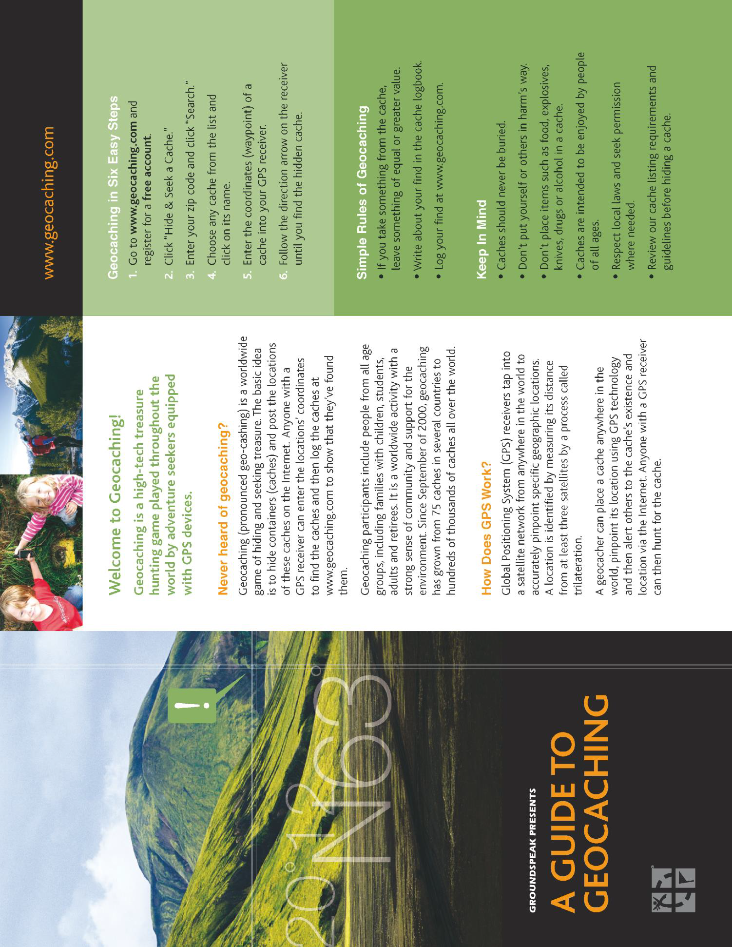

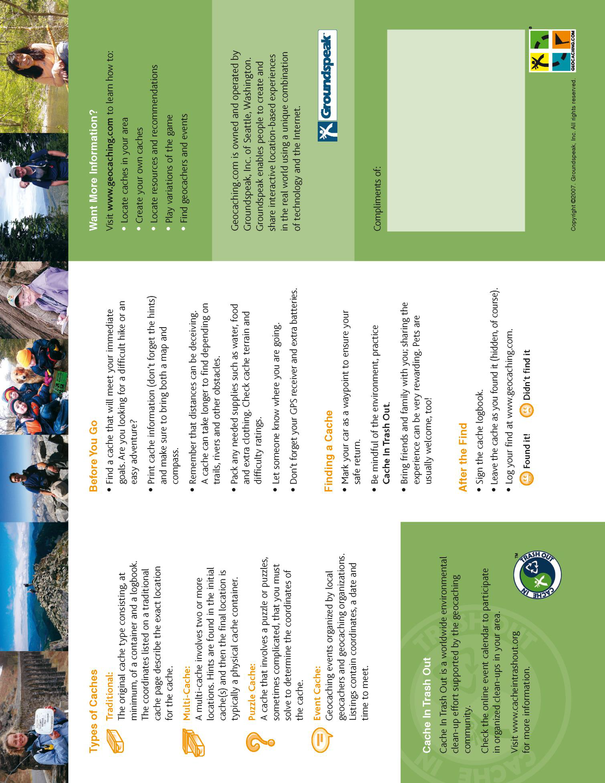

# Work Sheet

**Task 1: What is Geocaching?**

Answer:

**______________________________________________________**

**Task 2: What do the initials GPS stand for?**

Answer:

**______________________________________________________**

**Task 3: List the rules of Geocaching.**

Answer:

**______________________________________________________**

**Task 4: Who can be a Geocacher?**

Answer:

**______________________________________________________**

**Task 5: What is trilateration?**

Answer:

**______________________________________________________**

**Task 6: Name two ways a Geocacher could use a GPS.**

Answer:

**______________________________________________________**

**Task 7: Why would it be important to let someone else know where you are going when Geocaching?**

Answer:

**______________________________________________________**

**Task 8: In your opinion, what are some benefits of Geocaching? Describe two or three benefits in at least three sentences.**

Answer:

**______________________________________________________**

# Answers

**Task 1: What is Geocaching?**

Answer: Geocaching is a high-tech treasure hunting game played throughout the world by adventure seekers equipped with GPS devices.

**Task 2: What do the initials GPS stand for?**

Answer: Global Positioning System

**Task 3: List the rules of Geocaching.**

Answer:

• If you take something from the cache, leave something of equal or greater value

• Write about your find in the cache logbook

• Log your find at www.geocaching.com

**Task 4: Who can be a Geocacher?**

Answer: Geocaching participants include people from all age groups, including families with children, students, adults and retirees.

**Task 5: What is trilateration?**

Answer: When a location is identified by measuring its distance from at least three satellites.

**Task 6: Name two ways a Geocacher could use a GPS.**

Answer: Any two of

* Enter the geocaches coordinates to find or hunt for the cache
* Enter the geocache coordinates when you are hiding a cache
* For marking your car as a waypoint

**Task 7: Why would it be important to let someone else know where you are going when Geocaching?**

Answer: Answers will vary, but they should be about safety.

**Task 8: In your opinion, what are some benefits of Geocaching? Describe two or three benefits in at least three sentences.**

Answers will vary, but may include

* A sense of community and belonging with other people who participate
* Opportunity to socialize and try something new
* Exercise and outdoor time
* Opportunity to explore new places
* Opportunity to learn about now to navigate with a GPS

# Performance Descriptors

| Levels | Performance Descriptors | Needs Work | Completes task with support from practitioner | Completes task independently |
| --- | --- | --- | --- | --- |
| A1.2 | scans text to locate information |  |  |  |
|  | locates multiple pieces of information in simple texts |  |  |  |
|  | makes low-level inferences |  |  |  |
|  | makes connections between sentences and between paragraphs in a single text |  |  |  |
|  | reads more complex texts to locate a single piece of information |  |  |  |
|  | follows the main events of descriptive, narrative and informational texts |  |  |  |
|  | obtains information from detailed reading |  |  |  |
| B2.2 | writes texts to explain and describe |  |  |  |
|  | begins to sequence writing with some attention to  principles (e.g. time, importance) |  |  |  |
|  | uses limited range of vocabulary and punctuation appropriate to the task |  |  |  |
|  | begins to select words and tone appropriate to the task |  |  |  |
| B2.2 cont’d | begins to organize writing to communicate effectively |  |  |  |

This task: Was successfully completed Needs to be tried again

Learner Comments:

Instructor (print): Learner (print):

**__________________ _________________**