

Task Title: Read a Schedule for Information

OALCF Cover Sheet – Practitioner Copy

Learner Name: __________________________________________
Date Started: ___________________________________________
Date Completed: _________________________________________

Goal Path: | Employment | Apprenticeship
Secondary School | Post Secondary | Independence
Successful Completion: Yes No

Task Description: The learner will read a grocery store sign and schedule and answer questions.
Main Competency/Task Group/Level Indicator:
- Find and Use Information/Interpret documents/A2.1
- Communicate Ideas and Information/Write continuous text/B2.1
- Understand and Use Numbers/Manage time/C2.1
Materials Required:
- Pen/pencil and paper and/or digital device

Learner Information
People need to read schedules for many different reasons. Stores, libraries, schools, movies and TV Guides all have schedules that give you information.

Read the schedule for Big John’s Supermarket.

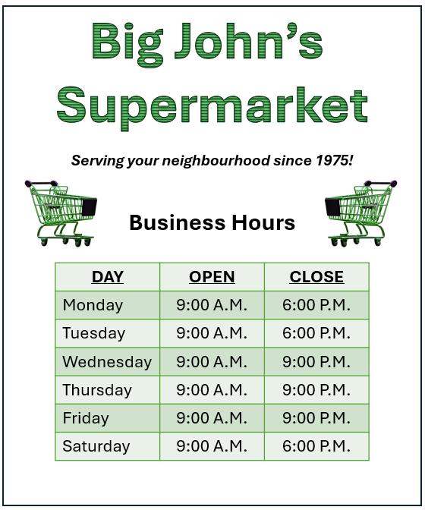

Work Sheet
Task 1: What is the purpose of this document?
Answer:
______________________________________________________
Task 2: What time does the store open on Tuesday?
Answer:
______________________________________________________
Task 3: Is the store open at 7:30 p.m. on Thursday?
Answer:
______________________________________________________
Task 4: What time does the store close on Monday?
Answer:
______________________________________________________
Task 5: How many days does the store stay open until 9:00 p.m.?
Answer:
______________________________________________________
Task 6: How many hours is the store open on Sunday?
Answer:
______________________________________________________
Task 7: When did Big John’s Supermarket come to the neighbourhood, and why do you think that is important information?
Answer:

______________________________________________________
Answers
Task 1: What is the purpose of this document?
Answer: to let customers know the days and hours the supermarket is open
______________________________________________________
Task 2: What time does the store open on Tuesday?
Answer: 9:00 a.m.
______________________________________________________
Task 3: Is the store open at 7:30 p.m. on Thursday?
Answer: Yes, the store is open until 9 p.m.
______________________________________________________
Task 4: What time does the store close on Monday?
Answer: 6:00 p.m.
______________________________________________________
Task 5: How many days does the store stay open until 9:00 p.m.?
Answer: 3
______________________________________________________
Task 6: How many hours is the store open on Sunday?
Answer: 0. The store is not open on Sunday.
______________________________________________________
Task 7: When did Big John’s Supermarket come to the neighbourhood, and why do you think that is important information?
Answer: 1975. This is important information because it lets customers know the store has been serving the community for a long time.
______________________________________________________

Performance Descriptors
Levels | Performance Descriptors | Needs Work | Completes task with support from practitioner | Completes task independently
A2.1 | scans to locate specific details
 | interprets brief text and common symbols
 | locates specific details in simple documents, such as labels and signs
B2.1 | writes simple texts to request, remind, or inform
 | conveys simple ideas and factual information
C2.1 | recognizes values in umber and word format
 | understands chronological order
 | interprets and represents time using whole numbers, decimals, and simple common fractions

This task: Was successfully completed Needs to be tried again

Learner Comments:

Instructor (print): Learner (print):
__________________ _________________

