

Task Title: Read Everyday Flyers 1

OALCF Cover Sheet – Practitioner Copy

Learner Name: __________________________________________
Date Started: ___________________________________________
Date Completed: _________________________________________

Goal Path: | Employment | Apprenticeship
Secondary School | Post Secondary | Independence
Successful Completion: Yes No

Task Description: The learner will read and interpret a Halloween Carnival flyer to answer questions.
Main Competency/Task Group/Level Indicator:
- Find and Use Information/Interpret documents/A2.1
- Communicate Ideas and Information/Write continuous text/B2.1
Materials Required:
- Pen/pencil and paper and/or digital device

Learner Information
Individuals receive flyers and invitations for parties and events.

Read the Halloween Flyer.

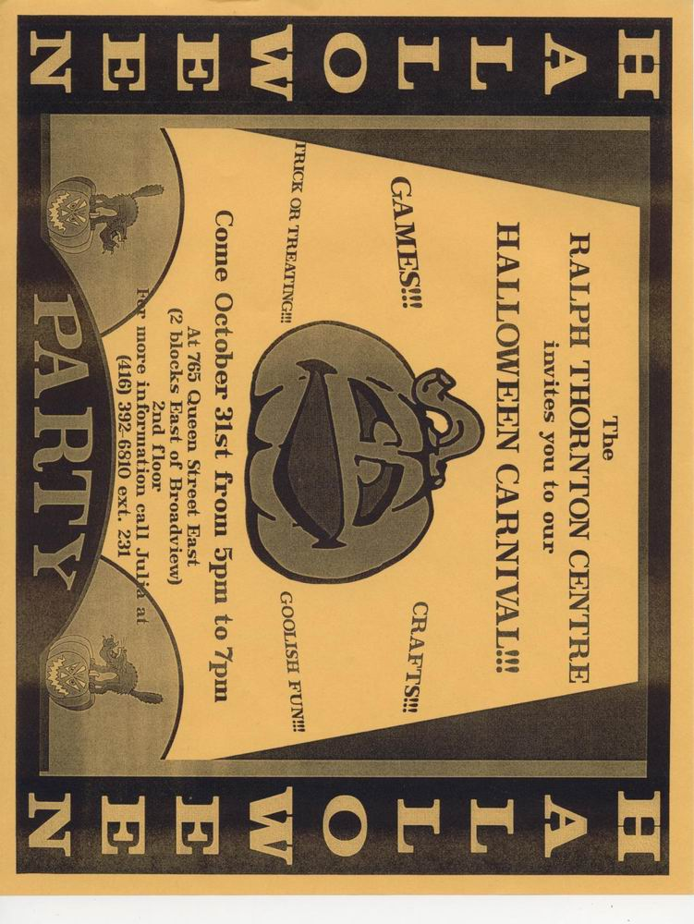
Halloween Flyer

Work Sheet
Task 1: What is the purpose of this flyer?
Answer:
______________________________________________________
Task 2: When is the party?
Answer:
______________________________________________________
Task 3: What time is the party being held?
Answer:
______________________________________________________
Task 4: Where is the party happening?
Answer:
______________________________________________________
Task 5: List two things a child can do at this party.
Answer:
______________________________________________________
Task 6: Community centres often have parties on Halloween night because they feel it is safer than going door-to-door. Do you feel it is unsafe for children to go door-to-door? Give 2 reasons for your answer.
Answer:

______________________________________________________
Answers
Task 1: What is the purpose of this flyer?
Answer: to give details about a Halloween Carnival and invite people to attend
______________________________________________________
Task 2: When is the party?
Answer: October 31
______________________________________________________
Task 3: What time is the party being held?
Answer: from 5 pm to 7 pm
______________________________________________________
Task 4: Where is the party happening?
Answer: the Ralph Thornton Centre, learner may include address (765 Queen Street East)
______________________________________________________
Task 5: List two things a child can do at this party.
Answer: any two of; games, crafts, trick or treating, goolish fun
______________________________________________________
Task 6: Community centres often have parties on Halloween night because they feel it is safer than going door-to-door. Do you feel it is unsafe for children to go door-to-door? Give 2 reasons for your answer.
Answer: Answers will vary.

______________________________________________________

Performance Descriptors
Levels | Performance Descriptors | Needs Work | Completes task with support from practitioner | Completes task independently
A2.1 | Scans to locate specific details
 | Interprets brief text and common symbols
 | Locates specific details in simple documents, such as labels and signs
 | Identifies how lists are organized (e.g. sequential, chronological, alphabetical
B2.1 | Conveys simple ideas and factual information
 | Uses sentence structure, upper and lower case, and basic punctuation
 | Uses highly familiar vocabulary

This task: Was successfully completed Needs to be tried again

Learner Comments:

Instructor (print): Learner (print):

__________________ _________________

