

Task Title: Read Everyday Flyers 2

OALCF Cover Sheet – Practitioner Copy

Learner Name: __________________________________________
Date Started: ___________________________________________
Date Completed: _________________________________________

Goal Path: | Employment | Apprenticeship
Secondary School | Post Secondary | Independence
Successful Completion: Yes No

Task Description: The learner will read a holiday hours flyer to answer questions.
Main Competency/Task Group/Level Indicator:
- Find and Use Information/Interpret documents/A2.1
- Communicate Ideas and Information/Write continuous text/B2.1
- Understand and Use Numbers/Manage time/C2.1
Materials Required:
- Pen/pencil and paper and/or digital device

Learner Information
Individuals receive flyers from stores at Christmas time to let them know about changes in store hours.

Read the “Holiday Hours Flyer”.

Holiday Hours Flyer
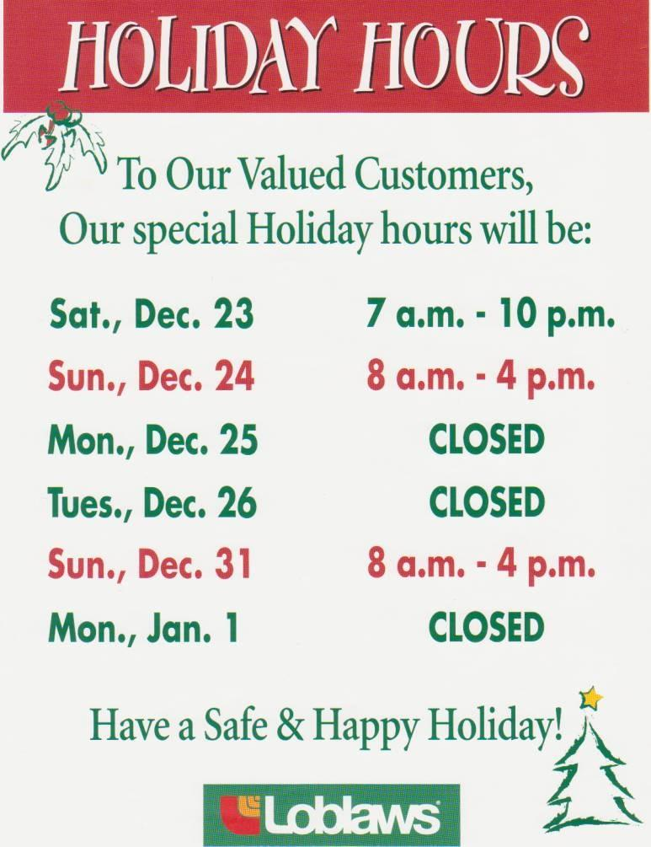
Work Sheet
Task 1: What is the purpose of this flyer?
Answer:
______________________________________________________
Task 2: Name the store this flyer is from.
Answer:
______________________________________________________
Task 3: What dates is the store closed?
Answer:
______________________________________________________
Task 4: What day is the store opened the latest?
Answer:
______________________________________________________
Task 5: What are the store hours on December 31?
Answer:
______________________________________________________
Task 6: Do you feel the store should be closed at 4:00 p.m. on December 31 or stay open later? Give at least one reason for your answer.
Answer:

______________________________________________________
Answers
Task 1: What is the purpose of this flyer?
Answer: to let customers know the hours Loblaws will be open over Christmas
______________________________________________________
Task 2: Name the store this flyer is from.
Answer: Loblaws
______________________________________________________
Task 3: What dates is the store closed?
Answer: December 25 and 26 and January 1 _____________________________________________________
Task 4: What day is the store opened the latest?
Answer: Saturday, December 23
______________________________________________________
Task 5: What are the store hours on December 31?
Answer: 8 a.m. to 4 p.m.
______________________________________________________
Task 6: Do you feel the store should be closed at 4:00 p.m. on December 31 or stay open later? Give at least one reason for your answer.
Answer: Answers will vary.

______________________________________________________

Performance Descriptors
Levels | Performance Descriptors | Needs Work | Completes task with support from practitioner | Completes task independently
A2.1 | Scans to locate specific details
 | Interprets brief text and common symbols
 | Locates specific details in simple documents, such as labels and signs
 | Identifies how lists are organized (e.g. sequential, chronological, alphabetical
B2.1 | Conveys simple ideas and factual information
 | Uses sentence structure, upper and lower case, and basic punctuation
 | Uses highly familiar vocabulary
C2.1 | Understands and uses common date formats
 | Interprets and represents time using whole numbers, decimals and simple common fractions

This task: Was successfully completed Needs to be tried again

Learner Comments:

Instructor (print): Learner (print):

__________________ _________________

