

Task Title: Read Everyday Flyers 3

OALCF Cover Sheet – Practitioner Copy

Learner Name: __________________________________________
Date Started: ___________________________________________
Date Completed: _________________________________________

Goal Path: | Employment | Apprenticeship
Secondary School | Post Secondary | Independence
Successful Completion: Yes No

Task Description: The learner will read a memo from their child’s school, answer questions and fill out a permission form.
Main Competency/Task Group/Level Indicator:
- Find and Use Information/Interpret documents/A2.1
- Communicate Ideas and Information/Create and complete forms/B3.1a
Materials Required:
- Pen/pencil and paper and/or digital device

Learner Information
Individuals receive memos/flyers from schools informing them of events and asking for permission for their child to attend.
Read the “Pizza Party Memo and Permission Form”.

Pizza Party Memo and Permission Form
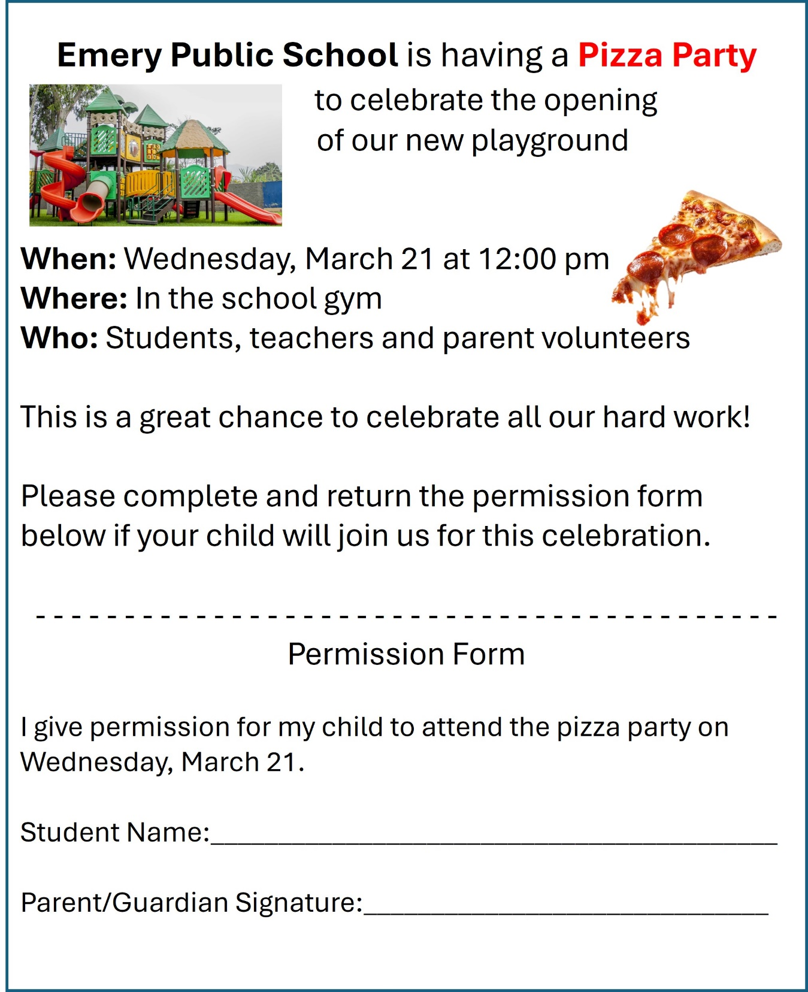
Work Sheet
Task 1: What is the purpose of this memo?
Answer:
______________________________________________________
Task 2: What is the school celebrating?
Answer:
______________________________________________________
Task 3: Where is the celebration taking place?
Answer:
______________________________________________________
Task 4: You have a child at the school and agree to let him join the party. Complete the permission form.
Answer: No response required here.

Task completed: Yes

____________________________________________________

Answers
Task 1: What is the purpose of this memo?
Answer: to invite students, teachers and parent volunteers to a school pizza party and to collect the names of students who plan to attend
______________________________________________________
Task 2: What is the school celebrating?
Answer: the completion of their new playground
______________________________________________________
Task 3: Where is the celebration taking place?
Answer: in the school gym
______________________________________________________
Task 4: You have a child at the school and agree to let him join the party. Complete the permission form.
Answer: Permission form at the bottom of the memo should be completed. Learner may use a fictitious name if desired.
______________________________________________________

Performance Descriptors
Levels | Performance Descriptors | Needs Work | Completes task with support from practitioner | Completes task independently
A2.1 | Scans to locate specific details
 | Interprets brief text and common symbols
 | Locates specific details in simple documents, such as labels and signs
 | Identifies how lists are organized (e.g. sequential, chronological, alphabetical
B3.1a | Makes a direct match between what is requested and what is entered

This task: Was successfully completed Needs to be tried again
Learner Comments:

Instructor (print): Learner (print):

__________________ _________________

