

Task Title: Read a Mall Directory

# OALCF Cover Sheet – Practitioner Copy

**Learner Name: __________________________________________**

**Date Started: ___________________________________________**

**Date Completed: _________________________________________**

|  |  |  |
| --- | --- | --- |
| **Goal Path:** | Employment | Apprenticeship |
| Secondary School | Post Secondary | Independence |

**Successful Completion:**  Yes No

**Task Description:** The learner will plan a shopping trip based on a mall layout, list of stores, and tasks to be accomplished.

**Main Competency/Task Group/Level Indicator:**

* Find and Use Information/Interpret documents/A2.2
* Communicate Ideas and Information/Complete and create documents/B3.2a
* Understand and Use Numbers/Manage time/C2.2
* Manage Learning/E.1

**Materials Required:**

* Pen/pencil and paper and/or digital device

# Learner Information

When going to a mall, you may want to plan your route so you can manage your time and efficiently go to multiple stores.

Scan the “Shopping Mall Directory” and “Store Directory” for Yourtown Shopping Mall.

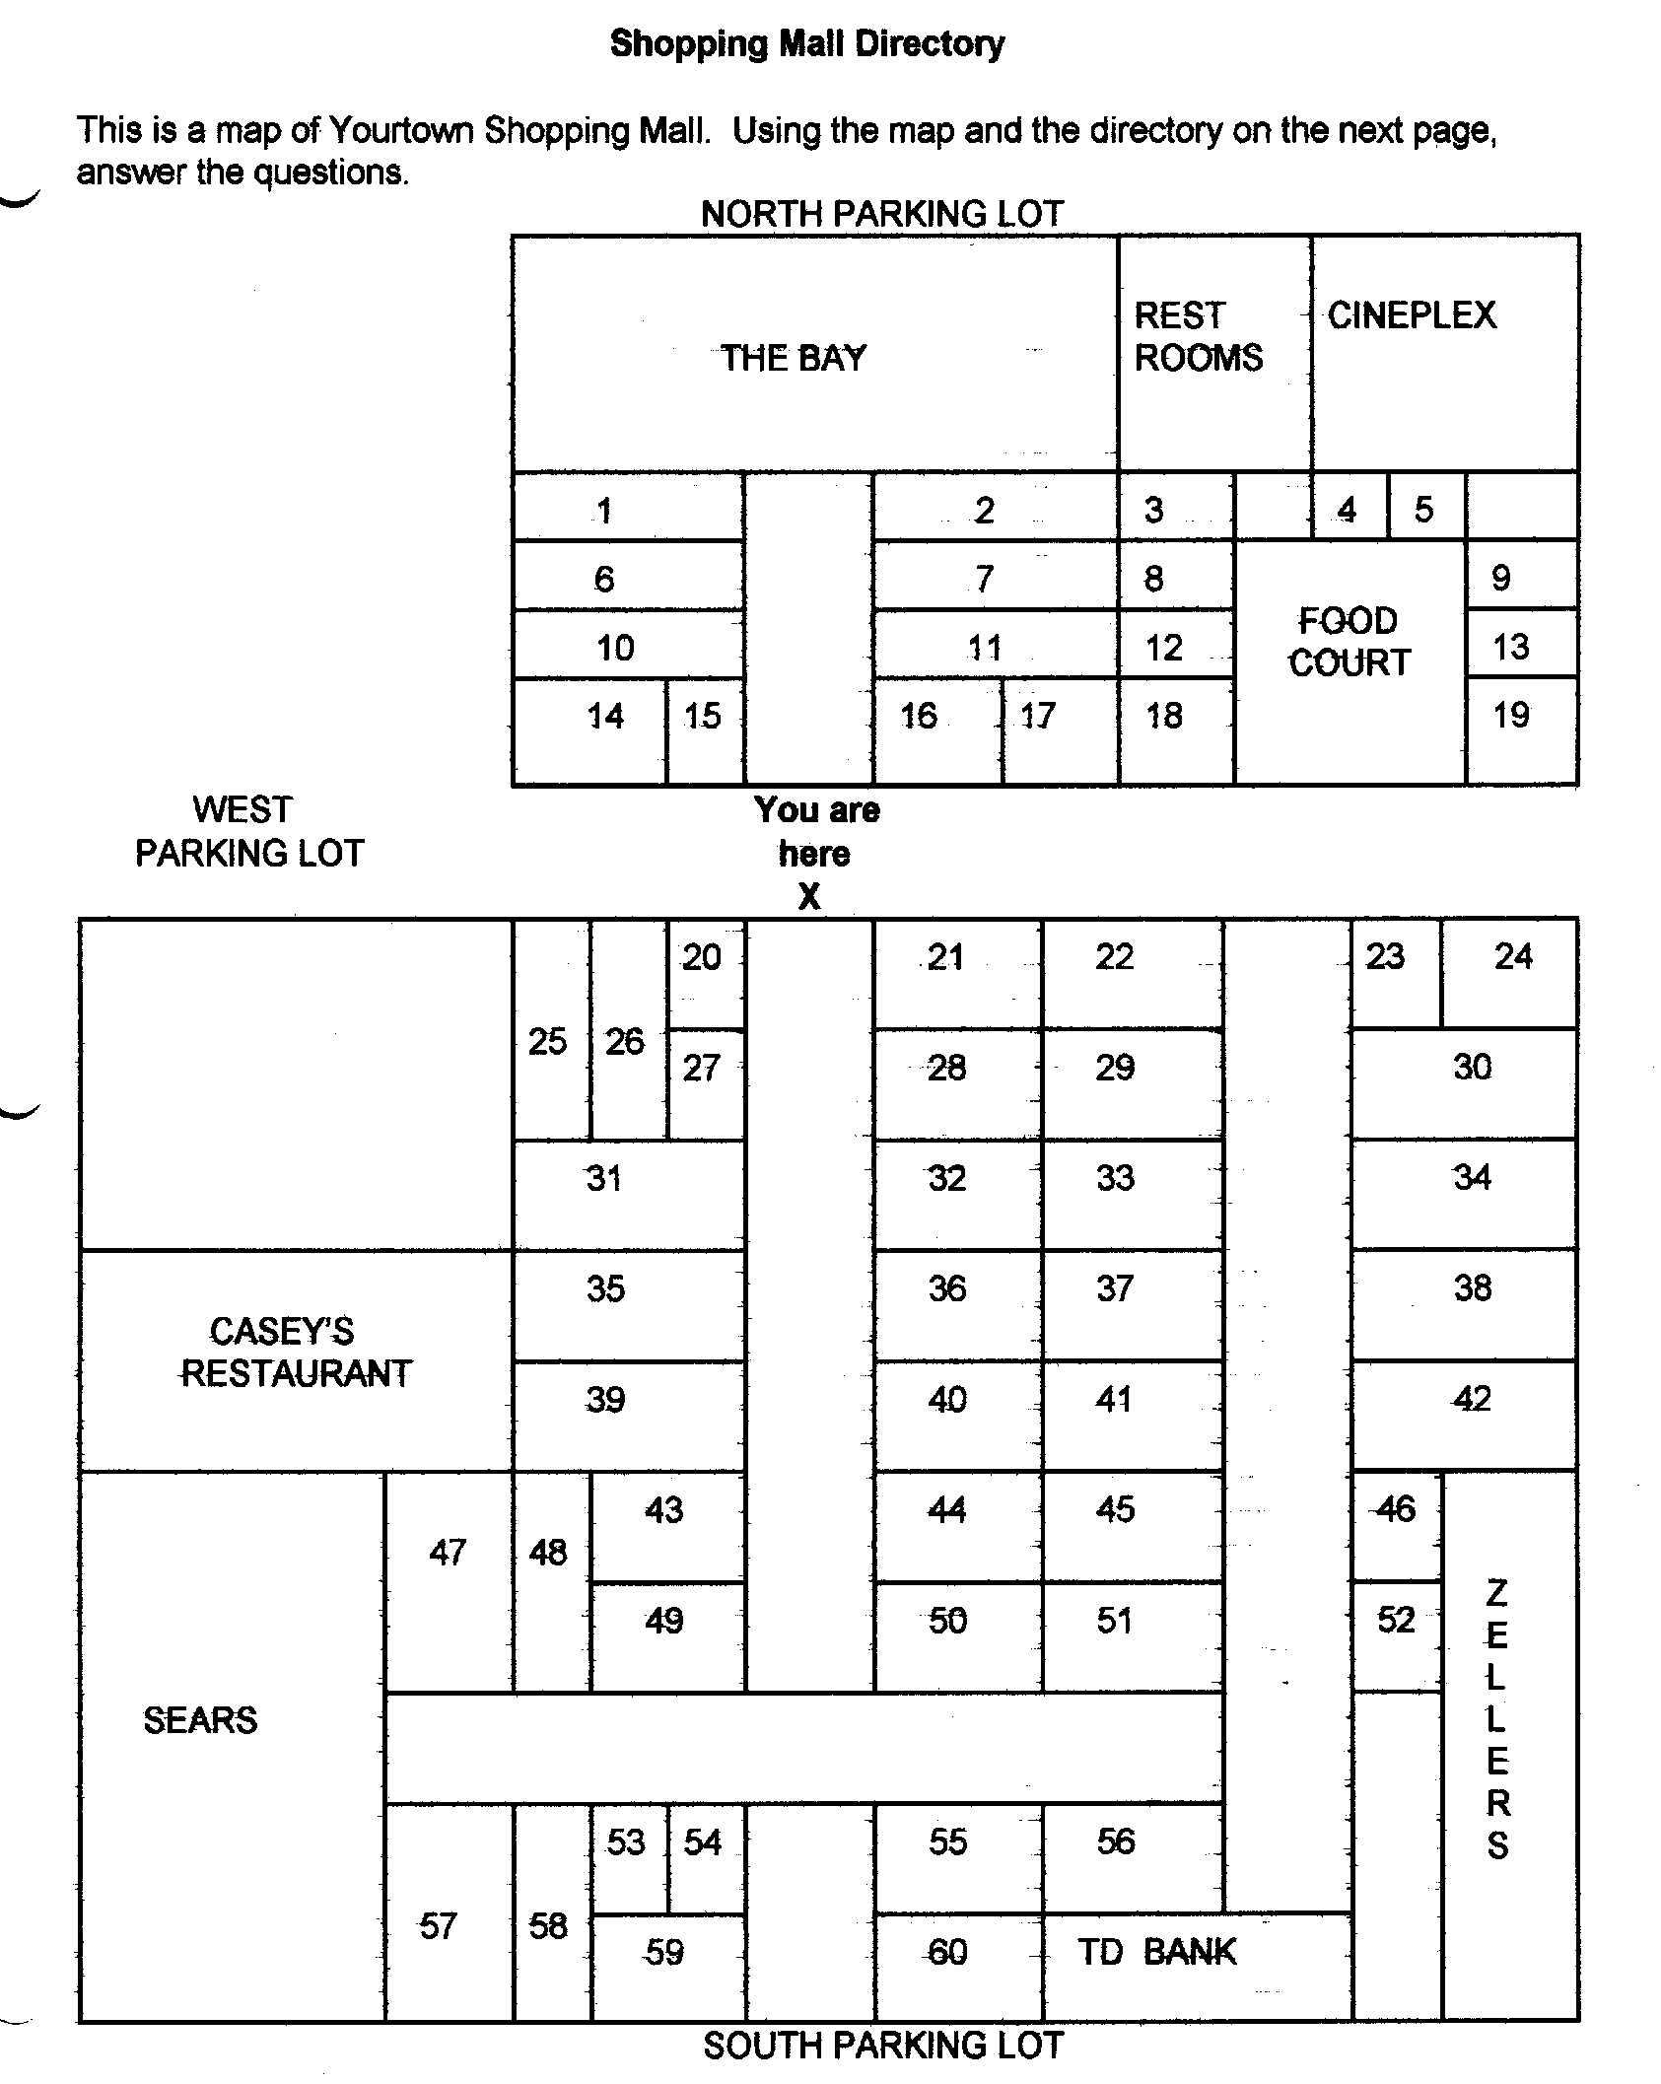

**Store Directory**

**Specialty Stores:**

The Body Shop 23

Dufferin Games 32

Fabric Land 30

Grand & Toy Stationery 38

Pet Paradise 55

Shopper’s Drug Mart 47

**Food:**

A & W 13

Baskin Robbins 19

Bulk Barn 60

Casey’s Restaurant

China Wok 4

Coffee Time 59

Cultures 9

Kentucky Fried Chicken 12

Laura Secord Candy 20

Marvellous Muffins 18

New York Fries 3

Pita Pizzazz 8

Pizza Hut 5

Second Cup Coffee 24

**Household:**

Dollar Store 6

Living Lighting 14

Pot Pourri 51

**Jewellery:**

Ardene’s 53

People’s Jewellers 16

**Ladies Wear:**

Alia 36

Au Coton 58

Bootlegger 50

Cleo’s 29

Cotton Ginny 26

Fairweather 35

Fran’s Lingerie 46

Laura’s Dress Shop 34

Northern 31

Reitman’s 17

Ricki’s 28

Smart Set 41

Suzy Shier 56

Tabi 11

The Gap 39

**Men’s Wear:**

Bootlegger 50

Grafton’s 37

Jack Fraser 44

Northern 31

Tip Top 21

**Shoes:**

Agnew Shoes 1

Naturalizer 25

**Sports:**

Champs 42

Sport Chek 57

**Bookstores:**

Coles Bookstore 43

WH Smith Bookstore 33

Newstand 54

**Cards, Gifts:**

Browser’s Nook 27

Carlton Cards 15

Dollar Store 6

It Store 52

**Children’s Wear:**

Disney Store 49

The Gap–Kids 39

Young Canada 45

**Department Stores:**

The Bay

Sears

Zellers

**Electronics:**

Bell Telephone Store 2

Black’s Camera 22

Jumbo Video 7

Music World 10

Radio Shack 40

Sam The Record Man 48

# Work Sheet

**Task 1: List the stores you would visit if you wanted to:**

* **look at digital cameras at an electronics store**
* **purchase a desk lamp**
* **buy a box of chocolates**
* **buy a child’s game**
* **buy a man’s tie**
* **buy a new pair of running shoes**
* **buy a birthday card.**

Answer:

**______________________________________________________**

**Task 2: Circle the stores you would like to visit on the “Shopping Mall Directory”.**

Answer: No response required here.

Task completed: Yes No

**______________________________________________________**

**Task 3: Plan your route by drawing lines between the stores you will visit, starting and ending at the “You are Here X” point in the map. If possible, you want to find the shortest route between all the stores. You do not want to walk back and forth through the mall multiple times.**

Answer: No response required here.

Task completed: Yes No

**______________________________________________________**

**Task 4: You plan to arrive at the mall at 9am. It will take 5 minutes to walk from the parking lot to the first store. You want to spend 10 minutes in each store. It will take approximately 5 minutes to walk from one store to the next. What time will you finish your shopping and return to your car?**

Answer:

**______________________________________________________**

**Task 5: Complete the Learner Self-Evaluation below.**

Learner Self- Evaluation

I understand how the directory is organized. Yes  No 

I could read the names of the stores easily. Yes  No 

I found my way around the map easily. Yes  No 

I now know how to find a particular store when I go shopping. Yes  No 

I will feel much more comfortable when I go to the mall. Yes  No 

Other Comments:

**______________________________________________________**

# Answers

**Task 1: List the stores you would visit if you wanted to:**

* **look at digital cameras at an electronics store**
* **purchase a desk lamp**
* **buy a box of chocolates**
* **buy a child’s game**
* **buy a man’s tie**
* **buy a new pair of running shoes**
* **buy a birthday card.**

Answers will vary. The learner should select a store from each of the categories that matches each product.

**Task 2: Circle the stores you would like to visit on the “Shopping Mall Directory”.**

Answers will vary but should match the list of stores given in Task 1.

**Task 3: Plan your route by drawing lines between the stores you will visit, starting and ending at the “You are Here X” point in the map. If possible, you want to find the shortest route between all the stores. You do not want to walk back and forth through the mall multiple times.**

Answers will vary. The route selected should be straightforward and connect all the stores the learner has identified.

**Task 4: You plan to arrive at the mall at 9am. It will take 5 minutes to walk from the parking lot to the first store. You want to spend 10 minutes in each store. It will take approximately 5 minutes to walk from one store to the next. What time will you finish your shopping and return to your car?**

Answers will vary depending on the route the learner has chosen. A sample timeline is as follows. Based on the time requirements, the learner should arrive at their car at 11am.

9:00am-9:05am: walk from parking lot to first store

9:05am-9:15am: Look for digital camera at electronics store

9:15am-9:20am: Walk from electronics store to lighting store

9:20am-9:30am: Look for desk lamps

9:30am-9:35am: Walk from lamp store to chocolate store

9:35am-9:45am: Look for chocolates

9:45am-9:50am: walk from chocolate store to toy store

9:50am-10:00am: look at toys

10:00am-10:05am: walk from toy store to clothing store

10:05am-10:15am: look for tie

10:15am-10:20am: walk from clothing store to sport store

10:20am-10:30am: look for running shoes

10:30am-10:35am: walk from sport store to card store

10:35am-10:45am: look at birthday cards

10:45am-11:00am: walk from card store to parking lot

Arrive at car at approximately 11:00am

**Task 5: Complete the Learner Self-Evaluation below.**

Answers will vary.

# Performance Descriptors

| Levels | Performance Descriptors | Needs Work | Completes task with support from practitioner | Completes task independently |
| --- | --- | --- | --- | --- |
| A2.2 | performs limited searches using one or two search criteria |  |  |  |
|  | extracts information from tables and forms |  |  |  |
|  | locates information in simple graphs and maps |  |  |  |
|  | uses layout to locate information |  |  |  |
|  | makes connections between parts of documents |  |  |  |
|  | makes low-level inferences |  |  |  |
|  | begins to identify sources and evaluate information |  |  |  |
| B3.2a | uses layout to determine where to make entries |  |  |  |
|  | begins to make some inferences to decide what information is needed, where and how to enter the information |  |  |  |
| C2.2 | makes simple estimates |  |  |  |
| E.1 | begins to monitor own learning |  |  |  |

This task: Was successfully completed Needs to be tried again

Learner Comments:

Instructor (print): Learner (print):

**__________________ _________________**