

Task Title: Reading a Community Organization Update

# OALCF Cover Sheet – Practitioner Copy

**Learner Name: __________________________________________**

**Date Started: ___________________________________________**

**Date Completed: _________________________________________**

| **Goal Path:** | Employment | Apprenticeship |
| --- | --- | --- |
| Secondary School | Post Secondary | Independence |

**Successful Completion:**  Yes No

**Task Description:** The learner will read an annual update from a community organization and answer questions about programs offered.

**Main Competency/Task Group/Level Indicator:**

* Find and Use Information/Read continuous text/A1.2

**Materials Required:**

* Pen/pencil and paper and/or digital device

# Learner Information

Non-profit organizations offer a variety of community services. They frequently provide updates about how often resources are used and where there might be additional needs.

Scan the excerpt from “2024 A Year in Review – Safe’n’Sound”.

**2024 A Year in Review – Safe’n’Sound** 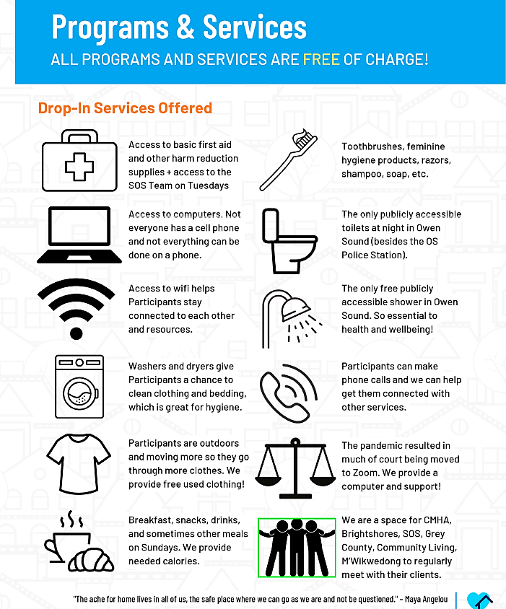

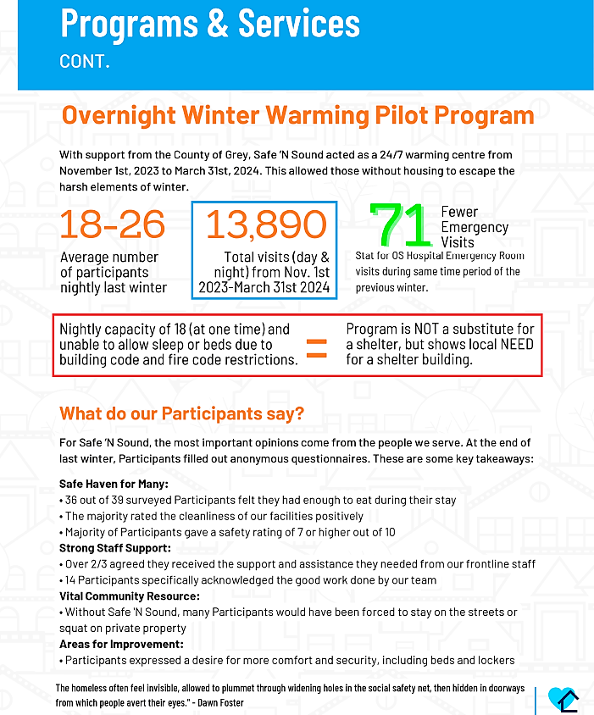

# Work Sheet

**Task 1: List six (6) drop-in services that are provided by Safe’n’Sound.**

Answer:

**______________________________________________________**

**Task 2: Which organizations use Safe’n’Sound to meet with their clients?**

Answer:

**______________________________________________________**

**Task 3: How many visits were there between November 1, 2024 and March 31, 2024 during the overnight winter warming pilot program?**

Answer:

**______________________________________________________**

**Task 4: When surveyed, what did participants suggest for improving the winter warming pilot program?**

Answer:

**______________________________________________________**

# Answers

**Task 1: List six (6) drop-in services that are provided by Safe’n’Sound.**

Answer: Any 6 of:

* First aid and harm reduction supplies
* Access to computers
* Access to wifi
* Access to washers and dryers
* Clothing
* Food
* Hygiene products
* Public toilet access at night
* Public shower access
* Phones
* Support for zoom calls (court support)
* Meeting space for clients to connect with other agencies (e.g. CMHA)

**Task 2: Which organizations use Safe’n’Sound to meet with their clients?**

Answer: CMHA, Brightshores, SOS, Grey County, Community Living, M’Wikwedong

**Task 3: How many visits were there between November 1 2024 and March 31 2024 during the overnight winter warming pilot program?**

Answer: 13,890 total visits (including daytime)

**Task 4: When surveyed, what did participants suggest for improving the winter warming pilot program?**

Answer: Participants expressed a desire for more comfort and security, including beds and lockers

# Performance Descriptors

| Levels | Performance Descriptors | Needs Work | Completes task with support from practitioner | Completes task independently |
| --- | --- | --- | --- | --- |
| A1.2 | scans text to locate information |  |  |  |
|  | locates multiple pieces of information in simple texts |  |  |  |
|  | makes low-level inferences |  |  |  |
|  | makes connections between sentences and between paragraphs in a single text |  |  |  |
|  | reads more complex texts to locate a single piece of information |  |  |  |
|  | follows the main events of descriptive, narrative and informational text |  |  |  |
|  | obtains information from detailed reading |  |  |  |
|  | begins to identify sources and evaluate information |  |  |  |



This task: Was successfully completed Needs to be tried again

Learner Comments:

Instructor (print): Learner (print):

**__________________ _________________**