

Task Title: Reading a Medicine Dosage Chart

# OALCF Cover Sheet – Practitioner Copy

**Learner Name: __________________________________________**

**Date Started: ___________________________________________**

**Date Completed: _________________________________________**

|  |  |  |
| --- | --- | --- |
| **Goal Path:** | Employment | Apprenticeship |
| Secondary School | Post Secondary | Independence |

**Successful Completion:**  Yes No

**Task Description:** The learner will interpret a medicine dosage chart to determine the correct dosage and time it should be given.

**Main Competency/Task Group/Level Indicator:**

* Find and Use Information/Interpret documents/A2.2
* Understand and Use Numbers/Manage time/C2.2

**Materials Required:**

* Pen/pencil and paper and/or digital device

# Learner Information

Tylenol® is the name brand for a medicine called Acetaminophen. It can be taken to help relieve pain from colds, headaches, and muscle aches. It can also be used to help reduce a fever.

You are looking after your friend’s child for the afternoon. You notice that the child has a mild fever. You call your friend on the phone and she says it’s ok to give the child Tylenol®.

Scan the “Tylenol® Dosage Chart”.

**Tylenol Dosage Chart**

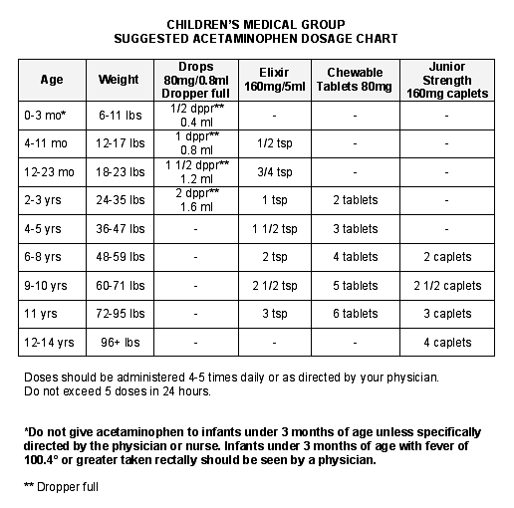

# Work Sheet

**Task 1: The child is 4 years old and weighs 40 pounds. List the types of Tylenol and the doses of each that you could give this child.**

Answer:

**______________________________________________________**

**Task 2: You give the child the first dose of medicine at 4:30pm. What time could you give the next dose?**

Answer:

**______________________________________________________**

**Task 3: What is the maximum number of doses you can give the child in a day (24 hours)?**

Answer:

**______________________________________________________**

# Answers

**Task 1: The child is 4 years old and weighs 40 pounds. List the types of Tylenol and the doses of each that you could give this child.**

Answer: 1 ½ tsp of Elixir (160mg/5ml); 3 Chewable Tablets (80mg)

**Task 2: You give the child the first dose of medicine at 4:30pm. What time could you give the next dose?**

Answer: Between 9:30pm and 10:30pm (4.8 (5) - 6 hours after the first dose)

**Task 3: What is the maximum number of doses you can give the child in a day (24 hours)?**

Answer: Maximum 5 doses in 24 hours

# Performance Descriptors

| Levels | Performance Descriptors | Needs Work | Completes task with support from practitioner | Completes task independently |
| --- | --- | --- | --- | --- |
| A2.2 | performs limited searches using one or two search criteria |  |  |  |
|  | extracts information form tables and forms |  |  |  |
|  | uses layout to locate information |  |  |  |
|  | makes connections between parts of documents |  |  |  |
|  | makes low-level inferences |  |  |  |
| C2.2 | converts between units of time (e.g. hours and days) |  |  |  |
|  | makes simple estimates |  |  |  |
|  | interprets, represents and converts time using whole numbers, decimals, percentages, ratios and simple, common fractions |  |  |  |
|  | chooses and performs required operation(s); may make inferences to identify required operation(s) |  |  |  |
|  | selects appropriate steps to reach solutions |  |  |  |

This task: Was successfully completed Needs to be tried again

Learner Comments:

Instructor (print): Learner (print):

**__________________ _________________**