

Task Title: Reading a Store Flyer

OALCF Cover Sheet – Practitioner Copy

Learner Name: __________________________________________
Date Started: ___________________________________________
Date Completed: _________________________________________

Goal Path: | Employment | Apprenticeship
Secondary School | Post Secondary | Independence
Successful Completion: Yes No

Task Description: The learner will read and interpret a store flyer, answer questions orally and follow instructions.
Main Competency/Task Group/Level Indicator:
- Find and Use Information/Interpret documents/A2.1
- Communicate Ideas and Information/Complete and create documents/B3.1a
- Understand and Use Numbers/Manage money/C1.1
Materials Required:
- Pen/pencil and paper and/or digital device
- Bills ($5 and $10) and coins ($.05, $.10, $.25, $1, $2)

Notes for Instructors/Practitioners
Give your learner a selection of bills and coins they can use to “buy” items in the flyer. After they have had a chance to review the flyer, ask them orally the questions listed below.
Note: The flyer indicates that all items are tax free, so the learner does not need to calculate tax. However, you may wish to discuss rounding to the nearest 0.05 (to account for no pennies when paying with cash) if your learner is not yet familiar with this.

Questions to Ask Learners
Task 1: What is the purpose of this flyer?

Task 2: Most flyers have a start and end date. What are the start and end dates for this sale?

Task 3: You would like to buy one package of Great Company Coffee Pods. Using the coins, show how much money you would need to give to the clerk to pay for it. Will you get any change back? If yes, show approximately how much change you will get back.

Task 4: Use the “Pharmasave Shopping Information” chart as your shopping list and write the price beside each item as given in the flyer.

Learner Information
Reviewing a flyer before going to a store can help you save money by purchasing items on sale. When you pay with cash, it is important to estimate how much change you expect to receive.

Review the “Pharmasave Flyer” and the “Pharmasave Shopping Information”.
Your instructor will ask you questions you will answer orally.

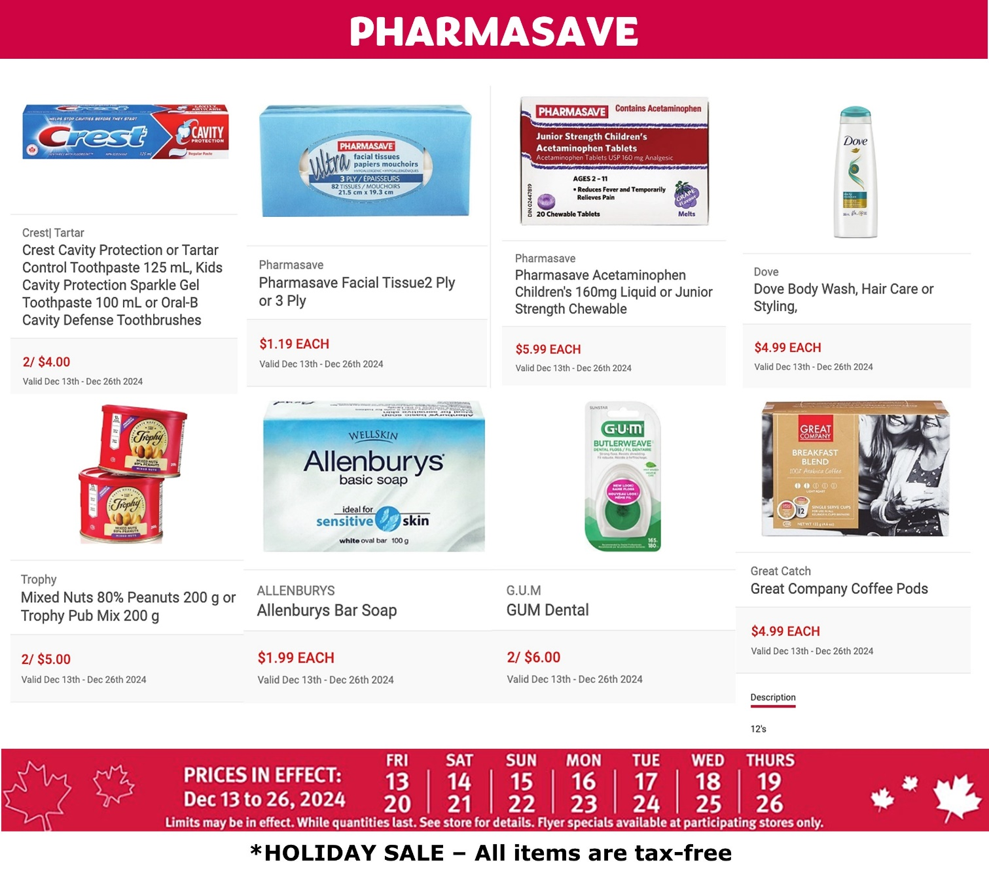
Pharmasave Flyer

Pharmasave Shopping Information

Item | Cost
Crest toothpaste

Allenburys bar soap

Dove bodywash

GUM dental floss

Trophy Mixed Nuts

Answers
Task 1: What is the purpose of this flyer?
Answer: to advertise sale items at Pharmasave during December.

Task 2: Most flyers have a start and end date. What are the start and end dates for this sale?
Answer: December 13 and December 26, 2024

Task 3: You would like to buy one package of Great Company Coffee Pods. Using the coins, show how much money you would need to give to the clerk to pay for it. Will you get any change back? If yes, show approximately how much change you will get back.
Answer: The item costs $4.99 The learner should count out at least $5 and estimate change accordingly.

Task 4: Use the “Pharmasave Shopping Information” chart as your shopping list and write the price beside each item as given in the flyer.
Answer:
Item | Cost
Crest toothpaste | 2/$4.00 (or $2.00 for one)
Allenburys bar soap | $1.99
Dove bodywash | $4.99
GUM dental floss | 2/$6.00 (or $3.00 for one)
Trophy Mixed Nuts | 2/$5.00 (or $2.50 for one)

Performance Descriptors
Levels | Performance Descriptors | Needs Work | Completes task with support from practitioner | Completes task independently
A2.1 | scans to locate specific details
 | interprets brief text and common symbols
 | locates specific details in simple documents such as labels and signs
B3.1a | makes a direct match between what is requested and what is entered
C1.1 | adds, subtracts, multiplies, and divides whole numbers and decimals
 | understands numerical order
 | identifies and performs required operation
 | interprets and represents costs using monetary symbols and decimals
 | rounds to nearest dollar
This task: Was successfully completed Needs to be tried again

Learner Comments:

Instructor (print): Learner (print):

__________________ _________________

