

Task Title: Select a Computer Desk

# OALCF Cover Sheet – Practitioner Copy

**Learner Name: __________________________________________**

**Date Started: ___________________________________________**

**Date Completed: _________________________________________**

|  |  |  |
| --- | --- | --- |
| **Goal Path:** | Employment | Apprenticeship |
| Secondary School | Post Secondary | Independence |

**Successful Completion:**  Yes No

**Task Description:** The learner will look at a flyer and choose a desk that will be big enough to hold a computer and a printer.

**Main Competency/Task Group/Level Indicator:**

* Understand and Use Numbers/Use measures/C3.1

**Materials Required:**

* Pen/pencil and paper and/or digital device
* Calculator or digital device with calculator function

# Learner Information

# Office Managers and administrative assistants may order office furniture for the workplace. Many people also order office furniture for home use. Before buying, purchasers must determine what size will meet workplace or home needs.

# Scan the “Staples Flyer Advertisements”.

# **Staples Flyer Advertisements**

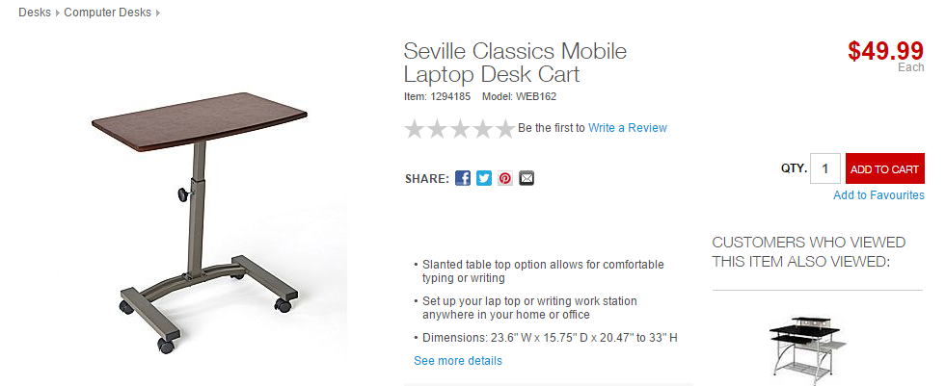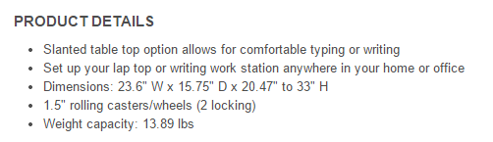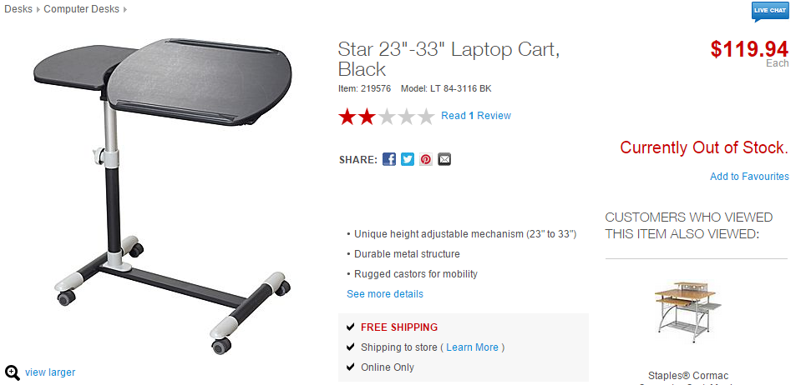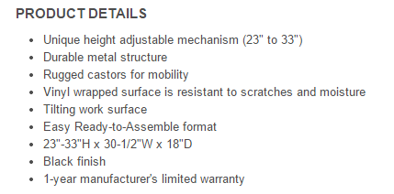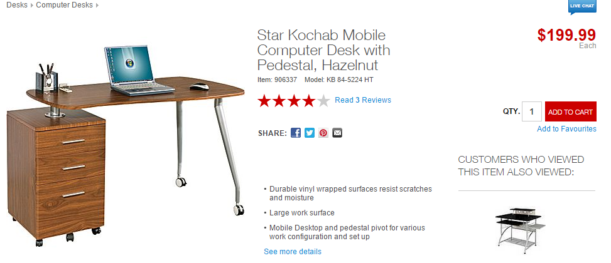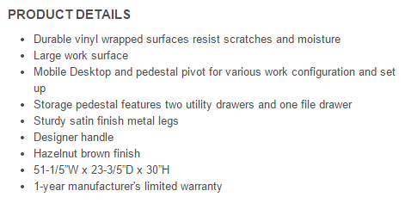

# Work Sheet

A mobile desk will be purchased from Staples. It must be large enough to hold both a laptop and a printer. The laptop is 15” wide, and the printer is 20” wide.

**Task 1: Calculate the minimum width that the desk must be, allowing 1” for clearance.**

Answer:

**______________________________________________________**

**Task 2: Circle the desk in the flyer that meets the width requirement.**

Answer: No written response required here.

Task completed: Yes: No:

**Task 3: The space where the desk will be set up is 48” wide, so the manager decides they will not put the printer on the desk. Which desk(s) can now be purchased?**

Answer:

**______________________________________________________**

# Answers

A mobile desk will be purchased from Staples. It must be large enough to hold both a laptop and a printer. The laptop is 15” wide, and the printer is 20” wide.

**Task 1: Calculate the minimum width that the desk must be, allowing 1” for clearance.**

Answer: 15 + 20 + 1 = 36”

**Task 2: Circle the desk in the flyer that meets the width requirement.**

Answer: The Star Kochab Mobile Computer desk should be circled.

**Task 3: The space where the desk will be set up is 48” wide, so the manager decides they will not put the printer on the desk. Which desk(s) can now be purchased?**

Answer: The Star Kochab cannot be purchased because it is too wide.

The two other desks (The Seville and The Star) can now be purchased because they only need 15” without the printer.

# Performance Descriptors

| Levels | Performance Descriptors | Needs Work | Completes task with support from practitioner | Completes task independently |
| --- | --- | --- | --- | --- |
| C3.1 | adds and subtracts whole number measurements |  |  |  |
|  | recognizes values in number and word format |  |  |  |
|  | identifies and performs required operation |  |  |  |
|  | interprets and represents measures using whole numbers, decimals and simple, common fractions (e.g. ½, ¼) |  |  |  |
|  | interprets and represents measures using symbols and abbreviations (e.g. inches as “, centimeters as cm, pounds as lbs, kilograms as kilos or kg) |  |  |  |
|  | follows apparent steps to reach solutions |  |  |  |
|  | uses strategies to check accuracy (e.g. estimating, using a calculator, repeating a calculation, using the reverse operation) |  |  |  |

This task: Was successfully completed Needs to be tried again

Learner Comments:

Instructor (print): Learner (print):

**__________________ _________________**