

Task Title: Shopping at Pharmasave

OALCF Cover Sheet – Practitioner Copy

Learner Name: __________________________________________
Date Started: ___________________________________________
Date Completed: _________________________________________

Goal Path: | Employment | Apprenticeship
Secondary School | Post Secondary | Independence
Successful Completion: Yes No

Task Description: The learner will review a flyer and calculate the total cost of various items at Pharmasave including sales tax.
Main Competency/Task Group/Level Indicator:
- Find and Use Information/Interpret documents/A2.1
- Communicate Ideas and Information/Manage money/C1.2
Materials Required:
- Pen/pencil and paper and/or digital device
- Calculator or digital device with calculator function

Learner Information
Reviewing store flyers and calculating the total cost of purchases in advance can help you track expenses and stay within your budget.
Review the Pharmasave flyer.

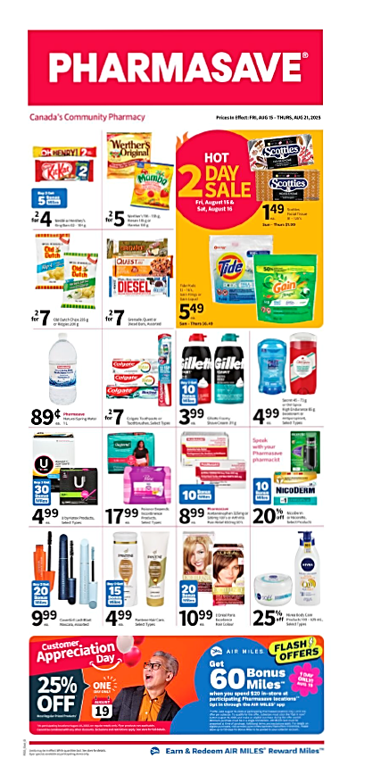

Work Sheet
Task 1: Calculate the total cost of
- 4 KitKat bars
- 4 bags of Old Dutch chips
These snack foods will have HST (13%) added to the price.
Answer:

______________________________________________________
Task 2: Calculate the total cost of
- 1 package of Tide pods
- 2 tubes of Colgate toothpaste
- 4 boxes of Scotties facial tissue
You are making your purchases on Saturday, August 16. These items will all have HST (13%) added to the price.
Answer:

______________________________________________________
Task 3: Calculate the total cost of two bottles of Acetaminophen. This item will have HST (13%) added to the price.
Answer:

______________________________________________________
Task 4: Calculate the total cost of all purchases in Tasks 1, 2, and 3.
Answer:

______________________________________________________

Answers
Task 1: Calculate the total cost of
- 4 KitKat bars
- 4 bags of Old Dutch chips
These snack foods will have HST (13%) added to the price.
Answer:
$8.00 +$14.00 = $22.00
$22.00 x 0.13 = $2.86
$22.00 + $2.86 = $24.86

Task 2: Calculate the total cost of
- 1 package of Tide pods
- 2 tubes of Colgate toothpaste
- 4 boxes of Scotties facial tissue
You are making your purchases on Saturday, August 16. These items will all have HST (13%) added to the price.
Answer:
$5.49 + $7.00 + $5.96 = $18.45
$18.45 x 0.13 = $2.40
$18.45 + $2.40 = $20.85

Task 3: Calculate the total cost of two bottles of Acetaminophen. This item will have HST (13%) added to the price.
Answer:
$8.99 x 2 = $17.98
$17.98 x 0.13 = $2.34
$17.98 + $2.34 = $20.32

Task 4: Calculate the total cost of all purchases in Tasks 1, 2, and 3.
Answer: $24.86 + $20.85 + $20.32 = $66.03

Performance Descriptors
Levels | Performance Descriptors | Needs Work | Completes task with support from practitioner | Completes task independently
A2.1 | scans to locate specific details
 | interprets brief text and common symbols
 | locates specific details in simple documents, such as lists or signs
 | requires support to identify sources and to evaluate and integrate information
C1.2 | calculates using numbers expressed as whole numbers, fractions, decimals, percentages and integers
 | calculates percentages
 | chooses and performs required operation(s); may make inferences to identify required operation(s)
 | selects appropriate steps to reach solutions
 | represents costs and rates using monetary symbols, decimals and percentages
 | interprets, represents and converts amounts using whole numbers, decimals, percentages, ratios and simple, common fractions (e.g. 1/2, 1/4)
 | uses strategies to check accuracy (e.g. estimating, using a calculator, repeating a calculation, using the reverse operation)

This task: Was successfully completed Needs to be tried again
Learner Comments:

Instructor (print): Learner (print):
__________________ _________________

