

Task Title: Telling Time Using an Analogue Clock

# OALCF Cover Sheet – Practitioner Copy

**Learner Name: __________________________________________**

**Date Started: ___________________________________________**

**Date Completed: _________________________________________**

|  |  |  |
| --- | --- | --- |
| **Goal Path:** | Employment | Apprenticeship |
| Secondary School | Post Secondary | Independence |

**Successful Completion:**  Yes No

**Task Description:** The learner will read different times on an analogue clock.

**Main Competency/Task Group/Level Indicator:**

* Communicate Ideas and Information/Write continuous text/B3.1a
* Understand and Use Numbers/Manage time/C2.1
* Manage Learning/E.1

**Materials Required:**

* Pen/pencil and paper and/or digital device

# Learner Information

# Many workplaces, classrooms and homes use analogue clocks. It is important to learn how to tell time in this format so you can plan your day and ensure you are on time for meetings, classes or personal appointments.

# Work Sheet

**Task 1: Look at the analogue clocks. On the first line under each clock, write the digital time that is shown on the clock face.**

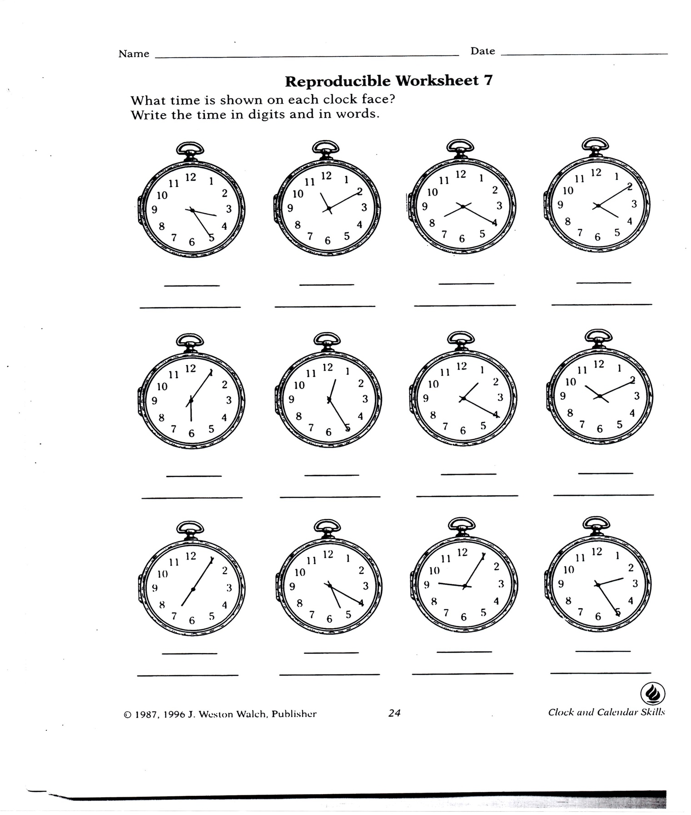

**Task 2: What part of the day is it when the time is a.m.?**

Answer:

**______________________________________________________**

**Task 3: What part of the day is it when the time is p.m.?**

Answer:

**______________________________________________________**

**Task 3: What part of time does the small hand on the clock indicate?**

Answer:

**______________________________________________________**

**Task 4: What part of time does the big hand on the clock indicate?**

Answer:

**______________________________________________________**

**Task 5: Complete the Learner Self-Reflection Checklist below.**

**Learner’s Self-Reflection:**

1. I can read the times on an analogue clock. Yes ❑ No ❑

2. I know what a.m. and p.m. mean. Yes ❑ No ❑

3. I feel confident telling time using an analogue clock. Yes ❑ No ❑

**______________________________________________________**

# Answers

**Task 1: Look at the analogue clocks. On the first line under each clock, write the digital time that is shown on the clock face.**

Answer:



3:25 11:10 8:20 4:10

6:05 12:25 1:20 10:10

7:05 5:20 9:05 2:25

**Task 2: What part of the day is it when the time is a.m.?**

Answer: From 12:00am (midnight) until 12:00pm (noon) (Morning hours)

**Task 3: What part of the day is it when the time is p.m.?**

Answer: From 12:00pm (noon) until 12:00am (midnight) (Night hours)

**Task 3: What part of time does the small hand on the clock indicate?**

Answer: The small hand indicates the hour

**Task 4: What part of time does the big hand on the clock indicate?**

Answer: The big hand indicates the minute

**Task 5: Complete the Learner Self-Reflection Checklist below.**

Answer: Answers will vary learner by learner and can indicate if the learner feels more upgrading on this topic is needed.

# Performance Descriptors

| Levels | Performance Descriptors | Needs Work | Completes task with support from practitioner | Completes task independently |
| --- | --- | --- | --- | --- |
| B3.1a | makes a direct match between what is requested and what is entered |  |  |  |
| C2.1 | reads time on analogue clock |  |  |  |
|  | represents times using standard conventions |  |  |  |
|  | uses strategies to check accuracy (using the clock) |  |  |  |
| E.1 | begins to monitor own learning |  |  |  |
|  | uses feedback to improve performance |  |  |  |

This task: Was successfully completed Needs to be tried again

Learner Comments:

Instructor (print): Learner (print):

**__________________ _________________**