

Task Title: These Boots are Made for Working

# OALCF Cover Sheet – Practitioner Copy

**Learner Name: __________________________________________**

**Date Started: ___________________________________________**

**Date Completed: _________________________________________**

|  |  |  |
| --- | --- | --- |
| **Goal Path:** | Employment | Apprenticeship |
| Secondary School | Post Secondary | Independence |

**Successful Completion:**  Yes No

**Task Description:** The learner will compare the costs of different work boots and calculate totals including sales tax.

**Main Competency/Task Group/Level Indicator:**

* Find and Use Information/Read continuous text/A1.2
* Understand and Use Numbers/Manage money/C1.2

**Materials Required:**

* Pen/pencil and paper and/or digital device
* Calculator or digital device with calculator function

# Learner Information

People working in construction, manufacturing, and many other environments must have work boots before going to a job site.

Scan the advertisements for Workboots #1, Workboots #2 and Workboots #3.

**Work Boots #1**

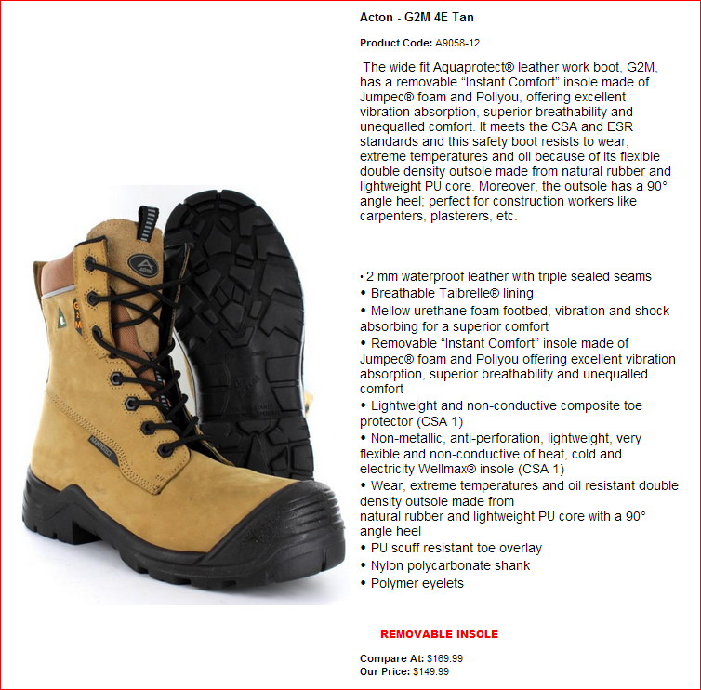

**Work Boots #2**

**Work Boots #3**

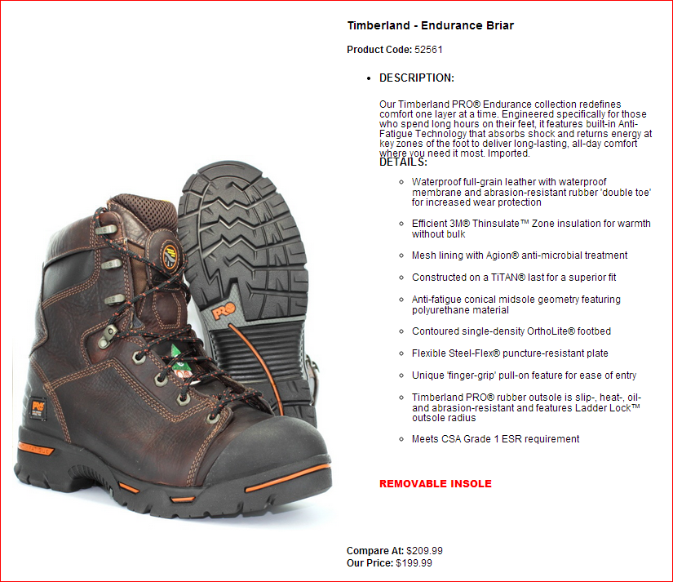

# Work Sheet

**Task 1: List the boots that are waterproof.**

Answer:

**______________________________________________________**

**Task 2: List the boots that have a removable insole.**

Answer:

**______________________________________________________**

**Task 3: List the boots that have a TPU bumper toe guard.**

Answer:

**______________________________________________________**

**Task 4: Calculate the total price for each pair of boots including sales tax (13%).**

Answer:

**______________________________________________________**

**Task 5: Calculate how much a customer would save if they purchase boot #1 instead of boot #3.**

Answer:

**______________________________________________________**

Answers

**Task 1: List the boots that are waterproof.**

Answer: #1 and #3 OR Acton - 2GM 4E Tan and Timberland - Endurance Briar

**Task 2: List the boots that have a removable insole.**

Answer: #1 and #3 OR Acton - 2GM 4E Tan and Timberland - Endurance Briar

**Task 3: List the boots that have a TPU bumper toe guard.**

Answer: #2 OR JB Goodhue - Dynamic

**Task 4: Calculate the total price for each pair of boots including sales tax (13%).**

Answer:

#1: $149.99 x 0.13 = $19.50. $149.99 + $19.50 = $169.49 total

#2: $159.99 x 0.13 = $20.80. $159.99 + $20.80 = $180.79 total

#3: $199.99 x 0.13 = $26.00. $199.99 + $26.00 = $225.99 total

**Task 5: Calculate how much a customer would save if they purchase boot #1 instead of boot #3.**

Answer: $225.99 - $169.49 = $56.50 savings

# Performance Descriptors

| Levels | Performance Descriptors | Needs Work | Completes task with support from practitioner | Completes task independently |
| --- | --- | --- | --- | --- |
| A1.2 | scans text to locate information |  |  |  |
|  | locates multiple pieces of information in simple texts |  |  |  |
|  | makes low-level inferences |  |  |  |
|  | makes connections between sentences and between paragraphs in a single text |  |  |  |
|  | reads more complex texts to locate a single piece of information |  |  |  |
|  | follows the main events of descriptive, narrative and informational texts |  |  |  |
|  | obtains information from detailed reading |  |  |  |
|  | begins to identify sources and evaluate information |  |  |  |
| C1.2 | calculates using numbers expressed as whole numbers, fractions, decimals, percentages and integers |  |  |  |
|  | calculates percentages |  |  |  |
|  | chooses and performs required operation(s); may make inferences to identify required operation(s) |  |  |  |

|  |  |  |  |  |
| --- | --- | --- | --- | --- |
| Levels | Performance Descriptors | Needs Work | Completes task with support from practitioner | Completes task independently |
|  | selects appropriate steps to reach solution(s); represents costs and rates using monetary symbols, decimals and percentages |  |  |  |
|  | interprets, represents and converts amounts using whole numbers, decimals, percentages, ratios and simple common fractions (e.g. 1/2, 1/4) |  |  |  |
|  | uses strategies to check accuracy (e.g. estimating, using a calculator, repeating a calculation, using the reverse operation) |  |  |  |

This task: Was successfully completed Needs to be tried again

Learner Comments:

Instructor (print): Learner (print):

**__________________ _________________**