

Task Title: Tips to Reduce your Energy Bill

OALCF Cover Sheet – Practitioner Copy

Learner Name: __________________________________________
Date Started: ___________________________________________
Date Completed: _________________________________________

Goal Path: | Employment | Apprenticeship
Secondary School | Post Secondary | Independence
Successful Completion: Yes No

Task Description: The learner will review a document listing ways to reduce energy bills and answer questions.
Main Competency/Task Group/Level Indicator:
- Find and Use Information/Read continuous text/A1.2
Materials Required:
- Pen/pencil and paper and/or digital device

Learner Information
Electricity is expensive and it is always helpful to learn ways to minimize costs.

Scan “Top Ten Fastest, Easiest and Best Ever Money-Saving Tips”.

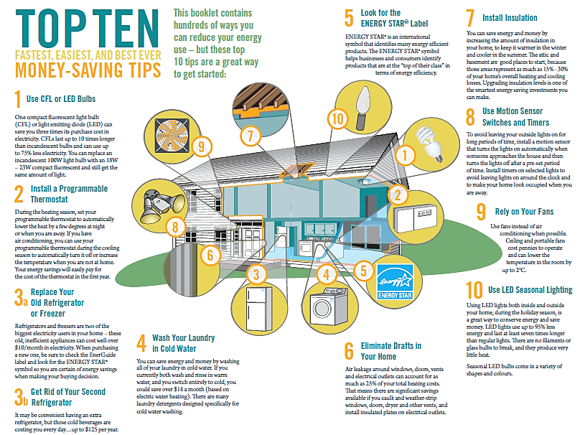

Work Sheet
Task 1: List five (5) ways to lower home energy costs.
Answer:

______________________________________________________
Task 2: List three (3) reasons why CFL and LED lightbulbs are better than incandescent lightbulbs.
Answer:

______________________________________________________
Task 3: What does the Energy Star label help identify?
Answer:

______________________________________________________

Task 4: If you use only cold water to wash your clothes, how much money could you save each month?
Answer:

______________________________________________________
Task 5: Explain how you can reduce drafts around windows, doors, vents and electrical outlets.
Answer:

______________________________________________________

Answers
Task 1: List five (5) ways to lower home energy costs.
Answer: Any five of
- Use CFL or LED bulbs
- Install a programmable thermostat
- Replace your old refrigerator or freezer
- Get rid of your second refrigerator
- Wash your laundry in cold water
- Look for the Energy Star label
- Eliminate drafts in your home
- Install insulation
- Use motion sensor switches and timers
- Rely on your fans
- Use LED seasonal lighting

Task 2: List three (3) reasons why CFL and LED lightbulbs are better than incandescent lightbulbs.
Answer: Any three of
- Save three times their cost
- They last 10 times longer
- Use up to 75% less electricity
- You can replace a 100W light bulb with an 18W-23W CFL and get the same amount of light

Task 3: What does the Energy Star label help identify?
Answer: energy efficient products/products at the top of their class in terms of energy efficiency

Task 4: If you use only cold water to wash your clothes, how much money could you save each month?
Answer: $14.00

Task 5: Explain how you can reduce drafts around windows, doors, vents and electrical outlets.
Answer: Caulk, weather-strip, and install insulated plates

Performance Descriptors
Levels | Performance Descriptors | Needs Work | Completes task with support from practitioner | Completes task independently
A1.2 | scans text to locate information
 | locates multiple pieces of information in simple texts
 | makes low-level inferences
 | makes connections between sentences and between paragraphs in a single text
 | reads more complex texts to locate a single piece of information
 | follows the main events of descriptive, narrative and informational texts
 | obtains information from detailed reading
 | begins to identify sources and evaluate information

This task: Was successfully completed Needs to be tried again

Learner Comments:

Instructor (print): Learner (print):
__________________ _________________

