

Task Title: Tracking Height and Weight Percentiles

# OALCF Cover Sheet – Practitioner Copy

**Learner Name: __________________________________________**

**Date Started: ___________________________________________**

**Date Completed: _________________________________________**

|  |  |  |
| --- | --- | --- |
| **Goal Path:** | Employment | Apprenticeship |
| Secondary School | Post Secondary | Independence |

**Successful Completion:**  Yes No

**Task Description:** The learner will use height and weight percentile charts to monitor a child’s growth over time.

**Main Competency/Task Group/Level Indicator:**

* Understand and Use Numbers/Manage Data/C4.3

**Materials Required:**

* Pen/pencil and paper and/or digital device

# Learner Information

Some health care professionals use height and weight percentile charts as one of their guidelines to monitor a child’s growth.

Scan the “Birth to 36 months: Boys” and the “Weight-for-age percentiles: Girls, birth to 36 months” growth charts.

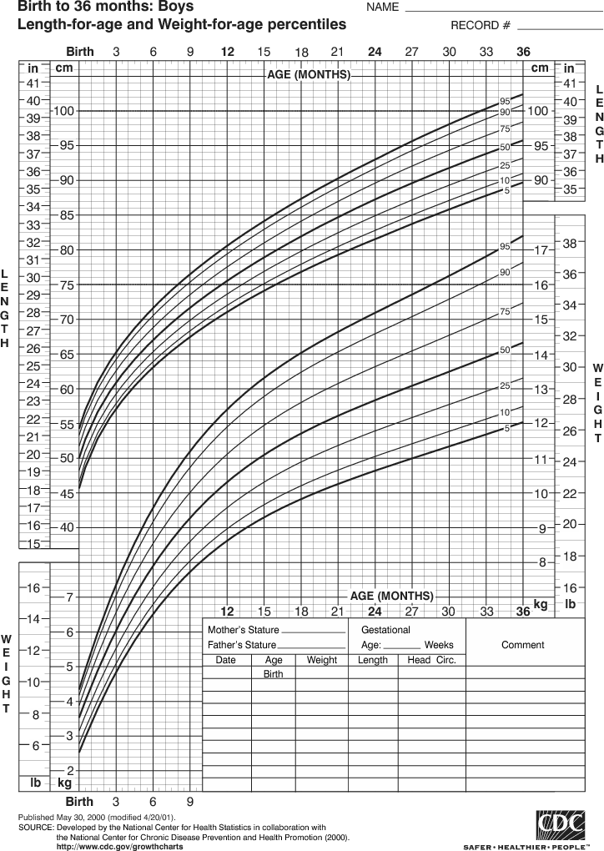

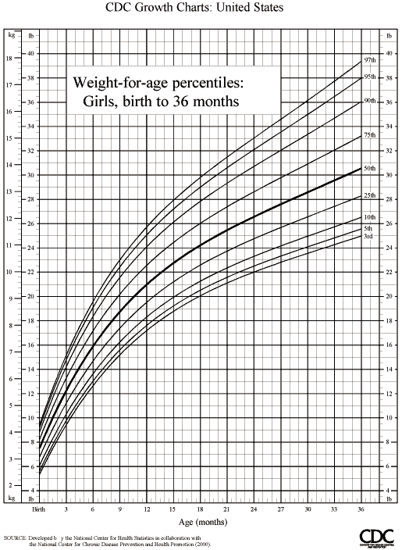

# Work Sheet

**Task 1a) Plot the following weight information on the “Birth to 36 months: Boys” percentiles chart.**

|  |  |  |  |  |
| --- | --- | --- | --- | --- |
| **Birth** | **8 lb 3 oz** |  | **21 months** | **26 lb 7 oz** |
| **3 months** | **12 lb 8 oz** |  | **24 months** | **27 lb 6 oz** |
| **6 months** | **16 lb** |  | **27 months** | **28 lb 4 oz** |
| **9 months** | **20 lb 15 oz** |  | **30 months** | **29 lb 1 oz** |
| **12 months** | **22 lb 1 oz** |  | **33 months** | **30 lb 4 oz** |
| **15 months** | **24 lb** |  | **36 months** | **31 lb 8 oz** |
| **18 months** | **25 lb 14 oz** |  |  |  |

Answer: No written response required here.

Task completed: Yes: No:

**Task 1b) Plot the same weights on the “Weight-for-age percentiles: Girls birth-36 months” chart.**

Answer: No written response required here.

Task completed: Yes: No:

**Task 1c) What difference do you notice between the lines you have created on the two charts?**

Answer:

**______________________________________________________**

**Task 2a) Plot the following height information on the “Birth to 36 months: Boys” percentiles chart:**

|  |  |  |  |  |
| --- | --- | --- | --- | --- |
| **Birth** | **21 ½”** |  | **21 months** | **33 ¾”** |
| **3 months** | **24 ¾”** |  | **24 months** | **34 ½”** |
| **6 months** | **27”** |  | **27 months** | **36 ¼”** |
| **9 months** | **29”** |  | **30 months** | **37”** |
| **12 months** | **30 ½”** |  | **33 months** | **38 ½”** |
| **15 months** | **31 ½”** |  | **36 months** | **39 ½”** |
| **18 months** | **32”** |  |  |  |

Answer: No written response required here.

Task completed: Yes: No:

**Task 2b: What percentile would this child fall into?**

Answer:

**______________________________________________________**

# Answers

**Task 1a) Plot the following weight information on the “Birth to 36 months: Boys” percentiles chart:**

Answer. See first chart below.

**Task 1b) Plot the same weights on the “Weight-for-age percentiles: Girls birth-36 months” chart.**

Answer: See second chart below.

**Task 1c)** **What difference do you notice between the lines you have created on the two charts?**

Answers will vary but the learner should observe that a girl will be in a higher percentile than a boy of the same age and weight.

**Task 2a) Plot the following height information on the “Birth to 36 months: Boys” percentiles chart:**

Answer: See first chart below.

**Task 2b)** **What percentile would this child fall into?**

Answer: This child would fall into the 91st percentile (90 to 93 is acceptable)

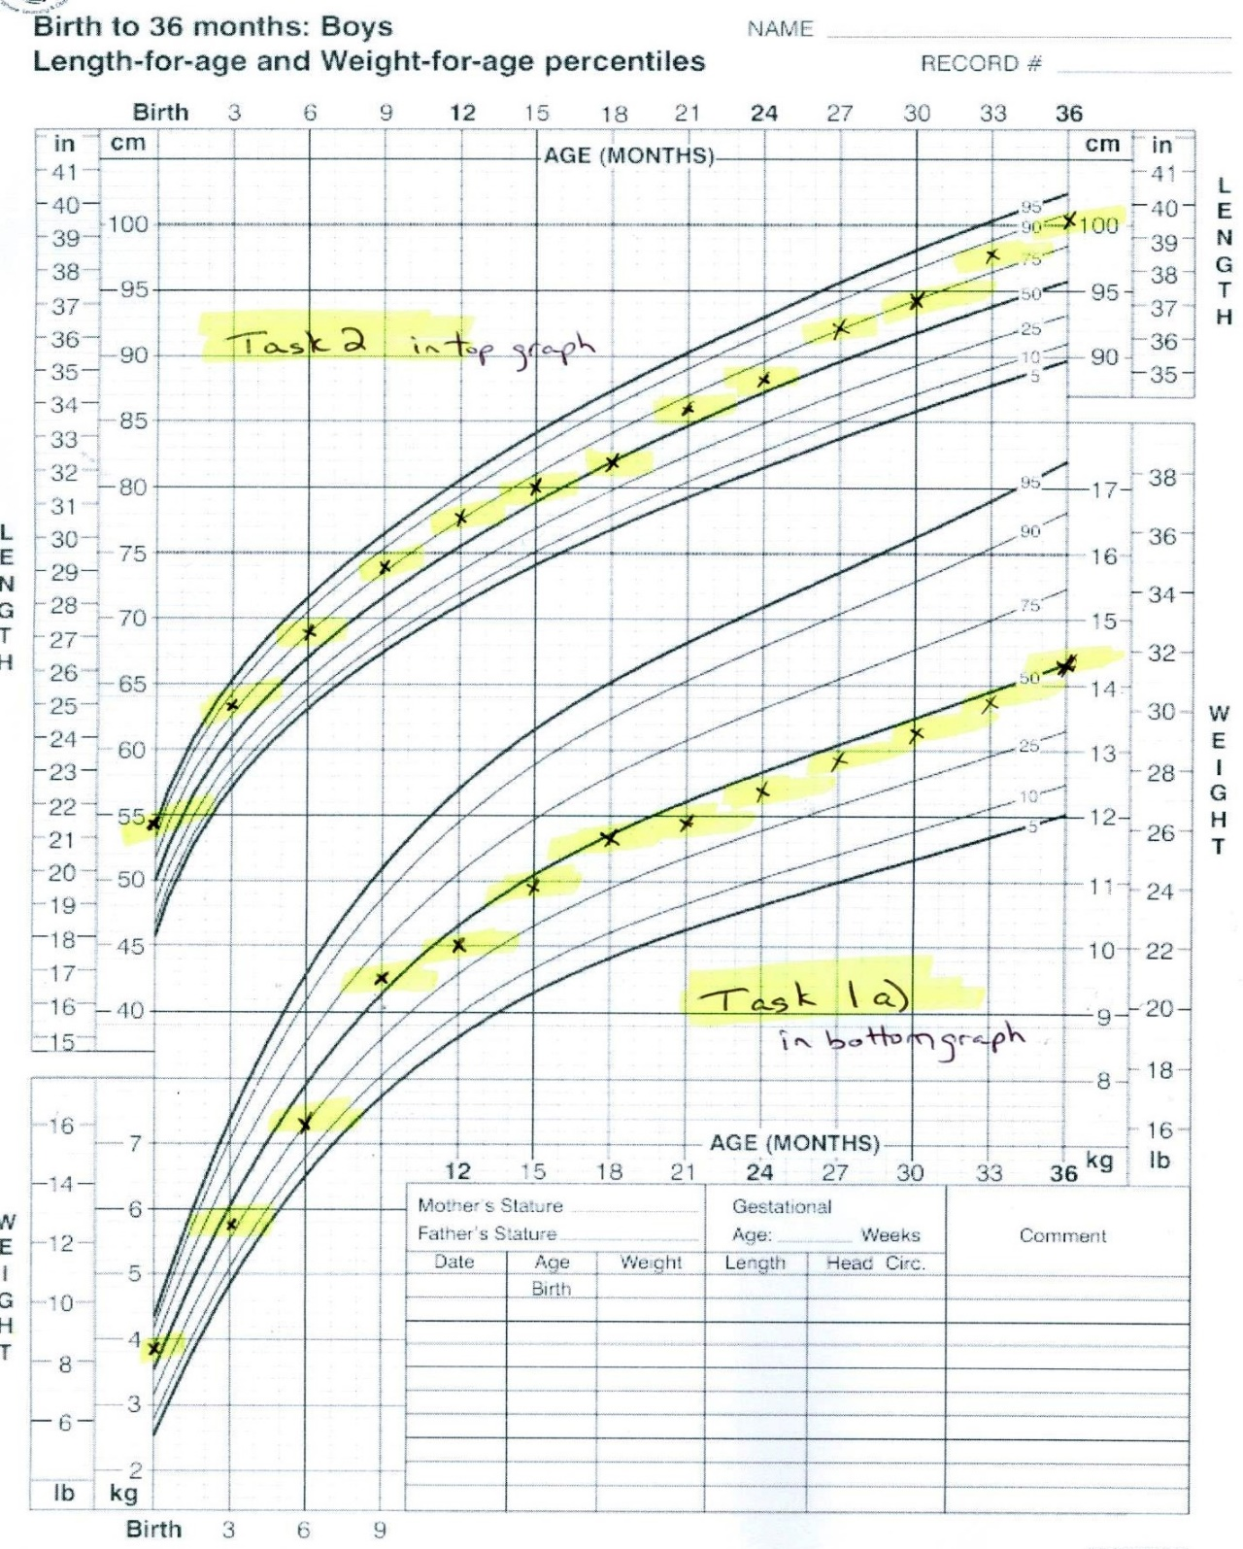

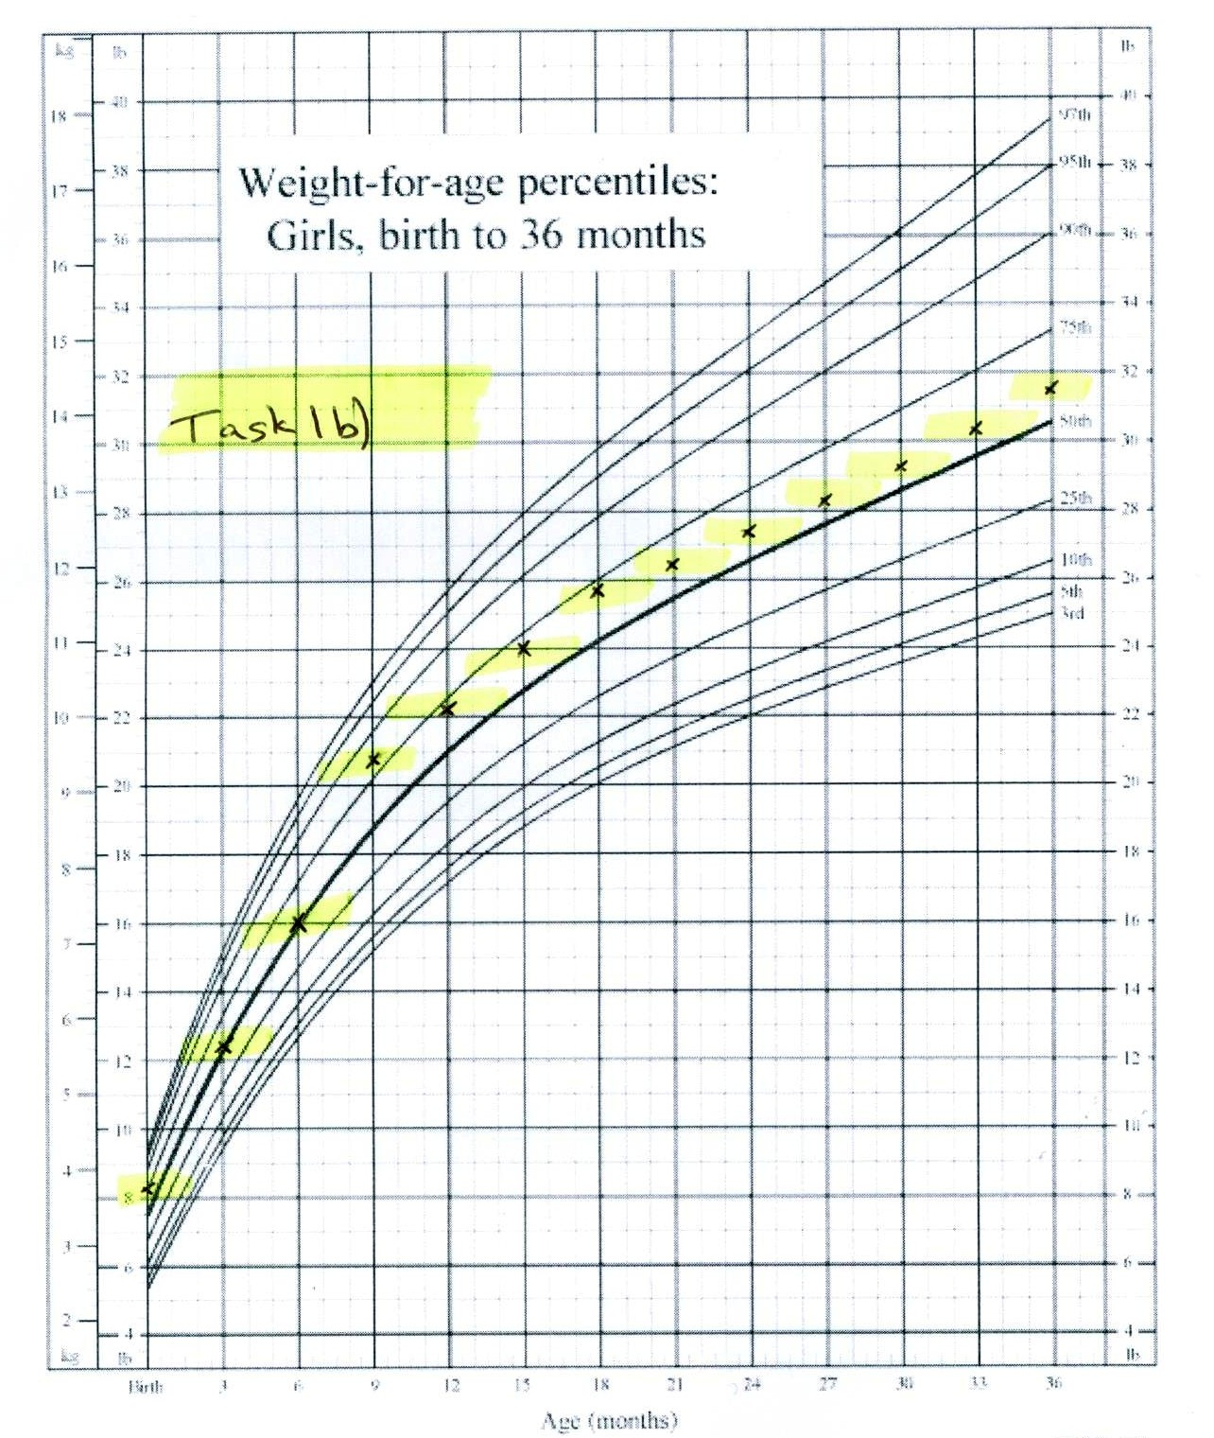

# Performance Descriptors

| Levels | Performance Descriptors | Needs Work | Completes task with support from practitioner | Completes task independently |
| --- | --- | --- | --- | --- |
| C4.3 | manages unfamiliar elements (e.g. context, content) to complete tasks |  |  |  |
|  | makes estimates involving many factors where precision is required |  |  |  |
|  | begins to recognize bias in data and in displays, such as graphs |  |  |  |
|  | selects appropriate steps to solutions from among options |  |  |  |
|  | interprets, represents and converts values using whole numbers, decimals, percentages, ratios and fractions |  |  |  |
|  | finds integrates and analyzes data |  |  |  |
|  | organizes and represents numerical information (e.g. tables, graphs) |  |  |  |
|  | makes predictions using data; identifies trends |  |  |  |

This task: Was successfully completed Needs to be tried again

Learner Comments:

Instructor (print): Learner (print):

**__________________ _________________**