

Task Title: Understand a Course Syllabus

# OALCF Cover Sheet – Practitioner Copy

**Learner Name: __________________________________________**

**Date Started: ___________________________________________**

**Date Completed: _________________________________________**

|  |  |  |
| --- | --- | --- |
| **Goal Path:** | Employment | Apprenticeship |
| Secondary School | Post Secondary | Independence |

**Successful Completion:**  Yes No

**Task Description:** The learner will read a college course syllabus and answer questions.

**Main Competency/Task Group/Level Indicator:**

* Find and Use Information/Read continuous text/A1.3

**Materials Required:**

* Pen/pencil and paper and/or digital device

# Learner Information

College and university professors provide detailed information in a course syllabus. This includes course materials, assignment requirements, reading lists, and deadlines.

Read the course syllabus for:

“Canadore College CMM125 College Communication I”

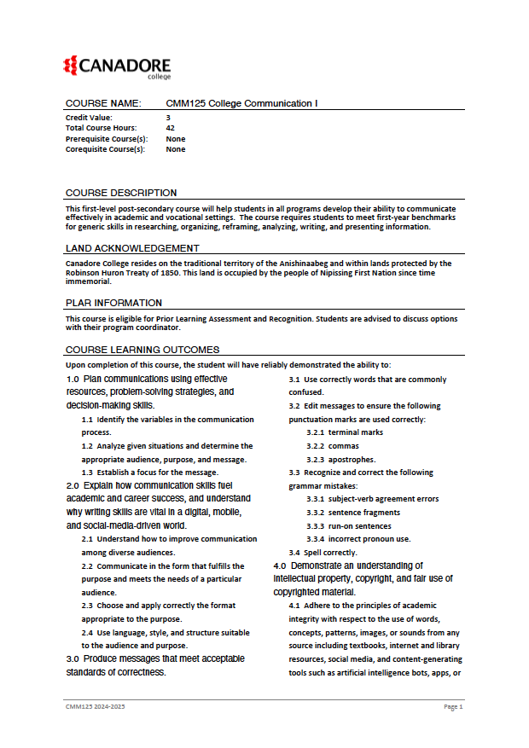

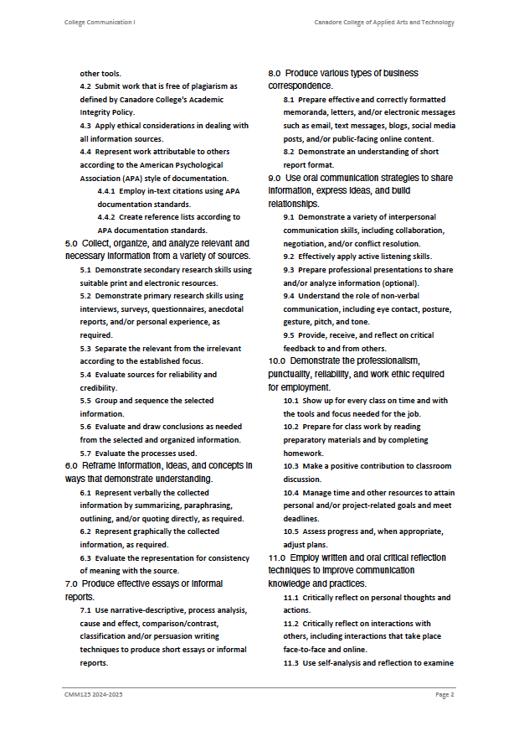

# 

# 

# 

# 

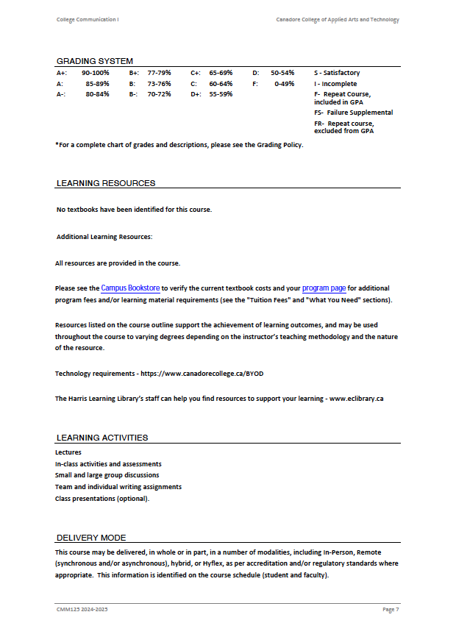

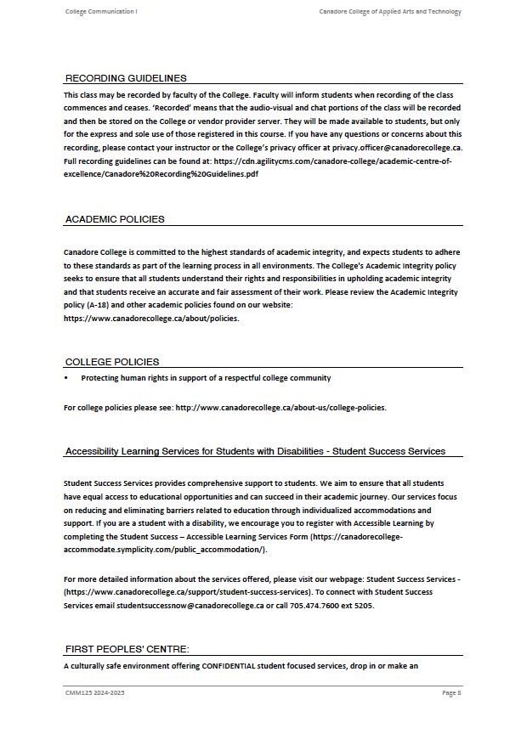

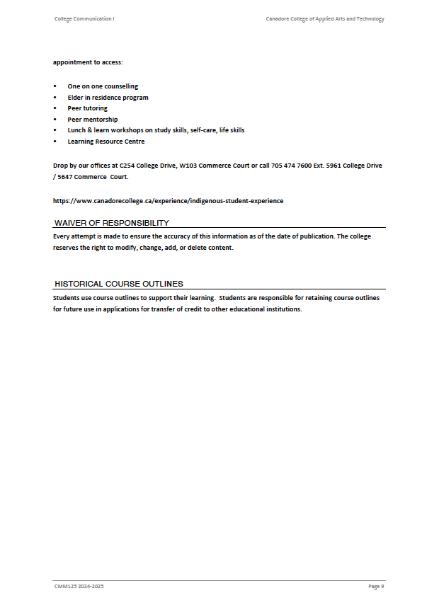

# Work Sheet

**Task 1: How many course hours are there for this course (CMM125 College Communication I)?**

Answer:

**______________________________________________________**

**Task 2: What are the prerequisites for this course?**

Answer:

**______________________________________________________**

**Task 3: List the program outcomes for a student enrolled in Business Fundamentals.**

Answer:

**______________________________________________________**

**Task 4: How much of the course evaluation is determined by quizzes?**

Answer:

**______________________________________________________**

**Task 5: List the textbooks required for this course.**

Answer:

**______________________________________________________**

Answers

**Task 1: How many course hours are there for this course?**

Answer: 42

**Task 2: What are the prerequisites for this course?**

Answer: There are no prerequisites

**Task 3: List the program outcomes for a student enrolled in Business Fundamentals.**

Answer:

* Use current technologies to support an organization’s business initiatives
* apply basic research skills to support business decision making
* describe marketing and sales concepts used to support the operations of an organization
* outline the functional areas of a business and their inter-relationships

**Task 4: How much of the course evaluation is determined by quizzes?**

Answer: 30%

**Task 5: List the textbooks required for this course.**

Answer: There are no textbooks

# Performance Descriptors

| Levels | Performance Descriptors | Needs Work | Completes task with support from practitioner | Completes task independently |
| --- | --- | --- | --- | --- |
| A1.3 | manages unfamiliar elements (e.g. vocabulary, context topic) to complete tasks |  |  |  |
|  | identifies the purpose and relevance of texts |  |  |  |
|  | skims to get the gist of longer texts |  |  |  |
|  | uses organizational features, such as headings, to locate information |  |  |  |
|  | follows the main events of descriptive, narrative, informational and persuasive texts |  |  |  |
|  | obtains information from detailed reading |  |  |  |
|  | identifies sources, evaluates and integrates information |  |  |  |

This task: Was successfully completed Needs to be tried again

Learner Comments:

Instructor (print): Learner (print):

**__________________ _________________**