

Task Title: Understanding Rigging Terminology

# OALCF Cover Sheet – Practitioner Copy

**Learner Name: __________________________________________**

**Date Started: ___________________________________________**

**Date Completed: _________________________________________**

| **Goal Path:** | Employment | Apprenticeship |
| --- | --- | --- |
| Secondary School | Post Secondary | Independence |

**Successful Completion:**  Yes No

**Task Description:** The learner will read and interpret terminology used in rigging.

**Main Competency/Task Group/Level Indicator:**

* Find and Use Information/Read continuous text/A1.2

**Materials Required:**

* Pen/pencil and paper and/or digital device

# Learner Information

Millwrights and other skilled tradespeople use different types of ropes and slings when hoisting and rigging loads.

Read “Rigging Terminology”.

**Rigging Terminology**

**Chain Grading Scale**: The chain grading system helps riggers understand a chain's capabilities. Chains are made of different materials and produced in various sizes, both of which affect their strength.

* Grade 30 chain is made of low‑strength carbon steel. It is used for light‑duty applications such as towing, lashing, and guard rails.
* Grade 43 chain is stronger than proof coil chain, and it is often used for more demanding tasks in trucking, logging, and farming.
* Grade 70 chain, also known as transport chain, is made of heat‑treated carbon steel. It is often used for towing and securing loads.
* Grade 80, 100, and 120 chains are made of heat‑treated alloy steel. Like other chain grades, these are used for tie‑downs, towing, and load securing.

**Eye Bolt**: An eye bolt is a bolt with a loop on one end. Riggers use eye bolts to connect a load to a rigging assembly.

There are two main types of eye bolts: machine eye bolts and nut eye bolts. Machine eye bolts are screwed directly into a threaded hole on a machine or other load. Nut eye bolts are inserted through an unthreaded hole and secured with a nut.

**Rigging**: Rigging is the equipment used to lift, suspend, support, tow, or tie down a load. It includes chains, wire ropes, slings, and the equipment used to connect these to a load, vehicle, supporting structure, or lifting machine such as a crane or hoist.

**Rigging Hooks**: Rigging hooks are heavy‑duty metal hooks. Several types of hooks are used in rigging, including slip hooks and grab hooks.

**Rigging Sling**: A rigging sling is a length of chain or rope with attachment points at both ends. The sling is attached to the load and then attached to a lifting hook or other rigging equipment.

Types of rigging slings include:

* Vertical hitch: connects one end of a sling to a crane hook and the other end to the load.
* Choker hitch: wraps a single sling around the load. One end of the sling passes through an attachment or loop on the other end and is then attached to a lifting hook or other rigging hardware.
* Basket hitch: the sling is wrapped around the load and both ends are connected to the hook.
* Bridle hitch: two or more vertical hitches to evenly distribute the load's weight.

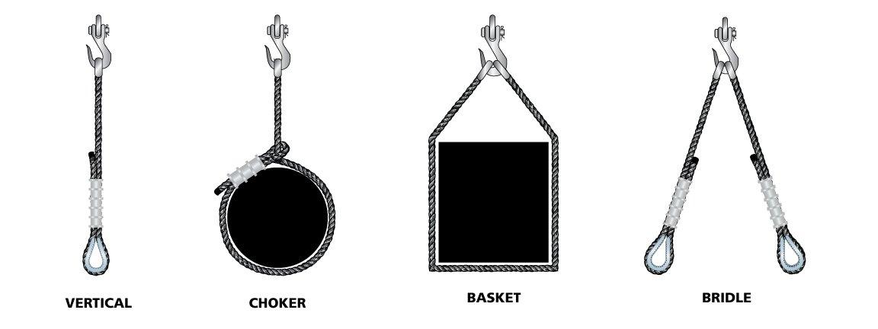

**Shackle**: A lifting shackle is comprised of a metal U‑shaped crown or bow with a pin penetrating the two free ends, which are called lugs. Shackles are used to connect two parts of a rigging assembly.

**Turnbuckle**: Turnbuckles reduce slack or adjust tension in rigging assemblies. They have a body with tapped holes into which turnbuckle ends with threaded shafts are screwed.

Material adapted from: <https://www.huyett.com/blog/rigging-terms?srsltid=AfmBOoq6RoDyK0Z5DdyRILYmQcK1Alp6acDqZ50cyMyd5rtkLiWh4B6u>

# Work Sheet

**Task 1: List the types of chains that are made of heat-treated alloy steel.**

Answer:

**______________________________________________________**

**Task 2: Describe the difference between machine eye bolts and nut eye bolts.**

Answer:

**______________________________________________________**

**Task 3: Describe the difference between a shackle and a lug.**

Answer:

**______________________________________________________**

**Task 4: What is the purpose of a turnbuckle?**

Answer:

**______________________________________________________**

# Answers

**Task 1: List the types of chains that are made of heat-treated alloy steel.**

Answer: Grade 80, 100, and 120 chains

**Task 2: Describe the difference between machine eye bolts and nut eye bolts.**

Answer: Machine eye bolts and nut eye bolts. Machine eye bolts are screwed directly into a threaded hole on a machine or other load. Nut eye bolts are inserted through an unthreaded hole and secured with a nut.

**Task 3: Describe the difference between a shackle and a lug.**

Answer: Lugs are the two free ends created by a lifting shackle which is comprised of a metal U‑shaped crown or bow with a pin penetrating the two free ends. Shackles are used to connect two parts of a rigging assembly.

**Task 4: What is the purpose of a turnbuckle?**

Answer: Turnbuckles reduce slack or adjust tension in rigging assemblies.

# Performance Descriptors

| Levels | Performance Descriptors | Needs Work | Completes task with support from practitioner | Completes task independently |
| --- | --- | --- | --- | --- |
| A1.2 | scans text to locate information |  |  |  |
|  | locate multiple pieces of information in simple texts |  |  |  |
|  | makes low-level inferences |  |  |  |
|  | makes connections between sentences and between paragraphs in a single text |  |  |  |
|  | reads more complex texts to locate a single piece of information |  |  |  |
|  | follows the main events of descriptive, narrative and informational texts |  |  |  |
|  | obtains information from detailed reading |  |  |  |
|  | begins to identify sources and evaluate information |  |  |  |



This task: Was successfully completed Needs to be tried again

Learner Comments:

Instructor (print): Learner (print):

**__________________ _________________**