

Task Title: Use a Floorplan to Design a Room

OALCF Cover Sheet – Practitioner Copy

Learner Name: __________________________________________
Date Started: ___________________________________________
Date Completed: _________________________________________

Goal Path: | Employment | Apprenticeship
Secondary School | Post Secondary | Independence
Successful Completion: Yes No

Task Description: The learner will create a floor plan using furniture and room measurements.
Main Competency/Task Group/Level Indicator:
- Find and Use Information/Interpret documents/A2.2
- Understand and Use Numbers/Use measures/C3.1
Materials Required:
- Pen/pencil and paper and/or digital device
- Calculator or digital device with calculator function (optional)

Learner Information
A floorplan can help you decide where to put furniture so that everything will fit.
Scan the “floorplan” and “furniture items and dimensions”.

Floorplan

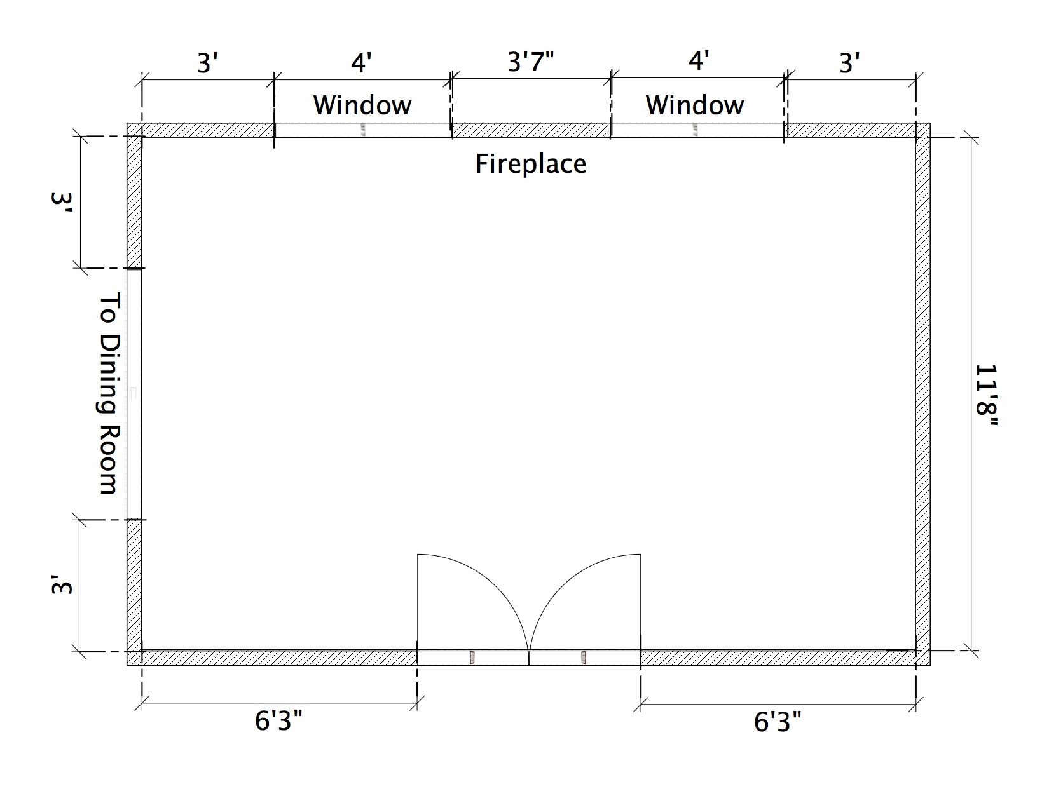

Furniture Items and Dimensions

Item | Dimensions
Couch | 6 feet x 3 feet
Loveseat | 4 feet x 3 feet
Chair | 3 feet x 3 feet
End table | 2 feet x 2 feet
Coffee table | 3 feet by 2 feet
Television stand | 3 feet x 2 feet
Bookshelf | 2 feet wide x 1 foot deep
Floor lamp | All floor lamps have a 1-foot diameter base
Dog bed | 2 feet x 2 feet
Plants | All plants have a 1-foot diameter base

Work Sheet
Task 1: Select five (5) items from the furniture list. Draw and label where you would like to put each item on the floorplan. Make sure there is at least 1 foot of empty space along each wall. Make sure furniture is not blocking windows or doorways.

Answer: No written response required here.

Task completed: Yes:

Answers
Answers will vary.

Performance Descriptors
Levels | Performance Descriptors | Needs Work | Completes task with support from practitioner | Completes task independently
A2.2 | extracts information from tables and forms
 | uses layout to locate information
 | makes connections between parts of documents
C3.1 | adds and subtracts whole number measurements
 | recognizes values in number and word format
 | recognizes simple, common shapes (e.g. circle, square, rectangle, triangle)
 | measure distance, length, width, height, weight, liquid volume, angles and temperature
 | makes simple estimates
 | interprets and represents measures using symbols and abbreviations (e.g. inches as “, centimeters as cm, pounds as lbs, kilograms as kilos or kg)

This task: Was successfully completed Needs to be tried again
Learner Comments:

Instructor (print): Learner (print):
__________________ _________________

